**DVB–SIS (Single Illumination System)**

**Concept and Implementation**

Revision History 10

1. Introduction 11

2. Scope 12

3. Concept 13

3.1 Concept behind the SIS Standard – parent and daughter sites 13

3.2 Specification of Parent Signals 14

3.2-1 Service information (PSI/SI) 14

3.2-1-1 Generation of PSI/SI 15

3.2-2 SIS Services carrying PCRabs 16

3.2-3 Layer 1 signaling 16

3.2-3-1 DVB-T2 case 16

3.2-3-2 DVB-T case 16

3.2-4 Other T2-MI packet types (DVB-T2 case) 16

3.2-5 Framing & Timing Information (F&TI) 17

3.2-5-1 DVB-T2 case 17

3.2-6 DVB-T case 17

3.2-7 DSA configuration information (DSACI) 17

3.2-7-1 DSA structure 18

3.2-7-1-1 XML schema representation 18

3.2-7-1-2 DSA internal structure 18

3.2-7-2 XML types and XML elements of the DSA configuration information 19

3.2-7-2-1 global configuration 19

3.2-7-2-2 Input configuration 19

3.2-7-3 Remultiplexing 19

3.2-7-3-1 TS Remultiplexing 19

3.2-7-4 PID processing 19

3.2-7-5 Service and PMT processing 20

3.2-7-6 PSI/SI processing 20

3.2-7-6-1 SIS information (PSI/SI) 20

3.2-7-6-2 SIS services 20

3.2-7-7 PAT processing 21

3.2-7-8 CAT processing 21

3.2-7-9 SDT and BAT processing 21

3.2-7-10 EIT processing 21

3.2-7-11 Output configuration 21

3.2-7-11 DSACI contains 21

3.2-8 DSA schema 22

3.2-9 In-band carriage of the DSACI XML file 22

3.2-10 preparation of metadata and content on parent site: 23

3.3 Carriage of signal components within the parent transport streams 24

3.4 Daughter site processing 24

3.4-1 Bootstrapping 27

3.4-1-1 Gaining access to DSACI provided in-band 27

3.4-1-2 Out-of-band DSACI provision 27

3.4-2 Input processing 28

3.4-2-1 Reception of parent transport streams 28

3.4-2-2 Arrival timestamping 28

3.4-2-3 Calculation of virtual timestamps (VATs) 28

3.4-2-3-1 CBR operation mode 28

3.4-3 TS re-multiplexing 28

3.4-3-1 TS DVB-T2 case 28

3.4-3-2 TS DVB-T case 29

3.4-3-2-1 Extraction of F&TI packets 29

3.4-4 Selection of relevant content from input TSs 29

3.4-5 Processing and generation of layer 2 signaling (PSI/SI) 29

3.4-5-1 Pass-through remultiplexing of selected parent tables/sections 29

3.4-5-2 conversion of parent table/sections on the fly (patching) 30

3.4-5-3 static table regeneration 30

3.4-5-3-1 SDT and BAT regeneration 31

3.4-5-4 Dynamic table regeneration 32

3.4-6 Placement of incoming packets in the outgoing TS 32

3.4-6-1 Deterministic scheduling 32

3.4-3 Framing 33

3.4-3-1 DVB-T2 case 33

3.4-3-1-1 TS splitting (optional) 33

3.4-3-1-2 Partial mode adaptation 33

3.4-3-1-3 Allocation of TS bits to interleaving frames 34

3.4-3-1-4 Null packet deletion 34

3.4-3-1-5 ISSY generation 34

3.4-3-1-6 Generation of BBFRAMEs 35

3.4-3-1-6-1 Allocation of bits to the BBFRAMEs of the interleaving frame 35

3.4-3-1-6-2 Mapping of mode-adapted bits into the BBFRAMES 35

3.4-3-1-6-3 BBHEADER generation 35

3.4-3-1-6-4 Packets to interleaving frames 35

3.4-3-2 DVB-T case 36

3.4-4 Extraction of T2-MI packets 36

3.4-5 Output processing 36

3.4-5-1 DVB-T2 case 36

3.4-5-1-1 T2-MI multiplexing 36

3.4-5-1-2 Transport of T2-MI packets in MPEG-TS 36

3.4-6 Processing of metadata and content received on daughter site 37

3.4-7 Environment of standard around SIS 37

4. Hardware 38

5. Software 39

5.1 Operating system selection guidelines 40

5.2 Developing applications using the TSDuck library 40

5.3 Installing TSDuck 41

5.3-1 Linux 41

5.4 Data Formats 41

5.4-1 Transport stream 41

5.4-1-1 Live transport streams 42

5.4-1-2 Stored transport streams 42

5.5 Bit rates 43

5.5-1 Interpretation 43

5.3-2 Representation 43

5.5-3 Specifying bitrate in command lines 44

5.5-4 Rebuilding with a different bitrate representation 44

5.6 PSI/SI signalization 44

5.6-1 PSI/SI binary format 44

5.6-1-1 Creating PSI/SI binary files 45

5.6-1-2 Using PSI/SI binary files 45

5.6-2 PSI/SI XML format 45

5.7 Compatibility and conflict between standards 46

5.7-1 supported standards 46

5.7-2 TSDuck options for default standard selection 47

5.8 Character sets 47

5.8-1 Standards and character sets 47

5.8-2 TSDuck options for character sets 47

5.8-3 Character set name 47

5.9 XML files 47

5.9-1 Usage of XML files by TSDuck 47

5.9-2 Inline XML content 47

5.9-3 XML model files 48

5.9-4 XML patch files 48

5.9-4-1 Structure matching 48

5.9-4-2 Attribute patching 48

5.9-4-3 Element patching 48

5.10 JSON and "normalized” report formats 48

5.10-1 "Normalized” report 48

5.10-2 JSON files 48

5.10-3 Automated XML-to-JSON conversion 49

5.10-3-1 Conversion rules 49

5.10-3-2 TSDuck options for automated XML-to-JSON conversion 49

5.11 Transport stream utilities 49

5.11-1 Command line syntax 49

5.11-1-1 Command line options 49

5.11-1-2 Integer values in command line options 49

5.11-1-3 Predefined common options 50

5.12 Using a pager command 50

5.13 Partial command line redirection from a file 50

5.14 Default options from the TSDuck configuration file 50

5.15 Bash command line completion 50

5.16 TSP Plugins 51

5.17 Hardware Device Support 51

5.17-1 Tuner receiver devices (DVB, ATSC, ISDB) 51

5.17-2 Operating system integration 51

5.17-2-1 Linux platforms 51

6. Operating System 53

7. Digital TV 54

7.1 The MPEG data stream 55

7.2 The MPEG-2 Transport Stream 56

7.3 The Packetized Elementary Stream (PES) 60

7.4 The MPEG-2 transport stream packet 62

7.5 Information for the receiver 67

7.5-1 Synchronizing to the transport stream 68

7.5-2 Reading out the current program structure 68

7.5-3 Accessing a program 70

7.5-4 Accessing Scrambled Program 71

7.5-5 Program Synchronization (PCR, DTS, PTS) 72

7.5-6 Additional Information in the Transport Stream (SI/PSI/PSIP) 75

7.5-7 Non-Private and Private Sections and Tables 75

7.5-8 The service information according to DVB (SI) 83

7.6 Asynchronous Serial Transport Stream Interface (TS-ASI) 95

7.7 DVB-IP interface 97

7.8 Single-Frequency Networks in DVB-T in practice 97

7.8-1 SFN measurement parameters 98

7.8-1-1 Guard Interval Violation 100

7.8-1-2 Pre-echoes 102

7.8-1-3 The 0-dB Echo 102

7.8-1-4 Quasi mobile receiving situation 102

7.8-1-5 Transmission of non-identical TPS Bits 103

7.8-1-6 Frequency Accuracy of the Transmitters 103

7.8-2 Practical Examples 103

7.8-2-1 Pre-echoes 105

7.8-2-2 The 0-dB Echoes 105

7.8-2-3 Quasi Mobile Channel 105

7.8-2-4 TPS Bits 105

7.8-2-5 Mobile DVB-T Reception 106

7.8-2-5-1 AWGN channel 107

7.8-2-5-2 Doppler Shift 108

7.8-2-5-3 Stationary Multi-path Reception 108

7.8-2-5-4 Mobile multi-path reception 109

7.8-2-5-5 Mobile Rice Channel 110

7.8-2-5-6 Rayleigh Channel 110

7.8-3 Response of DVB-T Receivers 112

7.8-4 Receiver Test 112

7.8-4-1 Minimum Receiver input level in the AWGN channel 113

7.8-4-2 Minimum SNR 113

7.8-4-3 Adjacent-Channel Occupancy 113

7.8-4-4 Co-channel reception 114

7.8-4-5 multi-path reception 114

7.8-4-6 Channel Search 114

7.8-4-7 Booting Speed and Action 114

7.8-4-8 Program Change 114

7.8-4-9 Teletext 114

7.8-4-10 VPS Functions 114

7.8-4-3-11 Dynamic PSI/SI tables 114

7.8-4-12 Firmware Configuration 115

7.8-4-13 Miscellaneous 115

7.8-5 Network Planning 115

7.8-6 Filling the Gaps in the coverage 115

7.8-7 Fall-off-the-cliff 118

7.8-8 Summary 118

7.9 MPEG-2 transport stream – TS 118

7.9-1 Generic Fixed Packetized Streams – GFPS 119

7.9-2 Generic Continuous Streams – GCS 120

7.9-3 Generic Encapsulated Streams – GSE 120

7.10 DVB-T2 121

7.10-1 Introduction 121

7.10-2 Theoretical Maximum Channel Capacity 121

7.10-3 DVB-T2- Overview 123

7.10-4 Baseband Interface 123

7.10-5 Forward Error Correction 125

7.10-6 COFDM Parameters 128

7.10-6-1 Normal Carrier Mode 130

7.10-6-2 Extended Carrier Mode 131

7.10-7 Modulation Patterns 133

7.10-7-1 Normal Constellation Diagram 134

7.10-7-2 Definition of Cell 135

7.10-7-3 Rotated Q-delayed Constellation Diagram 136

7.10-8 Frame Structure 138

7.10-8-1 P1 Symbol 140

7.10-8-2 P2 Symbols 141

7.10-8-3 Symbols, Frame, Superframe 142

7.10-9 Block diagram 143

7.10-10 Interleavers 144

7.10-10-1 Types of interleaver 145

7.10-10-2 DVB-T2 time interleaver configuration 146

7.10-11 Pilots 149

7.10-12 Sub-Slicing 151

7.10-13 Time-Frequency-Slicing (TFS) 152

7.10-14 PAPR Reduction 152

7.10-15 SISO/MISO Multi-Antenna Systems 154

7.10-15-1 MISO according to Alamouti 154

7.10-15-2 Modified Alamouti in DVB-T2 155

7.10-16 Future Extension Frames 158

7.10-17 Auxiliary Data Stream 159

7.10-18 DVB-T2-MI 159

7.10-19 SFNs in DVB-T2 159

7.10-20 Transmitter Identification Information in DVB-T2S 160

7.10-21 Performance 161

7.10-22 T2-Lite 161

7.10-23 Outlook 161

7.11 Modulation Signal Feed 162

7.12 Terrestrial Broadcast-Transmit Station 163

7.13 Modulator, Exciter 165

7.14 GPS Time/Frequency Reference 167

# Revision History

|  |  |  |
| --- | --- | --- |
| **Revision History** | | |
| **Date** | **Description** | **Modified By** |
| 10/25/2022 | Initial Release | nfernandez, nacuna, aabitria |
|  |  |  |
|  |  |  |

# Introduction

DVB-SIS (Single Illumination System) allows for terrestrial retransmission of signals addressing DTH satellite receivers. SIS stands for single illumination system, referring to the fact that a single satellite beam can be used simultaneously for DTH and to feed terrestrial networks.

Since the standard has been designed in a generic way, the satellite/terrestrial use case is just one possibility; in the future other use cases could be realized using DVB-SIS, e.g., a cable/terrestrial combination. The common denominator for all use cases is the deployment of MPEG-2 transport streams.

The DVB-SIS concept consists in deriving content and metadata from one delivery path (e.g., satellite) for re-delivery via another path (e.g., terrestrial). The video content for both paths is assembled into a single transport stream at a so-called parent site and broadcasted on the single network path; the video content for the other path is derived at the so-called daughter sites.

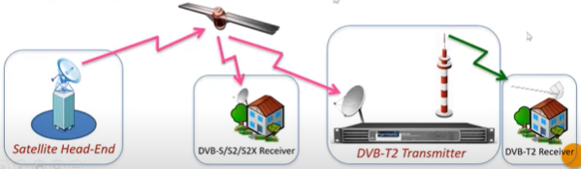

Figure 1.1: DVB-SIS (Single illumination System)

# Scope

This document will cover only the implementation of DVB-SIS from the software point of view, device driver of the modules being used, operating system, plug-in tools, and other software involvement.

The hardware or module using high level functionality will be discussed but not at the circuitry level.

# Concept

Concept behind the DVB-SIS Standard

Deriving content and metadata from delivery path A (e.g., satellite) for re-delivery via path B (e.g., terrestrial)

A chain consists of parent and daughter sites (generic concept, i.e., works for different A/B combinations)

Concepts cover SFN needs, i.e., enable output of bit-by-bit the same T2-MI stream from each DSA belonging to the same SFN.

At central interface H the following data is available:

* Service content (TV/Radio) and related PSI/SI
* Metadata produced by the CSG

In the end it is irrelevant how the content and metadata is produced for interface H

The metadata enables deterministic processing on daughter site.

## 3.1 Concept behind the SIS Standard – parent and daughter sites

* Control signal generator (CSG):
  + Produces all metadata required:
    - Framing & timing information (F&TI)
    - DSA configuration information (DSACI)
    - SIS services
* Daughter site adapter (DSA):
  + Receives n TSs at its input (interface J)
  + Allows for "out of band" input of DSACI via other paths (interface K)
  + Produces a single T2-MI stream at its output (interface L)

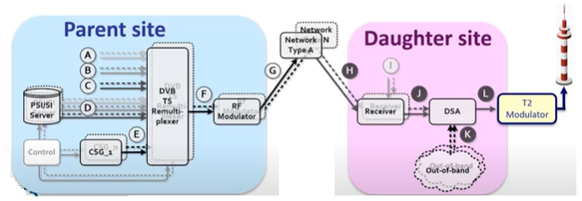

Figure 3.1-1: Parent and Daughter Site

## 3.2 Specification of Parent Signals

The parent signals at interface H shall comprise one or more DVB transport streams to ISO/IEC 13818-1 [5] and suitable for direct reception by DVB-compliant consumer receivers. Those transport streams contain DVB services as defined in ETSI EN 300 468 [6] and SIS metadata for generation of the T2-MI or mega-frame stream at the output of the DSA, i.e., Framing & timing information as well as DSA configuration information for the generation of the DTT multiplex.

### 3.2-1 Service information (PSI/SI)

PSI/SI signaling as defined in ISO/IEC 13818-1 [5] and ETSI EN 300 468 [6] shall be part of the parent signals for the types of services present in the multiplexes addressing the daughter site adapter:

* Parent network-only services
* Common services addressing parent network receivers and terrestrial transmitters:
  + The parent signal shall also include supplementary PSI/SI for DTT and DSACI configuration information, which is combination with the PSI/SI for the parent network enables the DSA to generate PSI/SI for the same services when re-transmitted terrestrial. The supplementary DTT PSI/SI is sent compliment to ISO IEC 13818-1 [5] and ETSI EN 300 468 [6].

The present document describes different approaches for the generation of DTT PSI/SI. These approaches will require the following information as part of the parent signal:

* Tables whose provision as stopped:
  + The parent signa; shall contain indication for stopping the provision of CATs as part of DSACI.
* Tables passed through with no change:
  + The parent signal shall contain DSACI signaling for PID remapping of the parent network PSI/SI table (PID remapping with same PID on parent network and DTT may be used).
* Tables which are modified using section patching:
  + The parent signal shall include parent network PSI/SI sections and DSACI signaling for the patching modification.
* Tables that are regenerated by the DSA:
  + The parent signal shall include parent network PSI/SI section and DSACI signaling for the table regeneration and multiplexing.
* DTT-only services, for which PSI/SI is carried as for all other services – with this exception:
  + SDT-DTI-only services shall be declared in the service description table as data services,
  + i.e., characterized by service_type 0C16 (data broadcast service)

#### 3.2-1-1 Generation of PSI/SI

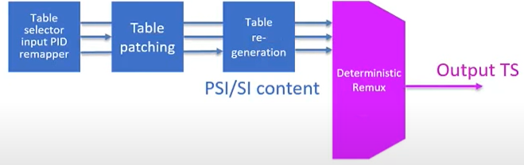  
Figure 3.2-1-1a: Generation of PSI/SI

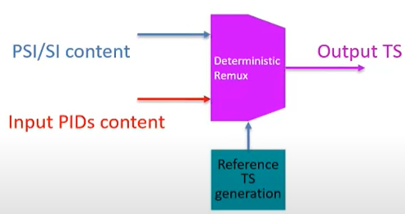  
Figure 3.2-1-1b: Generation of reference transport streams

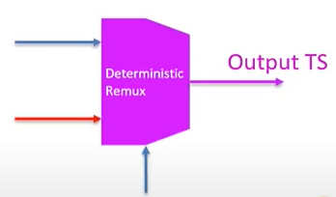  
Figure 3.2-1-1c: Placement of incoming packets in the outgoing TS

### 3.2-2 SIS Services carrying PCRabs

Each parent signal shall include a generated SIS service. This service carries PCRabs using the transport packet adaptation mechanism (see ISO/IEC 13818-1 [5]) on a PID that is designated as the PCR_PID in the PMT

The primary SIS service shall consist of the F&TI component, while in other SIS services from other parent signals the F&TI component is optional. In a single DSACI, a unique SIS services as flagged as primary. Hence the F&TI component of other SIS services may be ignored. In the case that the parent signal includes the F&TI component, this F&TI component may be sent on the PCRabs_PID.

A CSG shall be able to generate a DSACI file for configuration of re-transmitted services in the terrestrial modulation. That DSACI file shall – if provided – be part of the primary SIS services. Other SIS services may include DSACI for other terrestrial multiplexes.

Any SIS services may also consist of terrestrial PSI/SI for sheer terrestrial and hybrid services.

### 3.2-3 Layer 1 signaling

#### 3.2-3-1 DVB-T2 case

L1 signaling consists of T2-MI packets of type 1016 (L1-current) and, if applicable. Type 1116 (L1-future), as defined in ETSI TS 102 773 [1], T2-MI packets of type 1016 are used for DSA processing. T2-MI packets of type 1116 are simply piped through the DSA

#### 3.2-3-2 DVB-T case

L1 signaling for DVB-T shall be carried in an F&TI packet – based on the MIP structure (see ETSI TS 101 191 [4]).

### 3.2-4 Other T2-MI packet types (DVB-T2 case)

For DVB-T2 use case, a single CSG prepares all T2-MI packet types – except for the baseband frame type 0016. T2-MI packets of type BBF are created by the DSA and are inserted by the T2-MI multiplexer on daughter site. the same CSG shall provide T2-MI packets of type F016 carrying framing & timing information. The latter packets shall not be part of the T2-MI stream output as interface L, they are dedicated to DSA process only.

### 3.2-5 Framing & Timing Information (F&TI)

The framing & timing information provides metadata required by the DSA for building – in the DVB-T2 case – BBFRAMEs. Interleaving frame and T2-frames. In the DVB-T case mega-frames are built. The details of this deterministic process.

#### 3.2-5-1 DVB-T2 case

F&TI for DVB-T2 shall be carried in a T2-MI packet of type F016. The T2-MI packet shall be coded as shown in table 2. one such packet shall be sent for each T2-frame – prior to the provision of the data and metadata that T2-frame.

### 3.2-6 DVB-T case

Framing & timing information (F&TI), for DVB-T shall be carried in a MIP packet (see ETSI TS 101 191 [4]), to which the megaframe_timestamping function is added. The transport_packet_header has its PID defined by DSACI. I.e., the details PID for MIPs is not used. This way an F&TI packet is formed by the CSG.

This packet follows the MIP payload syntax shall carry a megaframe_timestamping function that belongs to a function loop broadcast to all transmitter (000016 is used as tx_identifier). On daughter site. The DSA shall remove the function when building actual MIP packets for the DVB-T transmitter.

Exactly one such packet shall be sent for each T mega-frame.

### 3.2-7 DSA configuration information (DSACI)

The definition of DSA Configuration information is applicable to both terrestrial transmission systems covered by the present document. i.e., DVB-T2 (ETSI-EN 302 755 [2]) and DVB-T (ETSI EN 300 744 [3])

The DSA is configured on the basis of the DSA configuration information (DSACI) provided by the CSG. DSACI is formatted as an XML. File, which provides all parameter settings required. Below all elements belonging to DSACI are outlined, namely the global configuration, the input configuration, the re-multiplexing and the output configuration.

This XML file may be provided to the DSA either in-band or out-of-band. In the latter case the transfer of the file to the DSA is user-defined and not covered by the present document. For in-band provision a carousel approach based on private section is used.

DSACI

* Is an XML configuration file for the DSA
* It is structured by groups of configuration elements
* Is either
  + Provided in-band on a dedicated PID of the primary SIS service
  + Provided out-of-band to the DSA

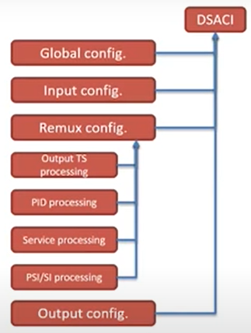  
Figure 3.2-7: DSACI

#### 3.2-7-1 DSA structure

##### 3.2-7-1-1 XML schema representation

Table 4 outlines by the top-level XML. Schema structure of the DSA configuration information.

##### 3.2-7-1-2 DSA internal structure

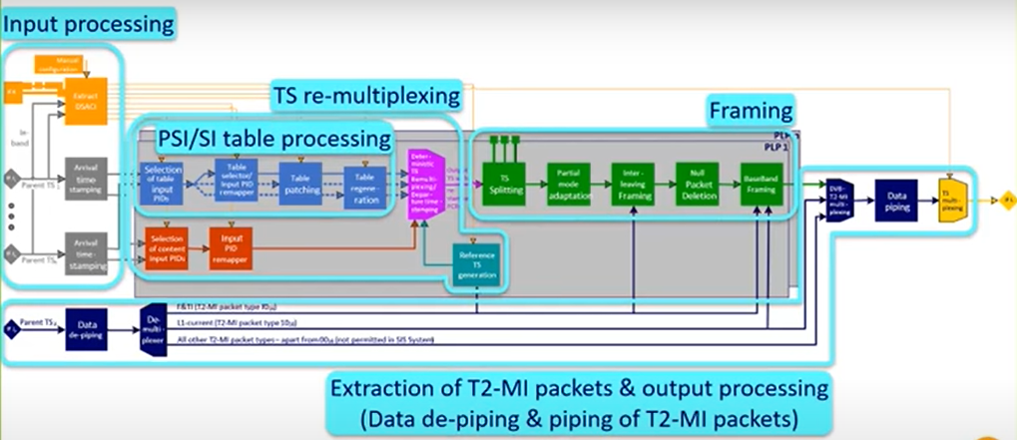  
Figure 3.2-7-1-2: DSA-internal structure

##### 3.2-7-2 XML types and XML elements of the DSA configuration information

##### 3.2-7-2-1 global configuration

The XML type_global_configuration consists of the XML elements current_DSA_group_id. Global_version_number, global_application_time and SIS_edition.

##### 3.2-7-2-2 Input configuration

The XML type_input_configuration identifies the transport streams at the input stage of the DSA services and service components are to be extracted from the daughter site re-transmission. This XML type also assigns a replacement identifier – source_id – to the double input_TS_id/input_ON_id. Furthermore, it identifies the PID of the PMT belonging to the SIS service and indicates the single primary SIS service

#### 3.2-7-3 Remultiplexing

The XML type_remultiplexing assigns output transport stream to physical layer pipes – in the case of DVB-T2. In the DVB-T case the PLP_ID has no meaning and should be ignored. Each PLP/TS assignment also consists of the elements pid_processing. Service_pmt_processing and psisi_processing. The latter element, in turn, consists of the element <pat>, <cat>, <sdt_bat> and <eit>/

##### 3.2-7-3-1 TS Remultiplexing

Placement of incoming packets in the outgoing TS

* Scheduling algorithm decisions based on computed:
  + Packets arrival times
  + Packet departure times
* Deterministic PCR correction applied

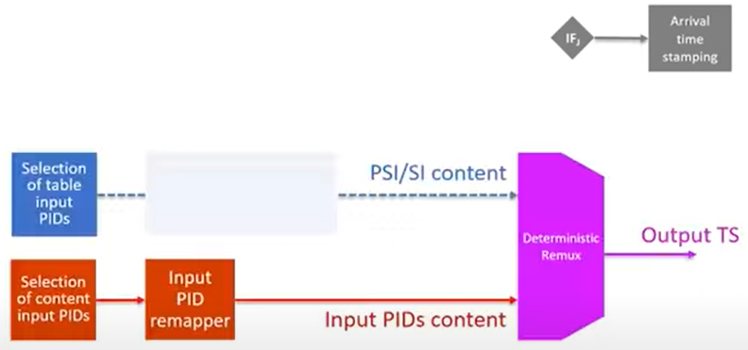  
Figure 3.2-7-3-1: TS Remultiplexing

#### 3.2-7-4 PID processing

The XML type_pid_processing replaces packet identifiers at the input of the DSA by PIDs as they shall appear at the output of the DSA. Packet identification being part of subsequent DSACI XML type is in almost all cased base on the element output_PID.

#### 3.2-7-5 Service and PMT processing

The XML type_service_pmt_processing maps service identifiers, service names and provider names from the related input settings to the corresponding output settings – for all services belonging to a single output TS. It also defines how PMTs are to be processed and identifies the still applicable CA systems for each service component. Note that descrambling for free-to-air terrestrial provision of service components takes place in the receivers being part of DSA machinery.

#### 3.2-7-6 PSI/SI processing

The XML type_psisi_processing consists of the XML elements pat, cat, sdt_bat and eit.

##### 3.2-7-6-1 SIS information (PSI/SI)

* Terrestrial PSI/SI can be produced as follows based on the related satellite PSI/SI tables:
  + Passed through, i.e., no information
  + Patched, i.e., parts of tables are modified, replaced or stuffed (size of the table remains constant)
  + Regenerated, i.e., the DSA produces tables based on DSACI and satellite PSI/SI
    - Virtual arrival timestamps (VATs) are assigned to the regenerated tables
* The SIS standard defines the mechanisms for these PSI/SI tables:
  + PMT, PAT, CAT, SDT, BAT, EIT
  + Remapping, i.e., replacement of PID's can be applied to all tables (and to all service components)
  + CATs can also be stopped from retransmission – reflecting a change from encrypted to free-to-air provision
* All other tables required for the terrestrial transmission need to be provided by the CSG in a hidden way, i.e., invisible to the satellite receivers

##### 3.2-7-6-2 SIS services

* SIS services consist of:
  + PCRabs: provides absolute time reference
  + F&TI: gives instructions to build a deterministic framing structure for modulation
  + DSACI: enables configuration of DSA processing
  + SIS-specific PSI/SI: elements of signaling needed by terrestrial PSI/SI reconstruction
* There is a single "primary SIS service" for a targeted terrestrial modulation
  + F&TI comes from primary SIS service
  + On other (secondary) SIS services F&TI is not required

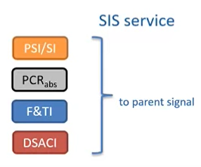

Figure 3.7-2: SIS Service

#### 3.2-7-7 PAT processing

The XML type_pat_processing_mode covers the processing of program association tables – see ISO/IEC 13818-1 [5] - and indicates the repetition period of those, their time offset to the beginning of the insertion windows. For the insertion window mechanism – as well as the version number of regenerated PATs.

#### 3.2-7-8 CAT processing

The XML type_cat_processing_mode covers the processing of conditional access tables – see ISO/IEC 13818-1 [5] - and indicates in the case of the patching the CAS identifiers as well as the EMMs to be retained, and in the case of regeneration this XML type assigns the repetition period of those, their time offset to the beginning of the insertion window. For the insertion window mechanism – as well as the version number of the CATs to be regenerated and output.

#### 3.2-7-9 SDT and BAT processing

The XML type_sdt_bat_processing_mode covers pass-through, patching and regeneration of service description tables and bouquet association tables – see ETSI EN 300 468 [6] - and indicates in the case of patching the DSACI sets for other multiplexes as well as it maps input bouquet identifiers to output ones. In the case of regeneration this XML type assigns an integer multiplier M_actual of the different repetition periods of SDT_other's as well as assigning further parameters making up the regenerated SDTs and BATs

#### 3.2-7-10 EIT processing

The XML type_eit_processing_mode covers pass-through, patching and regeneration of event information tables – see ETSI EN 300 468 [6].

#### 3.2-7-11 Output configuration

The XML type_output_processing configures the output TS(s) of the DSA as either a DVB-T-mega-frame stream (DVB-T case) or encapsulates the T2-MI packets at the output of the DSA into TS packets (interface L)

#### 3.2-7-11 DSACI contains

* Global configuration items
  + Target current DSA group id
  + Application time of the configuration
* Input configuration items
  + Define the input TSs sources according to TS id, ON id
  + Contains the PMT PID of the SIS service (relevant for OOB delivery of DSACI)
  + Allow identification of primary parent signal
* Re-multiplexing configuration items
  + Details on following slide
* Output configuration items
  + Define which terrestrial standard is addressed
  + Add PSI/SI elements for DVB T2-MI

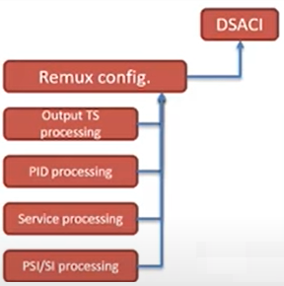  
Figure 3.2-7-11: DSACI Re-mux configuration

### 3.2-8 DSA schema

The DSACI schema, i.e., the mandatory XML syntax of the configuration information for the daughter site adapter is defined in annex A.

### 3.2-9 In-band carriage of the DSACI XML file

The DSACI XML file built on the basis of the schema described in clause 5.7.4 is gzipped prior to provision to the DSAs – in compliance with RFC1952 [12]

### 3.2-10 preparation of metadata and content on parent site:

* Different types of content and related PSI/SI are provided
  + AVD content (DTH only)
  + PSI/SI (DTH only)
  + AVD content (common DTT/DTH)
  + PSI/SI (DTT/DTH)
  + AVD content (DTT only)
  + PSI/SI (DTT only)
* Framing and timing information is generated and carried in T2-MI packets
  + F&TI
  + L1 signaling (T2-MI) packet type
  + Other T2-MI packets
* Remaining T2-MI packets carrying L1 signaling, T2 timestamps etc., are produced as well
* DSA Configuration information is composed of all instructions and all metadata required on daughter site for producing the desired T2-MI stream in a fully deterministic way
  + Global configuration
  + Input configuration
  + Re-multiplexing configuration
  + Output TS processing
  + PID processing
  + Service processing
  + PSI/SI processing
  + T2-MI output configuration

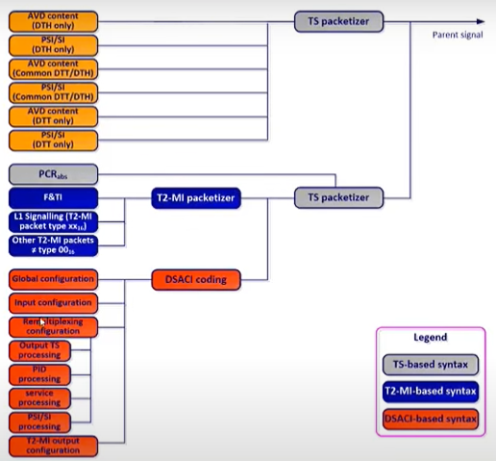  
Figure 3.2-10: Preparation of metadata and content on parent site

## 3.3 Carriage of signal components within the parent transport streams

Service components and PSI/SI intended for direct reception of the parent signal by commercial receivers shall be carried using the normal DVB mechanisms as specified in DVB-S, ETSI EN 300 421 [8], DVB-S2/S2X, ETSI EN 302 307-1 [9], ETSI EN 302 307-2 [10], DVB-T, ETSI EN 300 744 [3], DVB-T2, ETSI EN 302 755 [2] and DVB-SI, ETSI EN 300 468 [6].

## 3.4 Daughter site processing

The daughter side adapter (DSA) consists of the following stages that perform the listed operation (DVB-T2-specific operations appear in bold character, DVB-T-specific operations in *Italic characters*):

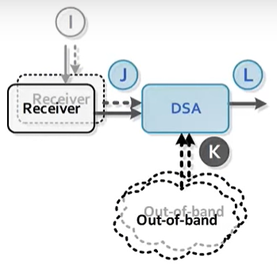  
Figure 3.4: Daughter Site

* Bootstrapping
  + Locate DSACI in-band or out-of-band (manual configuration)
* Input processing
  + Identification of the transport streams at the input stage of the DSA services and service components are to be extracted from for daughter site re-transmission.
  + Identification of the PIDs of the PMTs belonging to the SIS Services (one per Parent Signal)
  + Identification of the single Primary SIS Service beneath all SIS Services being part of the Parent Signals
  + (Virtual) arrival timestamping
* TS remultiplexing
  + Assigning output Transport Streams to Physical Layer Pipes - in the case of DVB-T2
  + Generation of Reference Transport Stream(s).
  + Selection of relevant content from input TSs
  + PSI/SI selection and insertion (optionally also generation of PSI/SI tables/sections).
  + Deterministic re-multiplexing.
* DVB-T mega-framing
  + Remove megaframe_timestamping function
* DVB-T2 baseband framing
  + TS splitting (optional).
  + Terrestrial Framing.
  + Null Packet Deletion (optional).
  + Baseband Frame generation.
* T2-MI packet handling
* Output processing

The aforementioned stages and tasks are illustrated with figures 5 and 6 for the DVB-T2 and -T cases respectively and are explained in the following clauses. Input processing and TS re-multiplexing are widely common for both broadcast systems - T2 and T. Framing, T2-MI packet handling and output processing, in turn, are T2- and T-specific. The structure of clause 6 reflects these circumstances

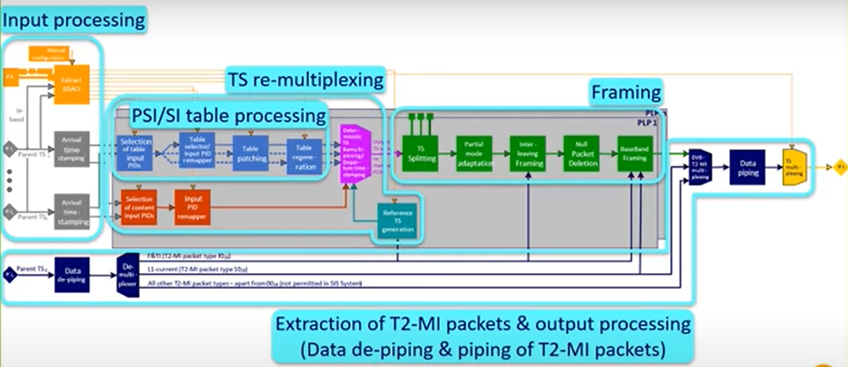

Figure 3.4a: DSA processing (DVB-T2 case)

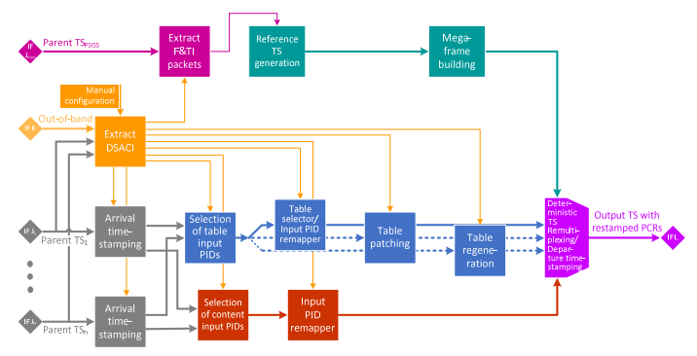

Figure 3.4b: DSA processing (DVB-T case)

### 3.4-1 Bootstrapping

The configuration of the receivers providing the Parent Signals to the DSA is out of scope of the present document. The described operations either for bootstrapping or any other later processing are based on the assumption that the different involved Parent Signals (Transport Streams) have been made available to the DSA.

The bootstrapping operation for the DSA consists of providing the DSA the path to the DSACI. Two cases are described - whether the DSACI is provided in-band (i.e. in one of the Parent Signals) or out-of-band.

#### 3.4-1-1 Gaining access to DSACI provided in-band

The initial manual configuration of the DSA consists of providing to the DSA the following:

* The [TSid/ON ID/Program Id] triple corresponding to the Primary SIS Service in the relevant Parent Signal where the DSA will find the current DSACI component.
* The current_DSACI_group_id identifying the current DSACI that this particular DSA shall use.

#### 3.4-1-2 Out-of-band DSACI provision

When DSACI is provided out-of-band, the initial manual configuration of the DSA consists of providing to the DSA the following:

* The path or location (e.g., URL, address, ..) where the DSA can find the current DSACI file.
* The current_DSACI_group_id identifying the current DSACI that this particular DSA shall use.

### 3.4-2 Input processing

#### 3.4-2-1 Reception of parent transport streams

The Daughter Site Adapter (DSA) receives one or several parent multiplex(es). Those are indicated by the DSA Configuration Information (DSACI) the DSA receives from the CSG.

The Daughter Site Adapter receives one or several parent Transport Streams. These DVB TS packets may be received over any standard DVB Transport Stream interface, such as DVB-S, -S2 or S2X, ASI or encapsulated within IP packets in accordance with ETSI TS 102 034 [7].

#### 3.4-2-2 Arrival timestamping

For each input TS on interface(s) H, packets shall have a timestamp (packet_arrival_time) computed according to the incoming PCRabs values:

#### 3.4-2-3 Calculation of virtual timestamps (VATs)

The Virtual Arrival Timestamping method enables insertion of TS packets that are not present in the Parent Signal or of TS packets that are regenerated by the DSA. This may be done to save bandwidth in the Parent Signal, for example by generating DTT PMT or EIT sections on daughter site as an alternative to receiving those from the CSG. The mechanism for the generation of a stream of TS packets ensures that multiple DSAs generate identical packets and an identical packet sequence.

Below, the method for insertion of TS packets generated with constant packet rate is defined. This method is intended for use for e.g. the insertion of regenerated PMTs.

##### 3.4-2-3-1 CBR operation mode

The Virtual Arrival Timestamp of TS packets is calculated by the DSA based on a time interval indicated as part of the DSA Configuration Information. The time interval in question is equivalent to the indicated table_repetition_period. The DSA converts that table_repetition_period into a time interval for the insertion of TS packets carrying the corresponding PSI/SI table sections as follows:

### 3.4-3 TS re-multiplexing

The TSs for each PLP shall be created by first generating a Reference TS (see clause 6.4.2), and then replacing null packets with selected packets from the incoming parent TSs, with packets stemming originally from the incoming parent TSs but were modified, and with packets generated locally by the DSA. Figure 6 illustrates the TS remultiplexing in detail, because for the DVB-T case that represents a major part of the DSA processing.

#### 3.4-3-1 TS DVB-T2 case

There shall be one RTS for each data PLP, but the RTSs for the PLPs within the same PLP_GROUP shall be identical in case a common PLP is present, see ETSI EN 302 755 [2].

The RTS shall include packets with PCRabs values equal to values of the PCRFTSP signaled in the F&TI signaling packets for the relevant PLP. Between these packets there shall be further Null packets with equally spaced PCRabs values (as defined below), such that the total number of packets including the packet with a given PCRFTSP value up to but excluding the packet with the subsequent PCRFTSP value shall be equal to the frame_packet_count in the T2-MI packet carrying F&TI containing the first PCRFTSP value.

#### 3.4-3-2 TS DVB-T case

In the case of DVB-T, a mega-frame building block, see ETSI TS 101 191 [4], sits between the Reference Transport Stream generator and the TS remultiplexer, see figure 6. The latter remultiplexer is directly connected to interface L.

##### 3.4-3-2-1 Extraction of F&TI packets

The F&TI packets are extracted by the DSA. The modulation parameters TPS are derived from the F&TI packets.

The DSA shall remove the megaframe_timestamping function when building the MIP packet for the DVB-T transmission and shall change the PID to the standardized PID 1516.

PCRabs is then assigned to the MIP packet.

The bitrate of the Reference Transport Stream, and therefore the number of packets in a mega-frame, NMF, is defined by the modulation parameters TPS.

The PCRabs value associated with the MIP packet for mega-frame n, denoted PCRmf (n), shall be equal to the value given by the PCR_ABS_BASE and PCR_ABS_EXT fields signaled in the megaframe_timestamping function of the MIP packet

### 3.4-4 Selection of relevant content from input TSs

The services and service components that shall be extracted for terrestrial re-transmission are determined by the DSA Configuration Information (DSACI). Within a Transport Stream, the TS packets are selected by PID.

The PID component selection shall also be used for remapping of PSI/SI sent on hidden PIDs.

### 3.4-5 Processing and generation of layer 2 signaling (PSI/SI)

Terrestrial PSI/SI is inserted into the output TS in a way that enables the receiver/decoder to select and locate the broadcast services and the components of the services. PSI/SI is partly dynamic and time-accurate to support changes in the service status and changes in the service composition.

PSI/SI for the terrestrial multiplex also assists the viewer in selecting services and the related events.

The following clauses detail the four methods available for insertion of terrestrial PSI/SI by the DSAs - depending on instructions being part of DSACI.

#### 3.4-5-1 Pass-through remultiplexing of selected parent tables/sections

When a Parent Signal component is also applicable to a DTT multiplex, it may be passed to the output without content modification. When the CSG builds a DSACI that complies with this situation. the DSA shall pass through all packets of the target PSI/SI component. According to the DSACI, the output PID may be modified to match the DTT PSI/SI consistency.

The CSG may also use this method to send DTT PSI/SI sections in Parent Signal on non-default PIDs and build the DSACI so that the DSA will remap the PIDs to match DTT PIDs. These sections are part of an SIS Service.

#### 3.4-5-2 conversion of parent table/sections on the fly (patching)

In addition to the method described above, the conversion mechanism may be used to modify table attributes according to the DSACI inserted by CSG. This method is applicable when the modified table does not need repacketization: Only CRC updates and section invalidation using stuffing sections are allowed. To ensure Continuity Counter consistency, no incoming packet of the same component shall be discarded. Depending on DSACI, the output PIDs may be modified.

#### 3.4-5-3 static table regeneration

* PAT, PMT, SDT, CAT regeneration:
  + The PAT table is created in compliance with ISO/IEC 13818-1 [5]. The DSACI configures the TS_id, version_number and lists the output program_number and the associated PMT_PIDs. The services are asserted in ascending order based on the output program_number.
  + The CAT table is created in compliance with ISO/IEC 13818-1 [5]. DSACI configures the version number and the list of CA_system_id /EMM_PID pairs. The CA_descriptors are inserted in ascending order of CA_system_id and ascending order of EMM_PID.
  + The PMT skeletons for services not making use of remapping or patching original PMTs their PMTs are created in compliance with ISO/IEC 13818-1 [5], clause 2.4.4.8. The fields program_number, PCR_PID, and the list of elementary streams are provided as part of DSACI. DSACI also indicates if conditional access information is to be removed. The following processing shall be implemented:
    - Extract the incoming PMTs identified by their related PMT_PID provided as part of DSACI.
    - Create the new PMT using information given by DSACI up to the program_info loop.
    - Compute the program_info loop, including a copy of the relevant descriptors in the same order as in the incoming table. When ca_providers are removed, the matching descriptors shall be removed from the loop too. The ones that are kept shall follow the same order as the corresponding input CA_descriptors.
  + Compute the elementary stream loop: Copy the required elementary streams in the same order as in the incoming table, while also keeping the desired descriptor in their original input order. When some of the ca_provider's are removed, the retained CA_descriptors shall appear in the same order as in the input PMT.
* Version Number of regenerated tables:
  + The Version Number of such a table is either part of the DSACI, i.e., provided by parent site, or it is identical to the Version Number of the incoming table.
  + The DSACI consists of an indication regarding the source of the Version Number.
* Insertion of tables into the output TS:
  + For SI specified within the present document the minimum time interval between the arrival of the last byte of a section to the first byte of the next transmitted section with the same PID, table_id and table_id_extension and with the same or different section_number shall be 25 ms. This limit applies for TSs with a total data rate of up to 100 Mbit/s.
* TS packetization:
  + The regenerated tables are composed of sections and the sections are packetized in TS packets according to the document ISO/IEC 13818-1 [5].
  + TS packetization shall be restricted to set the pointer_field to zero. In order to fill a TS packet after the end of a section, stuffing bytes 0xFF shall be added.
  + Padding based on using the adaptation_field shall not be used.

##### 3.4-5-3-1 SDT and BAT regeneration

The SDT table is created in compliance with ETSI EN 300 468 [6]. DSACI supplies the transport_stream_id, the version_number, the ONID, and the list of input service to select. Each service_id_is associated with the output service_id with EIT_schedule_flag, EIT_present_following_flag, running status, free_CA_mode_ and the output provider name. The following processing is implemented:

* Extract the SDT tables from the different inputs used to generate the output stream
* Create the new SDT using information given by DSACI.
* For each required service copy from the incoming table, the parameters linked to the input service, update the information using the DSACI.
* Insert in ascending order based on the output service_id the computed parameters.

The BAT table is created in compliance with ETSI EN 300 468 [6].

DSACI lists the different bouquets to manage. The following processing is implemented:

* Extract the BAT tables from the different inputs used to generate the output stream.
* For each extracted BAT, update, if necessary, the bouquet_id.

The SDT actual, SDT others and BAT generated sections are then played out using an insertion window. This insertion window is defined using the restriction that all SDT others and BAT repetition periods are the same (given by DSACI, as 90 kHz tick count). Additionally, the SDT actual repetition period shall be a multiple value of the SDT other repetition period (integer M_actual given by DSACI).

Thus, the insertion window is defined as the duration of the SDT other repetition period. The very first window started at SIS epoch + offset (given by DSACI).

In this window the priority of insertion content is SDT actual, SDT others from smallest to greatest transport stream id, and BAT from smallest to largest bouquet_id.

All sections are packetized as described in clause 6.4.4.4. Stuffing sections are added so that the resulting number of packets is a multiple of 16. This way, packets of PID 1116 have a continuity counter equal to zero at the beginning of each insertion window.

#### 3.4-5-4 Dynamic table regeneration

The Event Information Tables (EITs) shall provide the output (DTT) transport streams with information about:

* the Present/Following events for the Actual / Others DTT Transport Streams; and
* the Scheduled events for the Actual / Others DTT Transport Streams.

The repetition rates of the EIT tables for DTT systems shall be reduced as DTT transmission offers a lower bandwidth than is provided by DTH systems.

An algorithm shall guarantee that all DSAs regenerate deterministically all the EIT tables in order to produce identical output (DTT) transmission, which is the condition to operate Single Frequency Network.

The algorithm described in this clause provides a method to guarantee that every DSA will perform the regeneration of the EIT tables similarly, in order to fulfil the SFN condition.

The algorithm shall be implemented in three phases:

* Phase (A): creation of a list of EIT_slots evenly spread over the EIT insertion window.
* Phase (B): creation of a database of EIT_sections extracted from the input (DTH) Transport Stream(s).
* Phase (C): playout of the EIT_slots list by mapping of the extracted EIT_sections_data in a series of TS packets to be inserted in the output (DTT) transport stream.

### 3.4-6 Placement of incoming packets in the outgoing TS

The deterministic scheduling of incoming packets is based on the arrival timestamps computed at the input, in conjunction with the departure timestamps from the Reference TS generation. Incoming packets - and locally DSA-generated packets (belonging to PSI/SI tables regenerated by the DSA), which are equipped with Virtual Arrival Timestamps - replace null packets inside the Reference TS.

### 3.4-6-1 Deterministic scheduling

Scheduling is based on a first-in first-out process, with additional rules to solve packet collisions. The following rules apply for selecting an input TS packet for insertion into an output TS performed by the deterministic TS remultiplexer:

* An input TS packet that has to be played out replaces the first null packet of the target Reference Transport Stream that has a departure timestamp greater or equal to arrival timestamp of the input TS packet.
* When multiple TS packets (from single or multiple inputs) target the same null packet in the Reference Transport Stream, the input TS packet with the earliest arrival timestamp is chosen.
* When multiple TS packets with the same arrival timestamp (from multiple inputs) target the same null packet in the Reference TS, the packet with the greatest output PID is selected first.

All incoming packets not selected for play-out during the scheduling round described above shall join the set of packets candidate to the following scheduling round. A packet is removed from such set in case one of the following situations occurs:

* The TS packet is selected for insertion into the Reference TS on the basis of the mechanism described for the previous scheduling round in a following scheduling round (successful operation).
* The packet is not selected after being candidate for Nsteps_to_live scheduling steps (overflow condition).

As a consequence of the scheduling operation, an input TS packet n that holds a Program Clock Reference for a service, shall have its PCR value updated according to the following equation:

### 3.4-3 Framing

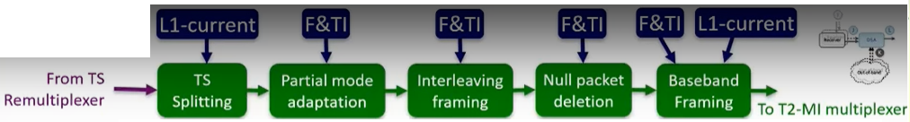  
Figure 3.4-3: Framing

#### 3.4-3-1 DVB-T2 case

##### 3.4-3-1-1 TS splitting (optional)

The PLP_GROUP_ID and PLP_TYPE fields of the configurable L1-post signalling - see ETSI EN 302 755 [2] - shall be used to determine whether a data PLP belongs to a PLP group. Each group of PLPs may contain one common PLP. If a common PLPs belongs to a PLP group, the TS Splitting model defined in Annex D of ETSI EN 302 755 [2] shall be applied to the PLPs of the group in order to generate a TSPS for each data PLP together with a TSPSC for the common PLP.

##### 3.4-3-1-2 Partial mode adaptation

Mode Adaptation shall be performed on the TS (or TSPS) for a given PLP that was generated as described in clause 6.4 (if common PLPs are used, see also clause 6.5.1.1 and ETSI EN 302 755 [2], Annex D). The partial Mode Adaptation process shall comprise:

* SYNC byte removal.
* Dummy ISSY insertion (if applicable).
* Dummy DNP insertion (if applicable).
* Dummy CRC-8 insertion (if applicable).

The Null Packet Deletion process shall not be performed at this stage. The dummy ISSY, DNP and CRC-8 bytes are inserted to ensure correct allocation to the Interleaving Frames (see clause 6.5.1.3). If NPD is used, the actual value of these bits will be calculated later when the Null Packet Deletion is performed (see clause 6.5.1.4) and at this stage they may be set to zero. Similarly, ISSY will be generated once the framing has been finalized (see clause 6.5.1.5).

##### 3.4-3-1-3 Allocation of TS bits to interleaving frames

The bits of the partially Mode-Adapted Transport Stream (see clause 6.5.1.2) shall be allocated to Interleaving Frames according to the signalling in the T2-MI packet of type F016 (F&TI) extracted in clause 6.6.

If Null Packet Deletion (NPD) is not enabled, the bits shall be allocated such that the first complete packet in the first BBFRAME of the Interleaving Frame is the one whose PCRabs value is equal to the value of PCRFTSP for the relevant Interleaving Frame and PLP, and such that the value of SYNCD signalled in the first BBFRAME of the Interleaving Frame is equal to FIRST_SYNCD for the relevant Interleaving Frame and PLP.

If Null Packet Deletion is enabled, the FIRST_SYNCD and PCRFTSP fields indicate the PCRabs for the first complete packet and the SYNCD value for the first BBFRAME under the conditions that neither (a) the packet indicated by PCRFTSP nor (b) the packet immediately preceding it are deleted by the NPD process. If condition (a) does not apply, then the first complete packet will have PCRabs > PCRFTSP; if condition (b) does not apply, then SYNCD will be zero.

The description above identifies the first bit allocated to a given Interleaving Frame. The last bit allocated to an Interleaving Frame shall simply be the bit preceding the first bit of the subsequent Interleaving Frame.

##### 3.4-3-1-4 Null packet deletion

If enabled, Null Packet Deletion shall now be performed. The DSA shall perform the following process:

* The last complete packet of an Interleaving Frame shall always be transmitted, i.e. it shall not be deleted.
* Any other null packet shall be deleted unless 255 previous null packets have already been deleted, in which case it shall be transmitted together with a DNP count of 255.
* The dummy DNP counts inserted in the Partial Mode Adaptation process (clause 6.5.1.2) shall be replaced by the correct DNP counts.
* The dummy CRC-8 values inserted in the Partial Mode Adaptation process (clause 6.5.1.2) shall be replaced by the correct CRC-8 values.

##### 3.4-3-1-5 ISSY generation

The three ISSY variables are inserted according to ETSI EN 302 755 [2].

When BUFS is inserted, it shall have the value indicated by BUFS in the relevant F&TI T2-MI packet (see clause 5.6.2) for the relevant PLP. When ISCRlong is used, the third byte shall be coded as defined in ETSI EN 302 755 [2].

TTO is inserted once per Interleaving Frame and applies to the first complete packet carried in the Interleaving Frame. The TTO_E, TTO_M and (if present) TTO_L fields shall have the values indicated in the fields of the same name in the relevant F&T T2-MI packet applying to this Interleaving Frame and PLP (see clause 5.6.2).

##### 3.4-3-1-6 Generation of BBFRAMEs

The bits allocated to an Interleaving Frame shall be mapped onto the number of BBFRAMEs indicated in the dynamic L1 signalling for the relevant PLP and Interleaving Frame. The relevant L1 signaling will be contained in an L1-current T2-MI packet extracted as described in clause 6.6.

The number of bits allocated to an Interleaving Frame may be less than the total capacity of the BBFRAMES, therefore BBFRAME padding may be performed. Padding may also be used for In-Band Signaling

###### 3.4-3-1-6-1 Allocation of bits to the BBFRAMEs of the interleaving frame

In the case of not applying NPD, the number of payload bits in the Interleaving Frame number n is:

FIRST_SYNCD(n) is signaled by the FIRST_SYNCD field of the Framing & Timing Information for Interleaving Frame n. FIRST_SYNCD(n+1) is identical to the NEXT_FIRST_SYNCD field for Interleaving Frame n.

If NPD is enabled, the number of bits that were allocated to the Interleaving Frame as described in clause 6.5.1.3 but which refers to the deleted null packets shall be subtracted from NpayloadIF(n) before performing the following calculations. The resulting number of bits is given by.

###### 3.4-3-1-6-2 Mapping of mode-adapted bits into the BBFRAMES

The bits of the mode-adapted TS shall be mapped into the Data Fields of the BBFRAMEs of the Interleaving Frame according to the DFL values of the BBHEADERs calculated as described in clause 6.5.1.6.2.

###### 3.4-3-1-6-3 BBHEADER generation

BBHEADERs are part of each BBFRAME and are 10 bytes long. Depending on the mode used - Normal Mode (NM) or High Efficiency Mode (HEM), see ETSI EN 302 755 [2] - they consist of the parameters outlined below with figures 13 and 14, respectively. Those figures illustrate the two header formats. The related parameter definitions of ETSI EN 302 755 [2] apply for the present document in the same way - in addition to the definitions below.

###### 3.4-3-1-6-4 Packets to interleaving frames

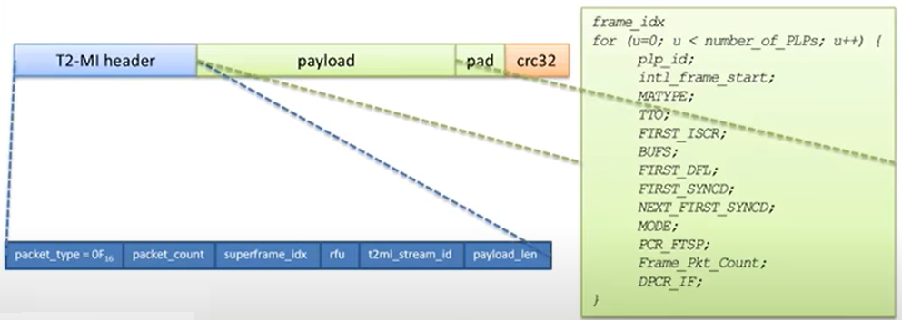  
Figure 3.3-3-1-6-4: Packets to interleaving frames

###### 3.4-3-2 DVB-T case

As explained in clause 6.4.2.3, the DVB-T-related mega-framing takes place as part of the TS re-multiplexing stage - between the Reference Transport Stream generator and the TS re-multiplexer. Between the TS re-multiplexer and the DSA output interface L no further processing is applied to the stream of DVB-T mega-frames.

### 3.4-4 Extraction of T2-MI packets

T2-MI packets (see ETSI TS 102 773 [1]) are received by the DSA in encapsulated form, i.e., embedded in TS packets compliant to the data piping method specified in ETSI TS 102 773 [1]. All T2-MI packets are decapsulated from the aforementioned TS packets - should their PID identify a T2-MI stream whose content is required for configuring the T2-MI stream that the DSA provides at interface L. This step is needed for the identification of the T2-MI packet types. Depending on the T2-MI packet type, the DSA applies a different processing as follows:

* T2-MI packets of type 0016 (Baseband Frame) are not permitted for SIS usage and are dropped by the DSA should they occur.
* T2-MI packets of packet types not equal to 0016 (Baseband Frame), 1016 (L1-current) or F016 (F&TI) are simply piped through and are encapsulated again in TS packets as specified in ETSI TS 102 773 [1] for insertion into the output T2-MI stream.
* T2-MI packets of packet types 1016 are used for configuring the DSA output stream and are in the end encapsulated again in TS packets as mentioned above for the previous mode of operation.
* T2-MI packets of type F016 (F&TI) are also used for configuring the DSA output stream but are discarded after processing and do not become part of the DSA output stream.

### 3.4-5 Output processing

#### 3.4-5-1 DVB-T2 case

##### 3.4-5-1-1 T2-MI multiplexing

When addressing DVB-T2 modulators with a T2-MI stream, the DSA inserts the L1 signaling - received via one of its inputs - into the output T2-MI stream. All T2-MI packet types - apart from types 0016 and F016 - shall be inserted unmodified into the output T2-MI stream. The order of T2-MI packets at the related input of the DSA shall be kept at its output. The T2-MI packets of type 0016 - consisting of Baseband Frames produced by the DSA - are inserted in the order that ETSI TS 102 773 [1] defines. The related T2-frames and -super-frames are identified by header parameters of the T2-MI packets received, see ETSI TS 102 773 [1]. The T2-MI header packet_count and CRC shall be updated in order to comply with ETSI TS 102 773 [1].

##### 3.4-5-1-2 Transport of T2-MI packets in MPEG-TS

The encapsulation of the T2-MI packets into TS packets shall follow the data piping mechanism described in ETSI TS 102 773 [1]. The overall TS bitrate, the PID value of the encapsulated T2-MI stream, and the presence of PCR may follow the related DSACI parameter settings, but other user-defined values may be used.

For carriage over a managed distribution network to the modulator, the PSI/SI parameters may take the values defined by DSACI or other alternative user defined values.

### 3.4-6 Processing of metadata and content received on daughter site

* Extraction according to DSACI:
  + Of services
  + Of components
* Preparation of terrestrial PSI/SI
  + Frame building:
* According to framing & timing information
* Using deterministic multiplexing algorithm

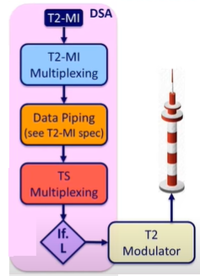  
Figure 3.4-6: Processing of metadata and content received on daughter site

### 3.4-7 Environment of standard around SIS

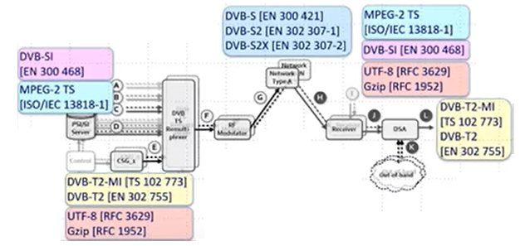  
Figure 3.4-7: Environment of standard around SIS

# Hardware

List and describe all the hardware modules being used here...

# Software

The initial option for software to use is the tsduck, tsduck is a transport stream toolkit containing a set of simple but flexible command-line utilities that run on Linux, Windows, and macOS.

Through tsp, the transport stream processor, many types of analysis and transformation can be applied on live or recorded transport streams. This utility can be extended through plugins. Existing plugins can be enhanced, and new plugins can be developed using a library of C++ classes.

## 5.1 Operating system selection guidelines

Here is a summary of the pros and cons of using TSDuck on the various operating systems.

* Linux pros:
  + Availability of a powerful shell environment. TSDuck is a light-weight toolkit with elementary tools and plugins which can be combined in an infinite number of ways. The user can obtain even more flexibility when combining them with the bash shell and all standard UNIX utilities (grep, sed, awk, etc.)
* Linux cons:
  + When used in a mobile environment, a laptop PC with Linux (or Linux/Windows dual boot) is required.
  + Some DVB tuners are not supported on Linux. Some supported tuners do not work well on Linux. Make sure to get fully supported DVB hardware.
* Windows pros:
  + Available on all “average user” laptop PC. Useful for transport stream capture and analysis in the field.
* Windows cons:
  + No or limited shell environment.
  + Some limitations in the support of DVB receiver devices (see 7.1.2.2, page 443, for more details). For instance, it is impossible to retrieve the actual tuning parameters of a transport stream as detected by the tuner device.

## 5.2 Developing applications using the TSDuck library

TSDuck is mainly a large C++ library for Digital TV applications. All TSDuck commands and plugins are thin wrappers on top of C++ classes from this library.

This library can be used by third-party applications, outside the TSDuck tools and plugins. To do that, you must install the “TSDuck development environment”.

Using the TSDuck library, you can develop independent Digital TV applications or TSDuck plugins. The provided services includes low-level features such as manipulating TS packets, intermediate features such as demuxing and packetizing tables and high-level features such as running TS processing pipelines inside your application (which means something like including tsp in your application).

Some high-level features of the TSDuck library can also be used from Python or Java, typically running TS processing pipelines or manipulating tables and sections inside Python or Java applications. The TSDuck Python and Java bindings are also documented in [44].

The following figure illustrates the TSDuck software and how it can interact with third-party applications.

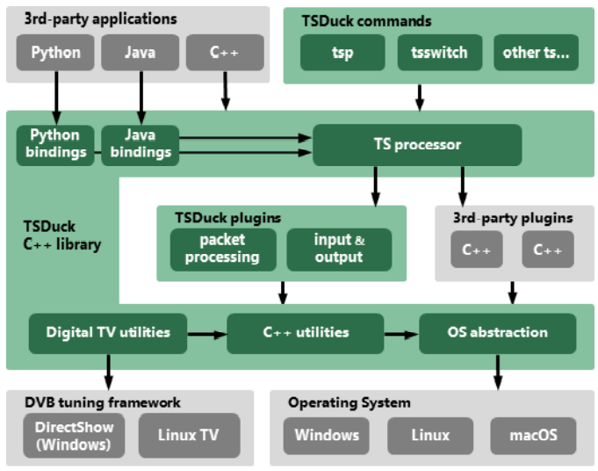

Figure 5.2: TSDuck Software Architecture

## 5.3 Installing TSDuck

The TSDuck installers are available from the “Download” section of the TSDuck Web site.

The basic installation provides all TSDuck tools and plugins. The command-line tools are directly accessible from the command prompt.

### 5.3-1 Linux

Two flavors of packages are available: .rpm for Fedora systems and .deb for Ubuntu systems. Currently, only 64-bit packages are available.

All tools are in /usr/bin. There is a separate package for the TSDuck development environment.

## 5.4 Data Formats

### 5.4-1 Transport stream

Transport streams shall conform to the MPEG-2 system layer format as defined in ISO 13818-1 [1].

#### 5.4-1-1 Live transport streams

Live transport streams can be read by TSDuck from:

* Live sources using specialized hardware, cheap DVB tuners or Dektec ASI devices.
* UDP/IP using various encapsulations (the encapsulation of TS packets in UDP packets does not matter since TSDuck automatically retrieves the TS packets inside UDP packets and simply ignores everything in between).
* HTTP or HTTPS streams without encapsulation (ie. raw TS streams, but not manifest-based formats such as DASH or HLS).
* HLS (HTTP Live Streaming) with transport stream segments (not fMP4).

#### 5.4-1-2 Stored transport streams

Transport streams can be read from and written to binary files, called TS files.

A standard TS file must contain contiguous 188-byte TS packets without any encapsulation. All TS packets shall start with the MPEG-defined synchronization byte 0x47. Any packet not starting with this synchronization byte is considered invalid and rejected.

Unless specified otherwise, most TSDuck utilities and plugins can read or write several non-standard TS formats. The supported formats are listed in the table below.

The command line option --format name can be used to specify a precise file format.

On input, the file format is automatically detected for each file. But the auto-detection may fail in some cases (for instance when the first time-stamp of an M2TS file starts with 0x47 in which case the file would be incorrectly identified as TS). Using the option -format forces a specific format to avoid ambiguities.

On output, the default format is a standard TS file.

The table below lists all possible format names as used with the option -format.

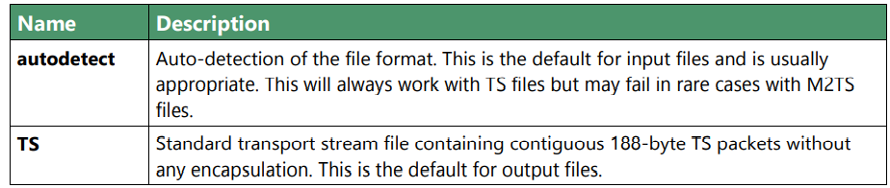

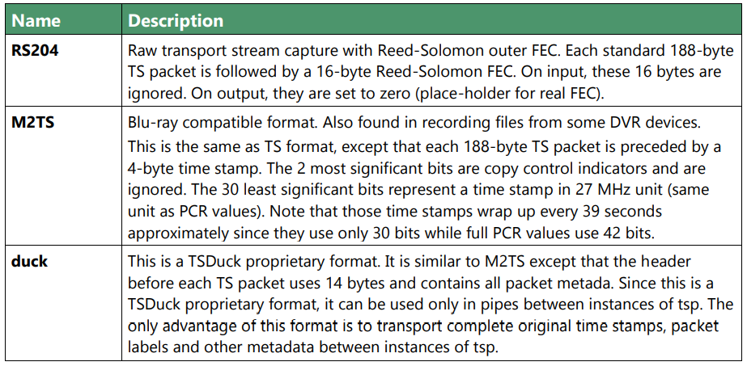

Table 5.4-1-2: Transport stream file formats

When dealing with non-conformant TS files coming from outside, the utility tsresync can be used to extract the TS packets and recreate a pure 188-byte TS file. Here is a sample list of common non-conformant TS files which can be processed by tsresync:

* Raw capture of TS packets with the 16-byte trailing Reed-Solomon correction code.
* Network capture files as produced by tools like Wireshark. Such files contain network packets, containing IP packets, containing UDP packets, containing TS packets.

In all these cases, tsresync can extract all TS packets and recreate a “pure” TS file which can be manipulated by the various utilities and plugins from the TSDuck suite.

## 5.5 Bit rates

### 5.5-1 Interpretation

In the manipulation of transport streams, using “bitrates” is quite common. Unless specified otherwise, all bitrate values are in bits per second, based on 188-byte TS packets.

### 5.3-2 Representation

Although it is quite common to manipulate bitrates as integral values, there are some cases where the fractional value may have some importance. In broadcast systems, for instance, the bitrate of a transport stream is directly computed from the modulation method and its parameters. And the result is rarely an integral value.

When manipulating multi-megabits-per-second transport streams, a fraction of bit per second is usually negligible but not always. When a TSDuck tool runs for hours or days, these small fractions can make a difference.

There were several user requests to use more precise representations of bitrates instead of integers. However, requirements from different users are sometimes conflicting. Representing smaller fractions may lead to less accuracy or overflows in intermediate computations. There is no perfect representation for all needs.

As a consequence, TSDuck can be compiled with four different representations of bitrates. The default one provides the best balance so far between precision and performance. For specific needs, TSDuck may be rebuilt with a customized representation.

### 5.5-3 Specifying bitrate in command lines

Many TSDuck tools or plugins get bitrates values from command line options. With all representations of bitrates, it is possible to specify integer values (see section 3.1.2 about specifying integer values in command lines).

Depending on the representation, it is also possible to specify more precise values. Using fixed-point or floating-point values, it is possible to use a decimal point. With fixed-point values, do not provide more decimal digits than the precision. With fractions, it is possible to provide fractional values, for instance “12345/67”.

### 5.5-4 Rebuilding with a different bitrate representation

When compiling TSDuck, the default bitrate representation is a floating-point value. This is also the representation in pre-built binaries.

Rebuilding TSDuck with another representation is possible but must be consistent. All tools and shared libraries must have been built with the same representation. Special symbols and linker dependencies are generated to prevent mixing binaries and libraries with different representations.

To select a different representation of bitrates, simply define the corresponding C++ macro in the build system. See the source file src/libtsduck/base/types/tsBitRate.h for the various macros.

## 5.6 PSI/SI signalization

TSDuck can manipulate PSI/SI sections and tables outside of transport streams. Sections and tables can be extracted from a transport stream, saved and manipulated in various file formats and injected in other transport streams.

There are two main file formats for PSI/SI: binary section files and XML text files.

These two formats are documented in the next sections. In the general case, tools which extract PSI/SI sections and tables can be saved in any format and tools which use PSI/SI can read them from any format as well. The utility tstabcomp, the table compiler, can translate between the two formats.

Some key differences between the two formats are:

* Binary section files contain collections of individual sections in any order, not necessarily complete tables. XML files contain complete tables only.
* Binary section files contain the exact representation, byte by byte, of sections which were extracted from a transport stream. XML files contain a higher-level representation.
* Binary section files are not easily modifiable. XML files contain text which can be manually edited using any text editor or XML tool.

### 5.6-1 PSI/SI binary format

A PSI/SI binary file contains one or more sections in a simple binary format. Each section is directly written in the file without any encapsulation or synchronization information. All sections are contiguous in the file.

A binary file must be read from the beginning. The header of each section contains the section length. Using this length information, it is possible to locate the next section, starting right after the current section, and so on down to the end of the file.

#### 5.6-1-1 Creating PSI/SI binary files

PSI/SI binary files can be extracted from live streams or TS files using tstables or the plugin tables. The extracted sections are identical, byte by byte, to the transported sections. By default, all sections of a given table are contiguously saved in the binary file, in increasing order of section number. Thus, a complete table can be easily rebuilt by reading sections one by one.

With the option --all-sections, tstables and the plugin tables save all individual sections in their order of reception. In that case, the order and repetition of sections in the binary files are not defined.

PSI/SI binary files can also be created by tstabcomp, the table compiler. Tables are described in XML format (see 2.3.2) and compiled into a binary file. Since tstabcomp processes complete tables, all sections of a table are also contiguously saved in the binary file, in increasing order of section number, just like tstables by default.

#### 5.6-1-2 Using PSI/SI binary files

The content of binary section files can be viewed using tstabdump. This utility displays the content of each individual section in a human-readable format, regardless of the order of sections in the file.

Binary section files can be used to packetize or inject sections in a stream (command tspacketize and plugin inject). The sections are packetized or injected in their order of appearance in the file.

Finally, binary section files can also be decompiled by tstabcomp to recreate the corresponding XML files from the binary tables. But note that XML files contain complete tables only. This means that tables can be recreated only when their sections are contiguous and in increasing order of section number in the binary file.

### 5.6-2 PSI/SI XML format

An XML file containing PSI/SI tables for TSDuck uses as root node. The root node contains any number of tables.

Unlike binary files which may contain individual sections, XML files can only contain complete tables. The XML format represents a higher-level view of a table, regardless of the binary implementation in one or more sections.

The following sample XML file contains the definition for simple (and incomplete) PAT and PMT.

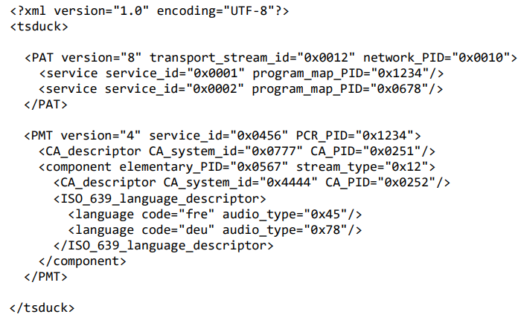

Figure 5.6-2: PSI/SI XML format

All XML files shall be encoded in UTF-8 format to allow international character sets in service names or event descriptions for instance. The initial declaration line “?xml version="1.0” encoding="UTF-8"?>" is optional but recommended.

## 5.7 Compatibility and conflict between standards

### 5.7-1 supported standards

The intrication of digital TV standards is complex and sometimes problematic for the user who wants to analyze the structure of a transport stream. TSDuck tries to help, either using command line utilities and plugins, and C++ classes for applications which are built on top of the TSDuck library.

The first layer of standard is MPEG [1]. It is the common root of all regional or international standards in digital TV. The MPEG standard defines the transport stream format, PES, sections and descriptors, the PSI (Program-Specific Information such as PAT, CAT, PMT) and a number of descriptors. The allocated ranges of tables ids and descriptor tags for MPEG is reserved and never conflicts with other standards1 .

At the second layer, then come the regional standards: DVB (Europe), ATSC (USA), ISDB (Japan). Note that these standards are also used in other parts of the world, in addition to their original regions.

The third layer is made of ANSI/SCTE standards. They are application-level standards such as emergency alerts (SCTE 18), splice signalization for advertisement (SCTE 35) or encryption (SCTE 52), These standards were originally designed to complement ATSC in the USA, but they are sometimes used in conjunction with DVB (especially SCTE 35). Parts of the SCTE 52 standard were also reused in ATIS-defined standards for IP-TV encryption.

### 5.7-2 TSDuck options for default standard selection

By default, TSDuck tries to guess the standards which are used in a transport stream. The following options can be used to indicate from the beginning how tables and descriptors should be interpreted. They are briefly repeated in the documentation of all commands to which they apply.

## 5.8 Character sets

### 5.8-1 Standards and character sets

Each standard defines its own way of representing characters in tables and descriptors.

### 5.8-2 TSDuck options for character sets

TSDuck commands and plugins which manipulate tables and descriptors have specialized options to indicate the character set to use.

By default, the standard DVB text encoding is used in DVB and ISDB structures.

The following options can be used to alter the behavior of TSDuck. They are briefly repeated in the documentation of all commands to which they apply.

### 5.8-3 Character set name

The available table names for option --default-charset are:

## 5.9 XML files

### 5.9-1 Usage of XML files by TSDuck

XML files are used as configuration and data files. They are used as input and output by TSDuck.

All TSDuck XML files are used as root node. They shall be encoded in UTF-8 format. The initial declaration line “<?xml version=1.0” encoding= UTF-8?> is optional but recommended.

For TSDuck users, XML files are mostly used to represent PSI/SI tables. This format can be used anywhere tables are used, either on input or output.

### 5.9-2 Inline XML content

In most TSDuck commands, if the name of an input XML file starts with "<?xml", it is considered as inline XML content, meaning that the string in the command line is directly the XML content and not a file name.

A similar mechanism exists for output XML files. When an application such as tsp runs for a long time, possibly forever, other applications may want to grab XML output files are soon as they are created. In that case, it is possible to output the whole content of an output XML file as one single line through the message logger (the standard error device by default). If another application filters the tsp standard error, it will get each XML file as one single text line. To facilitate the filtering of actual XML lines, it is possible to specify a marker prefix in the line, typically some easily recognizable pattern. See the description of the option --log-xml-line in the command tstables and the plugin tables.

### 5.9-3 XML model files

For each type of XML file, TSDuck uses a model file which describes the expected XML structure of the corresponding data or configuration file. XML model files use extension. model.xml.

This XML model mechanism can be considered as a minimalist equivalent of XML-Schema, with less features but much more light-weight.

### 5.9-4 XML patch files

An XML patch file is a template for transformations to apply on XML files. It is typically used to apply on-the-fly transformations on various PSI/SI tables by plugins such as pat, pmt, bat, cat, sdt, nit when the requested transformations cannot be handled by other options.

#### 5.9-4-1 Structure matching

A patch file is also an XML file. Its structure mimics the structure of XML input files. This is a template which is compared with the input file. More precisely, each XML element in the patch file (including its parent hierarchy) is compared with equivalent structures in the input file. To have a match, the node name and all parent node names must be identical and all attributes which are specified in the node in the patch file must be present and have the same value in the input file.

#### 5.9-4-2 Attribute patching

Once a match is found for a given XML element, it is possible to alter the value of the attributes of this matching element using special attributes starting with “x-“.

#### 5.9-4-3 Element patching

Similarly, the special attribute x-node is used to add or delete an entire XML element.

## 5.10 JSON and "normalized” report formats

TSDuck uses various text formats for report files. They are briefly described here.

### 5.10-1 "Normalized” report

The name “normalized report” refers to a predictable text format which can be easily parsed using scripts to automate operations. This is an alternative output format for tools which otherwise produce reports in a human-friendly readable format which is harder to parse and may change in future versions.

### 5.10-2 JSON files

While the previous normalized reports are easy to parse in scripts, they were created in a time where no widely-used standard parser-friendly format existed. Nowadays, most standard parsable files use the JSON format.

### 5.10-3 Automated XML-to-JSON conversion

With TSDuck, JSON is used for analysis reports while XML is used to store more complex configuration or data structures such as PSI/SI tables.

An application which needs to analyze the PSI/SI tables which are extracted by some TSDuck command or plugin can simply parse the extracted XML text. Although many tools and libraries exist to parse XML, some developers may prefer to parse JSON rather than XML. In that case, TSDuck provides an automated XML-to-JSON conversion.

#### 5.10-3-1 Conversion rules

There is no standard way to convert XML to JSON. Several tools exist and each of them has its own conversion rules. Because of the differences between XML and JSON, no conversion is perfect, and the result is sometimes not what would have been specified if JSON had been used from the beginning. However, the result is usually good enough for automatic parsing in an application. The translation rules for the TSDuck automated XML-to-JSON conversion are described below. Note that the default rules can be fine-tuned using an XML model for the input document (see 2.6.3) and specific command line options

#### 5.10-3-2 TSDuck options for automated XML-to-JSON conversion

The following command line options are used in various TSDuck commands and plugins to fine-tune the automated XML-to-JSON conversion.

## 5.11 Transport stream utilities

The transport stream toolkit provides a number of command-line utilities. The main one is tsp, the transport stream processor. The other utilities are small tools which work on transport stream files.

With a few exceptions, the transport stream files are continuous streams of 188-byte TS packets. These files can also be pipes. With the help of the tsp and its input and output plugins, the TS packets can be piped from and to various devices and protocols (files, DVB-ASI, DVB-S, DVB-C, DVB-T, multicast IP, etc.)

### 5.11-1 Command line syntax

#### 5.11-1-1 Command line options

All utilities are simple command-line tools. They accept “options” and “parameters”. The syntax of options follows the GNU getopt_long(3) conventions. See the corresponding Linux manual page for details

In short, this means that all options have a “long name” preceded by a double dash and optionally a “short name” (one dash, one letter). Long options can be abbreviated if there is no ambiguity.

Although this syntax is inspired by Linux and the GNU utilities, the same syntax is used on Windows.

#### 5.11-1-2 Integer values in command line options

When an option or parameter is documented to require an integer value (PID, identifier, etc.), this value can be uniformly specified in decimal or hexadecimal format with the 0x prefix.

In decimal values, the commas which are used as separators for groups of thousands are ignored. Since most commands display large values with separators in order to improve the readability, these values can be simply copied / pasted in subsequent command lines.

#### 5.11-1-3 Predefined common options

All commands accept the following common options:

--debug[=N ] Produce verbose debug output. Specify an optional debug level N. Do not use this option in normal operation. Without this option, no debug output is produced. When the option is specified but not the level N, the default debug level is 1, that is to say a reasonable amount of information. The higher the debug level is, the more output is produced. The amount of debug information depends on the command. Some commands do not generate any debug information.

--help The option displays the syntax of the command and exits. If either the standard output or the standard error is a terminal, the help text is “paged” through a system utility such as less or more, whichever is available. The environment variable PAGER can be used to specify an alternate pager command with its parameters (see 3.1.4). To redirect the help text to a file, you must redirect both the standard output and standard error. Otherwise, since at least one of the two is a terminal, the pager will be used. Example: tsp --help &>help.txt All tsp plugins also accept the option--help which provides help on this specific plugin.

--verbose Display verbose information.

--version[=name ] The option displays the TSDuck version and exits. The optional name indicates which type or format of version to display. The default is long. Other values are described in the table below.

## 5.12 Using a pager command

Some commands which produce a very verbose output are automatically redirected to a “pager” command such as less or more, whichever is available. The redirection is performed only when the standard output is a terminal.

## 5.13 Partial command line redirection from a file

In any command, it is possible to read some or all options and parameters from a file. The syntax is “@filename” where filename is a text file containing options and parameters.

## 5.14 Default options from the TSDuck configuration file

For bash users, when the bash-completion package is installed, specific completion scripts are added for TSDuck. Plugin names, command and plugin options, predefined enumeration values for options are automatically completed.

## 5.15 Bash command line completion

For bash users, when the bash-completion package is installed, specific completion scripts are added for TSDuck. Plugin names, command and plugin options, predefined enumeration values for options are automatically completed.

## 5.16 TSP Plugins

This chapter contains the reference documentation of all plugins for tsp, the transport stream processor. The input and output plugins can also be used by the command tsswitch.

## 5.17 Hardware Device Support

### 5.17-1 Tuner receiver devices (DVB, ATSC, ISDB)

The tuner receiver devices are specialized hardware devices which receive DVB-T, DVB-S, DVB-C, ATSC, ISDB-T, ISDB-S signals and transmit the demodulated binary transport stream to the computer system.

The input of a tuner receiver device is the antenna cable. The receiver device has either an F-connector (satellite, cable) or a standard TV connector (terrestrial, cable).

Most terrestrial receivers come with a small linear antenna. The usage of such an antenna should be avoided when possible since the reception is usually very poor. Always use the signal coming from a classical roof TV antenna when available (wall TV socket).

The physical output of a tuner receiver is a standard PC bus, usually PCIe or USB. Legacy devices also included PCI, PCMCIA (PC Card) or Express Card. Some PCIe devices are actually composed of one or more USB receivers and a USB-to-PCI bridge.

Most receivers simply contain a tuner and a demodulator. They transmit the complete transport stream over the bus (PCIe, USB, etc.) The demultiplexing and MPEG audio / video decoding is performed by some software, either in the kernel of the operating system or in a user-space application. Since TSDuck works on transport streams, the embedded hardware demux are never used. So, the simplest and cheapest receivers are usually fine for TSDuck.

Some receivers contain two or more tuners in order to receive several independent transport streams. They usually appear as distinct devices in the operating system.

Some receivers support multiple protocols, for instance DVB-T/T2 and DVB-C. The way they appear on a system depends on the vendor driver. For instance, the same device may appear as one single tuner supporting DVB-T/T2/C on Linux and two distinct tuners on Windows (one for DVB-T/T2 and one for DVB-C).

### 5.17-2 Operating system integration

### 5.17-2-1 Linux platforms

The tuner receiver devices are managed by Linux under the common “LinuxTV” framework which is part of V4L (“Video for Linux”).

* **Drivers**:

The drivers for the DVB receiver devices come with the Linux kernel.

The drivers for recent devices may not be integrated yet into the mainstream Linux kernel, see [38] for details on how to install the latest Linux drivers for DVB devices.

* **Firmware**:

Some devices need a firmware file in /lib/firmware which is loaded by the driver when the system boots or when the device Some firmware files are packaged with the Linux kernel, but

only when no copyright applies. Most firmware files are extracted from the proprietary Windows drivers of the device and are not free. Consequently, they are not included in the kernel distributions. Such proprietary firmware files must be fetched from various sites all over the Web. Some distros provide a package named linux- is plugged-in (USB device for instance).

# Operating System

List and describe the operating system used

# Digital TV

From about 2010 to 2012, television has really arrived in the age of high-definition TV (HDTV). For this purpose, enough channels have been available since the analog switch-off on satellites, and HDTV flat screens have meanwhile appeared in almost every living room. Screen diagonals have grown steeply compared to just a few years ago. Today, their size averages around 40 to 55 inches. Unpleasant side effects of the first flat screens, like restricted viewing angle and motion blur, have been eliminated; picture quality is now outstanding and incomparably better than that of CRT devices. "Smart TV”and "HbbTV” features are usually also integrated into the sets, merging the world of TV with the world of the internet. Also, ultra-high-resolution television (UHDTV) has been advertised intensively since 2014, but, although UHDTV devices are on offer and transmission chain is available, ultra-high-resolution content and the corresponding channel capabilities are not yet widespread. However, television is only part of the broadcasting scene, which, of course, also includes radio. The latter is still mostly received in analog form, although e.g., in Germany, DAB/DAB+ have seen strong growth since 2011, and a rich offering in terms of receivers and content is now available. The term "broadcasting” refers to the transmission of information, be it voice, image or sound, or data transmitted from a single point – the transmitter – to many points – the radio receivers. As a particular feature of broadcasting, the source is unaffected by the number of receivers, i.e., the channel capacity is not impacted as the number of receivers listening to that single transmitter increases. This is the big difference to a mobile radio link or an internet connection where peer-to-peer communication is used. Also, broadcast networks have so far always been designed for high noise-to-tolerance and are hence robust in disaster situations. This makes broadcasting a safe medium for distributing information to the population even under difficult conditions.

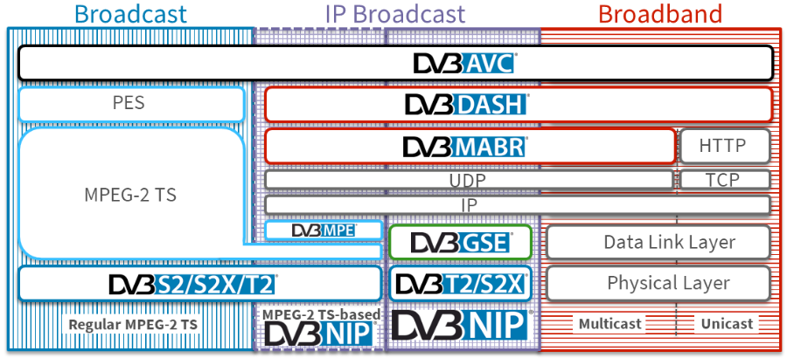

Figure 7: MPEG TS vs IP Protocol Stack

## 7.1 The MPEG data stream

Moving Pictures Experts Group, that is to say MPEG, deals mainly with the digital transmission of moving pictures. However, the data signal defined in the MPEG-2 Standard can also generally carry data which has nothing at all to do with video and audio and could be internet data.

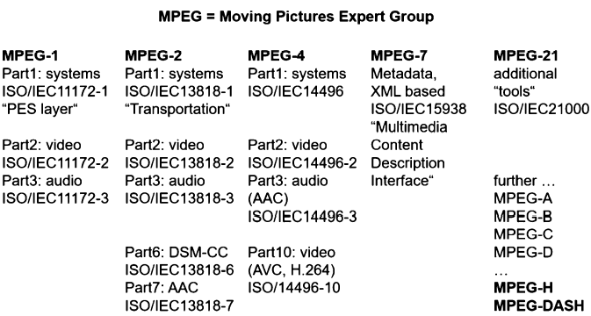

Figure 7.1: MPEG Standard

As in the MPEG Standard itself, first the general structure of the MPEG data signal will be described in complete isolation from video and audio. An understanding of the data signal structure is also of greater importance in practice than a detailed understanding of the video and audio coding.

This data signal carries typically some or many programs (= services) each consisting of lip-synchronous video, audio and data stream. It is called MPEG-2 transport stream. all that different MPEG-1, MPEG-2, MPEG-4, etc. Codecs can be mixed and transported in that MPEG-2 transport stream. There is only MPEG-2 transport stream and there is no MPEG-4 transport stream.

## 7.2 The MPEG-2 Transport Stream

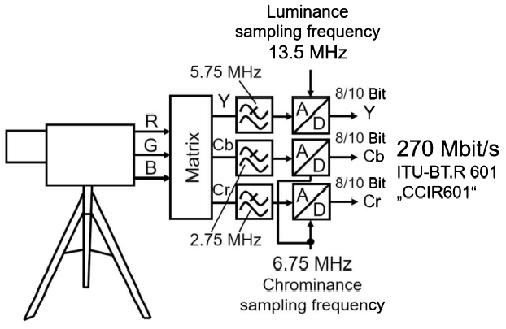

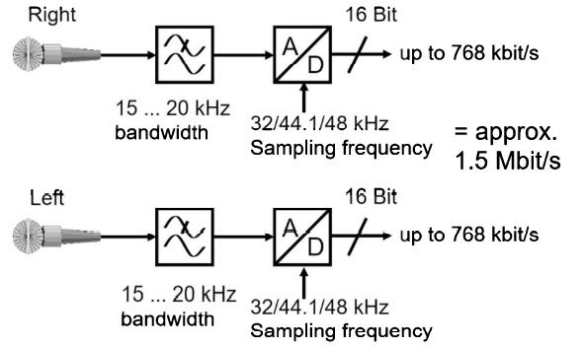

Figure 7.2: Video and Audio data signals

All the same, the description of the data signal structure will begin with the uncompressed video and audio signals. An SDTV (Standard Definition Television) signal without data reduction has a data rate of 270 Mbit/s and a digital stereo audio signal in CD quality has a data rate of about 1.5 Mbit/s.

The video signals are compressed to about 1 Mbit/s in MPEG-1 and to about 2-7 Mbit/s in MPEG-2. The video data rate can be constant or variable (statistical multiplex). The audio signals have a data rate of about 100 – 400 kbit/s (mostly 192 kbit/s) after compression, the audio data rate is always constant and a multiple of 8 kbit/s. The compressed video and audio signals in MPEG are called elementary streams, ES in brief. There are thus video streams, audio streams and, quite generally, data streams, the latter containing any type of compressed or uncompressed data. Immediately after having been compressed (i.e., encoded), all the elementary streams are divided into variable-length packets, both in MPEG-1 and in MPEG-2.

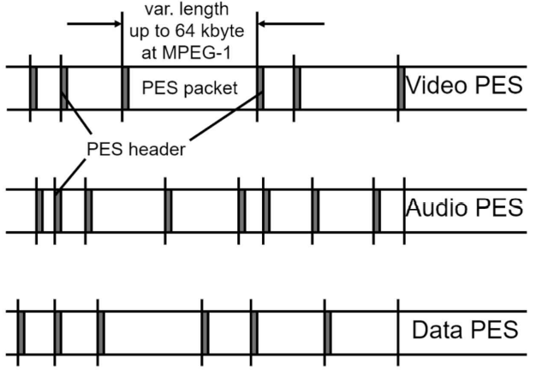

Figure 7.2b: MPEG Elementary Stream

Since it is possible to have sometimes more and sometimes less compression depending on the instantaneous video and audio content, variable length containers are needed in the data signal. These containers are needed in the data signal. These containers carry one or more compressed audio signal segments in the case of the audio signal. These elementary streams. Thus, divided into packets are called packetized elementary streams, or simply PES for short.

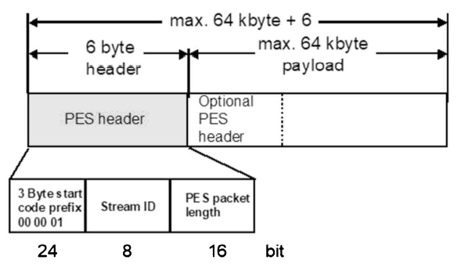

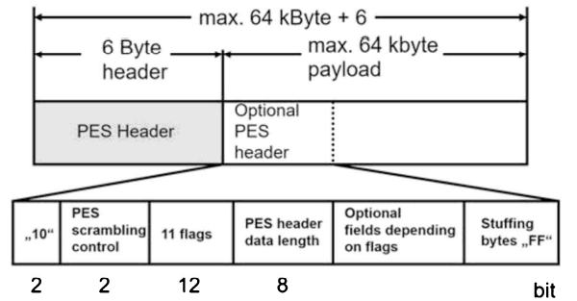

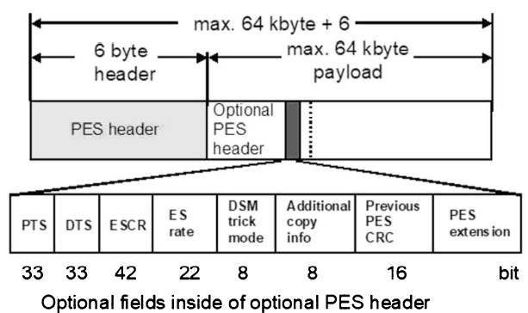

Figure 7.1c: the PES Packet

Each PES packet usually has a size of up to 64 Kbytes. It consists of a relatively short header and of a payload. The header contains inter alia a 16-bit-long length indicator for the maximum packet length 64 Kbytes. The payload part contains either the compressed video and audio streams or a pure data stream. According to the MPEG standard, however, the video packets can also be longer than 64 Kbytes in some cases. The length indicator is then set to zero and the MPEG decoder must use another mechanism for finding the end of the packet.

## 7.3 The Packetized Elementary Stream (PES)

All elementary streams in MPEG are first packetized in variable-length packets called PES packets. The packets, which primarily have a length of 64 Kbytes, begin with a PES header of 6 bytes minimum length. The first 3 bytes of this header represent the start code prefix, the content of which is always 00 00 01 and which is used for identifying the start of a PES packet. The byte following the start code is the stream ID which describes the type of elementary stream following in the payload. It indicates whether it is e.g., a video stream, an audio stream or a data stream which follows. After that there are two packet length bytes which are used to address up 64 Kbytes of payload. If both bytes are set to zero, a PES packet having a length which may exceed 64 Kbytes can be expected. The MPEG decoder then must use other arrangements to find the PES packet limits, e.g., the start code.

After these 6 bytes of PES header, an optional PES header is transmitted which is an optional extension of the PES header and is adapted to the requirements of the elementary stream currently being transmitted. It is controlled by 11 flags in a total of 12 bits in this optional PES header. These flags show which components are actually present in the optional fields in the optional PES header and which are not. The total length of the PES header is shown in the PES header data length field. The optional fields in the optional header contain, among other things, the presentation time stamps (PTS), and the decoding time stamps (DTS) which are important for synchronizing video and audio. At the end of the optional PES header there may also be stuffing bytes. Following the complete PES header, the actual payload of the elementary stream is transmitted which can usually be up to 64 Kbytes long or even longer in special cases, plus the optional header.

In MPEG-1, video PES packets are simply multiplexed with PES packets and stored on a data medium. The maximum data rate is about 1.5 Mbit/s for video and audio and the data stream only includes a video stream and an audio stream.

This packetized elementary stream (PES) with its relatively long packet structures is not, however, suitable for transmission and especially not for broadcasting a number of programs in one multiplexed data signal.

In MPEG-2, on the other hand, the objective has been to assemble up to 6, 10, or even 20 independent TV or radio programs to form one common multiplexed MPEG-2 data signal. This data signal is then transmitted via satellite, cable or terrestrial links. To this end, the long PES packets are additionally divided into smaller packets of constant length. From the PES packets, 184-byte-long pieces are taken and to these another 4-byte-long header is added. Making up 188-bytes-long packets called "transport stream packets” which are then multiplexed.

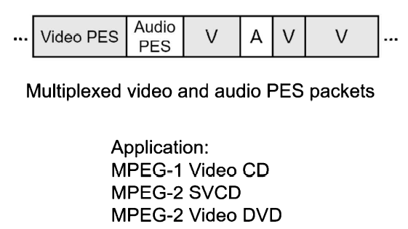

Figure 7.3a: Multiplexed PES packets

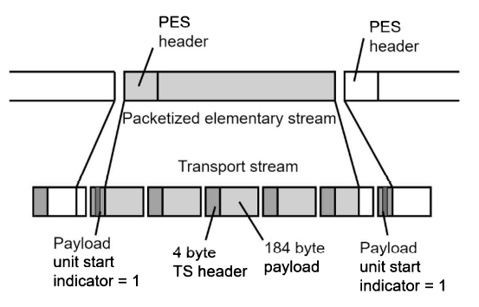

Figure 7.3b: Forming MPEG-2 transport stream packets

To do this, first the transport stream packets of one program are multiplexed together. A program can consist of one or more video and audio signals and an extreme of this is a formula 1 transmission with a number of camera angles (track, spectators, car, helicopter) and presented in different languages. All the multiplexed data streams of all the programs are then multiplexed again and combined to form a complete data stream which is called an MPEG-2 transport stream (TS for short).

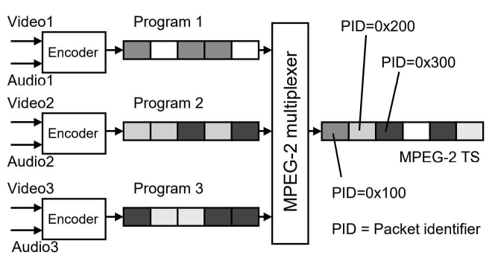

Figure 7.3c: Multiplexed MPEG-2 transport stream packets

An MPEG-2 transport stream contains the 188-byte-long transport. Stream packets of all programs with all their video, and audio and data signals. Depending on the data rates, packets of one or the other elementary streams will occur more or less frequently in the MPEG-2 transport stream. For each program there is one MPEG encoder which encodes all elementary stream packets. The data rate for each program is usually approx. 2-7 Mbit/s but the aggregate data rate for video, audio and data can be constant or vary in accordance with the program content at the time. This is then called statistical multiplex. The transport stream of all programs is then combined in a multiplexed MPEG-2 data stream to form one overall transport stream. Which can then have a data rate of up to about 40...55 Mbit/s. There are often up to 6, 8 or 10 or even 20 programs in one transport stream. The data rates can vary during the transmission, but the overall data rate must remain constant. A program can contain video and audio, only audio (audio broadcast) or only data, and the structure is thus flexible and can also change during the transmission. To be able to determine the current structure of the transport stream during the decoding, the transport stream also carries lists describing the structure, so-called tables.

## 7.4 The MPEG-2 transport stream packet

The MPEG-2 transport stream consists of packets having a constant length. This length is always 188 bytes, with 4 bytes of header and 184 bytes of payload. The payload contains video, audio or general data. The header contains numerous items of importance to the transmission of the packets. The first header byte is the sync byte. It always has a value of 47hex (0x47 in C/C++ syntax) and is spaced a constant 188 bytes apart in the transport stream. It is quite possible, and certainly not illegal, for there to be a byte having the value 0x47 somewhere else in the packet; even this cannot be avoided.

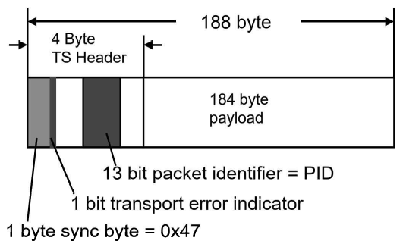

Figure 7.4a: MPEG-2 transport stream packet

The sync byte is used for synchronizing the packet to the transport stream and it is its value plus the constant spacing which is being used for synchronization. According to MPEG, synchronization at the decoder occurs after five transport stream packets have been received. Another important component of the transport of the transport stream is the 13 bit-long packet identifier or PID that describes the current content of the payload part of this packet. The hexadecimal 13-bit number in combination with tables is also included in the transport stream show which elementary stream or content this is.

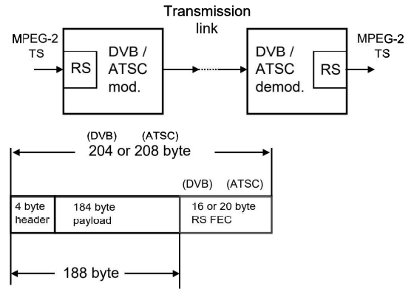

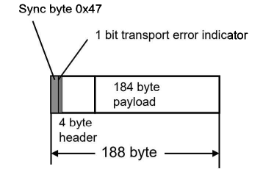

Figure 7.4b: Reed-Solomon FEC

The bit immediately following the sync bit is the transport error indicator bit. With this bit, transport stream packets are flagged as errored after their transmission. It is set by demodulators at the end of the transmission link if e.g., too many errors have occurred and there had been no further possibility to correct these by means of error correction mechanisms used during the transmission. In DVB-x1 (Digital Video Broadcasting, first regeneration), e.g., the primary error protection used is always the Reed Solomon error correction code. In one of the first stages of the (DVB-S, DVB-C or DVB-T) modulator, 16 bytes of error protection are added to the initial 188 bytes of the packet. These 16 bytes of error protection are added to the initial 188 bytes of the packet. These 16 bytes of error protection are a special checksum which can be used for repairing up to 8 errors per packet at the receiving end. If, however, there are more than 8 errors in a packet, there is no further possibility for correcting the errors, the error protection has failed, and the packet is flagged as errored by the transport error indicator. This packet must now no longer be decoded by the MPEG decoder which, instead, must mask the error which, in most cases, can be seen as a type of blocking in the picture.

It may be necessary occasionally to transmit more than 4 bytes of header per transport stream packet. The header is extended into the payload field in this case. The payload part becomes correspondingly shorter, but the total packet length remains a constant 188 bytes. This extended header is called an adaptation field. The other contents of the header and of the adaptation field. Adaptation control bits in the 4 byte-long header show if there is an adaptation field or not.

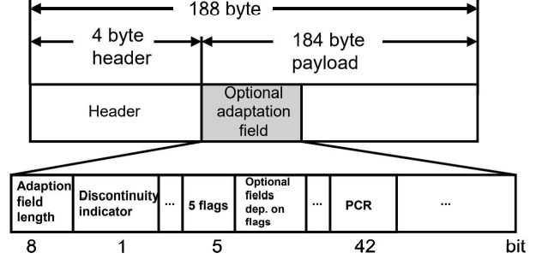

Figure 7.4c: Adaptation field

The structure and especially the length of a transport stream packet are very similar to a type of data transmission known from telephony and LAN technology, namely the asynchronous transfer mode or ATM in short. Today, ATM is used both in long-haul networks for telephony and internet calls and for interconnecting computers in a LAN network in buildings. ATM also has a packet structure, the length of one ATM cell is 53 bytes containing 5 bytes of header and 48 bytes of payload. Right at the beginning of MPEG-2 it was considered to transmit MPEG-2 data signals via ATM links. Hence the length of an MPEG-2 transports stream packet. Taking into consideration one special byte in the payload part of an ATM cell, this leaves 47 bytes of payload data. It is then possible to transmit 188 bytes of useful information by means of 4 ATM cells, corresponding exactly to the length of one MPEG-2 transport stream packet. And indeed, MPEG-2 transmission over ATM links was in use. Examples of this were found e.g., in Austria where all national studios of the Austrian broadcasting institution ORF (Osterreichischer Rundfunk) were linked via an ATM network (called LENT). In Germany, too, MPEG stream were exchanged over ATM links. But nowadays ATM links are replaced by IP technology.

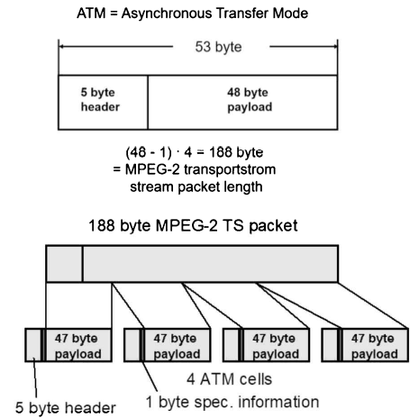

Figure 7.4d: ATM cell

When MPEG signals are transmitted via ATM links, various transmission modes called ATM adaptation layers can be applied at the ATM level. The mode shown in Figure 7.4d. corresponds to ATM adaptation layer 1 without FEC (i.e., AALI without FEC (forward error correction)). ATM adaptation layer 1 with FEC (AAL1 with FEC) or ATM adaptation layer 5 (AAL5) are also possible. The most suitable layer appears to be AAL1 with FEC since the contents are error-protected during the ATM transmission in this case.

The fact that the MPEG-2 transport stream is a completely asynchronous data signal is of particularly decision significance. There is no way of knowing what information will follow in the next time slot (= transport stream packet). This can only be determined by means of the PID of the transport stream packet. The actual payload data rates in the payload can fluctuate; there may be stuffing to supplement the missing 184 bytes. This asynchronism has great advantages with regard to future flexibility, making it possible to implement any new method without much adaptation. But there are also disadvantages: the receiver must always be monitored and thus uses more power; unequal error protection as, e.g., in DAB (digital audio broadcasting) cannot be applied and different contents cannot be protected to a greater or lesser degree as required.

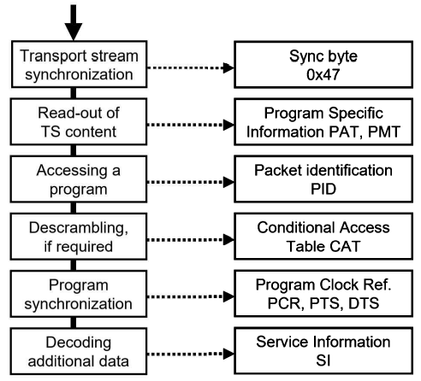

Figure 7.4e: Information for the receiver

## 7.5 Information for the receiver

In the following paragraphs, the components of the transport stream which are necessary for the receiver will be considered. Necessary components mean in this case: what does the receiver, i.e., the MPEG decoder, need for extracting from the large number of transports stream packets with the most varied content exactly those which are needed for decoding the desired program? In addition, the decoder must be able to synchronize correctly to this program. The MPEG-2 transport stream is a completely asynchronous signal and its contents occur in a purely random fashion or on demand in individual time slots. There is no absolute rule which can be used for determining what information will be contained in the next transport stream packet. The decoder and every element on the transmission link must lock the packet structure. The PID (packet identifier) can be used for finding out what is being transmitted in the respective element. On the other hand, this asynchronism has advantages because of the total flexibility provided but there are also disadvantages with regard to power saving. Every single transport stream packet must first be analyzed in the receiver.

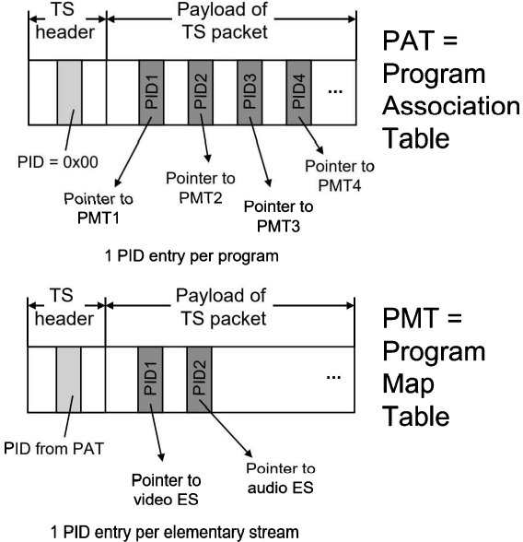

Figure 7.5a: PAT and PMT

### 7.5-1 Synchronizing to the transport stream

When the MPEG-2 decoder input is connected to an MPEG-2 transport stream, it must first lock to the transport stream, i.e., to the packet structure. The decoder, therefore, looks for the sync bytes in the transport stream. These always have the value of 0x47 and always appear at the beginning of a transport stream packet. They are thus present at constant intervals of 188 bytes. These two factors together, the constant value of 0x47 and the constant spacing of 188 bytes, are used for the synchronization. If a byte having a value 0f 0x47 appears, the decoder will examine the positions of n times 188 bytes before and after this byte in the transport stream for the presence of another sync byte. If there is, then this is a sync byte. If not, then this is simply some code word which has accidentally assumed this value. It is inevitable that the code word of 0x47 will also occur in the continuous transport stream. Synchronization will occur after 5 transport stream packets and the decoder will lose lock after a loss of 3 packets (as quoted in the MPEG-2 standard).

### 7.5-2 Reading out the current program structure

The number and the structure of the programs transmitted in the transport stream is flexible and open. The transport stream can contain one program with one video and audio elementary stream, or there can be 20 programs or more, some with only audio, some with video and audio and some with video and a number of audio signals which are being broadcast. It is, therefore, necessary to include certain lists in the transport stream which describe the instantaneous structure of the transport stream.

These lists provide the so-called program specific information, or PSI in short. The first table is the program association table (PAT). This table occurs precisely once per transport stream but is repeated every 0.5 sec. This table shows how many programs there are in this transport stream. Transport stream packets contained in this table have the value zero as packet identifier (PID) and can thus be easily identified. In the payload part of the program association table, a list of special PIDs is transmitted. There is exactly one PID per program in the program association table.

These PIDs are pointers, as it were, to other information describing each individual program in more detail. They point to other tables, the so-called program map table (PMT). The program map tables, in turn, are special transport stream packets with a special payload part and special PID. The PIDs of the PMTs are transmitted in the PAT. If it is intended to receive, e.g., program no.3, PID no. 3 is selected in the list of all PIDs in the payload part in the program association table (PAT). If this is, e.g., 0x1FF3 in their header. These packets are then the program map table, in turn, contains PIDs which are the PIDs for all elementary streams contained in this program (video, audio, data).

Since there can be a number of video and audio streams – as for instance in a movie broadcast in various languages – the viewer must select the elementary streams to be decoded. Ultimately, he will select exactly 2 PIDs – one for the video stream and one for the audio stream, resulting e.g., in the two hexadecimal numbers PID1 = 0x100 and PID2 = 0x110. PID1 is then e.g., the PID for the video stream to be decoded and PID2 is the PID for the audio stream to be decoded. From now on, the MPEG-2 decoder will only be interested in these transport stream packets, collect them, i.e., demultiplex them and assemble them again to form the PES packets. It is precisely these PES packets which are supplied to the video and audio decoder in order to generate another video-and-audio signal.

The composition of the transport stream can change during the transmission, e.g., local programs can only be transmitted within certain windows. A TV receiver must, therefore, continuously monitor the background of the instantaneous structure of the transport stream, read out the PAT and PMTs and adapt to new situations. The header of a table contains a so-called version management for this purpose which signals to the receiver whether something has changed in the structure. It is regrettable that this does still not hold true for all DVB receivers. A receiver often recognizes a change in the program structure only after a new program search has been started. In many regions in Germany, so-called regional window programs are inserted into the public service broadcast programs at certain times of the day. These are implemented by a so-called dynamic PMT, i.e., the contents of the PMT are altered and signal changes in the PIDs of the elementary streams.

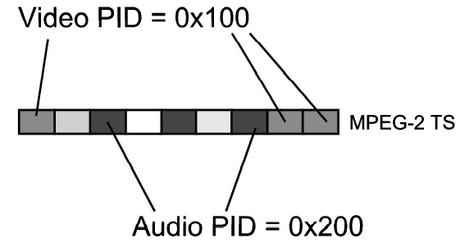

Figure 7.5-2: Accessing a program via video and audio PIDs

### 7.5-3 Accessing a program

After the PIDs of all elementary streams contained in the transport stream have become known from the information contained in the PAT and the PMTs and the user has committed himself to a program, a video and audio stream, precisely two PIDs are now defined (Figure 7.5-2): the PID for the video signal to be decoded and the PID for the audio signal to be decoded. The MPEG-2 decoder, on instruction by the user of the TV receiver, will now only be interested in these packets. Assuming then that the video PID is 0x100 and the audio PID is 0x110: in the following demultiplexing process all TS packets with 0x100 will be assembled into video PES packets and supplied to the video decoder. The same applies to the 0x110 audio packets which are collected together and reassembled to form PES packets which are supplied to the audio decoder. If the elementary streams are not scrambled, they can now also be decoded directly.

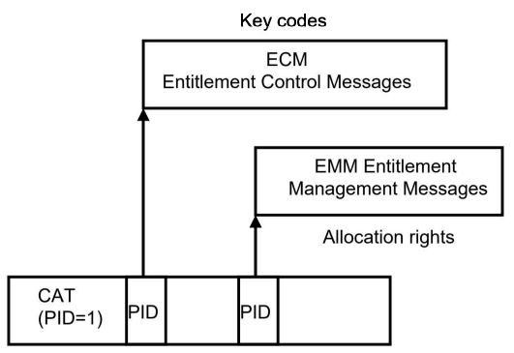

Figure 7.5-3: The Conditional Access Table

### 7.5-4 Accessing Scrambled Program

However, the elementary streams are transmitted scrambled. All or some of the elementary streams are transmitted protected by an electronic code in the case of pay TV or for licensing reasons involving local restrictions on reception. The elementary streams are scrambled (Figure 7.5-4b) by various methods (Viaccess, Betacrypt, Irdeto, Conax, Nagravision etc.) and cannot be received without additional hardware and authorization. This additional hardware must be supplied with the appropriate descrambling and authorization data from the transport stream. For this purpose, a special table is transmitted in the transport stream, the conditional access table (CAT) (Figure 7.5-3).

The CAT supplies the PIDs for other packets in the transport stream in which this descrambling information is transmitted. This additional descrambling information is called ECM (entitlement control message) and EMM (entitlement management message). The ECMs are user administration. The important factor is that only the elementary streams themselves may be scrambled, and no transport stream headers (or tables, either). Neither is it permitted to scramble the transport stream header or the adaptation field.

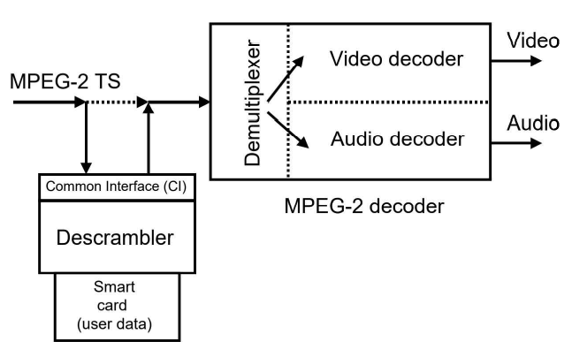

Figure 7.5-4a: Descrambling in the DVB receiver

The descrambling itself is done outside the MPEG decoder in additional hardware related to the descrambling method, which can be plugged into a so-called common interface (CI) in the set-top box. The transport stream is looped through this hardware before being processed further in the MPEG decoder. The information from the ECMs and EMMs and the user's personal code from the smart card then enable the streams to be descrambled.

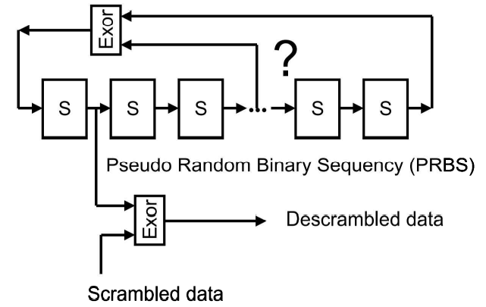

Figure 7.5-4b: Scrambling and descrambling by PRBS

### 7.5-5 Program Synchronization (PCR, DTS, PTS)

Once the PIDs for video and audio have been determined and any scrambled programs have been descrambled and the streams have been demultiplexed, video and audio PES packets are generated again. These are then supplied to the video and audio decoder. The actual decoding, however, requires a few more synchronization steps. The first step consists of linking the receiver clock to the transmitter clock. As indicated initially, the luminance signal is sampled at 13.5 MHz and the two-chrominance signal is sampled at 6.75 MHz. 27 MHz is multiple of these sampling frequencies, which is why this frequency is used as reference, or basic, frequency for all processing steps in the MPEG encoding at the transmitter end. A 27 MHz oscillator in the MPEG encoder feeds the stream time clock (STC). The STC is essentially a 42-bit counter which is clocked by this same 27 MHz clock and starts again at zero after an overflow. The LSB positions do not go up to FFF but only to 300. Approximately every 26.5 hours the counter restarts at zero. At the receiving end, another system time clock (STC) must be provided, i.e., another 27 MHz oscillator connected to a 42-bit counter is needed. However, the frequency of this 27 MHz oscillator must be in complete synchronization with the transmitting end, and the 42-bit counter must also count in complete synchronism.

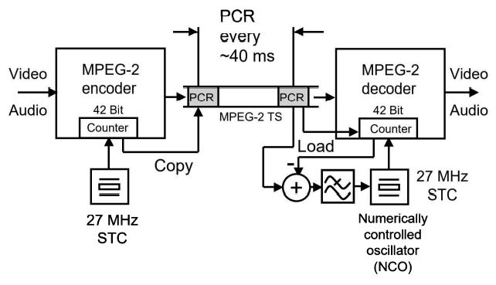

Figure 7.5-5a: Program Clock Reference

To accomplish this, reference information is transmitted in the MPEG data stream (Figure 7.5-5a). in MPEG-2, these are the Program Clock Reference (PCR) values which are nothing else than an up-to-date copy of the STC counter fed into the transport stream at a certain time. The data stream thus carries an accurate internal clock time. All coding and decoding processes are controlled by this clock time. To do this, the receiver, i.e., the MPEG decoder, must read out the clock time, namely the PCR values, and compare them with its own internal system clock, that is to say its own 42-bit counter.

If the receiver PCR values are locked to the system clock in the decoder, the 27 MHz clock at the receiving end matches the transmitting end. If there is a deviation, a controlled variable for a PLL can be generated from the magnitude of the deviation, i.e., the oscillator at the receiving end can be corrected. In parallel, the 42-bit count is always reset to the received PCR value, a basic requirement for system initialization and in the event of a program change.

The PCR values must be present in sufficient numbers, that is to say with maximum spacing, and relatively accurately, that is to say free of jitter. According to MPEG, the maximum spacing per program is 40 ms between individual PCR values. The PCR jitter must be less than +-500 ns. In early time PCR problems manifest themselves in the first instance in that instead of a color picture, a black/white picture is displayed. PCR jitter problems can occur during the re-multiplexing of a transport stream, among other things. The reason is that e.g., the order of the transport stream packets is changed without the PCR information continued in them also being changed. There is frequency a PCR jitter of up to +- 30 us even though only +- 500 ns is allowed. This can be handled by many decoders but not by all. The PCR information is transmitted in the adaptation field of a transport stream packet belonging to the corresponding program. The precise information about the type of TS packets which this is done can be found in the corresponding program map table (PMT). The PMT contains the so-called PCR_PID which, however, corresponds to the video PID of the respective program in most cases. After program clock synchronization has been achieved, the video and audio coding steps are then executed in lock with the system time clock (STC).

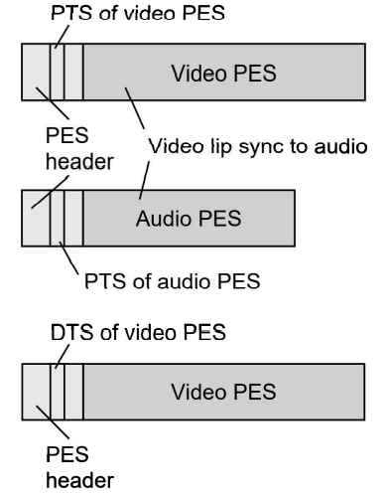

Figure 7.5-5b: PTS and DST

However, another problem now presents itself. Video and audio must be decoded and reproduced with lip synchronization. In order to be able to achieve lip sync, i.e., synchronization between video and audio, additional timing information is keyed into the headers of the video and audio PESs. This timing information is derived from the system time clock (STC, 42 bits). Using the 33 most significant bits (MSB) of the STC, these values are entered into the video and audio PES headers at maximum intervals of 700 ms are called presentation time stamps (PTS) as will be seen later in the section on video coding, the order in which the compressed picture information is transmitted will differ from the order in which it is recorded. The frame sequence is now scrambled in conformity with certain coding rules, a necessary measure in order to save memory space in the decoder. To recover the original sequence, additional time stamps must be keyed into the video stream. These are called decoding time stamps (DTS) and are also transmitted in the PES header.

An MPEG-2 decoder in a TV receiver is then able to decode the video and audio streams of a program, resulting again in video and audio signals, either in analog form or in digital form.

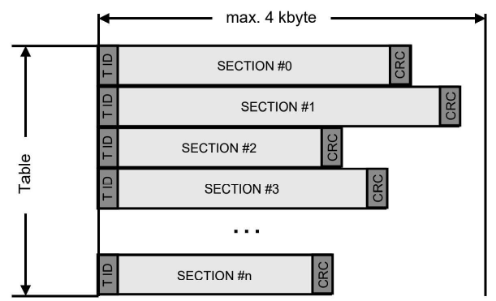

Figure 7.5-5c: Sections and tables

### 7.5-6 Additional Information in the Transport Stream (SI/PSI/PSIP)

According to MPEG, the information transmitted in the transport stream is fairly hardware-oriented, only relating to the absolute minimum requirements, as it were. However, this does not make the operation of a TV receiver particularly user-friendly. For example, it makes sense, and is necessary, to transmit program names for identification purposes. It is also desirable to simplify the search for adjacent physical transmission channels. It is also necessary to transmit electronic program guides (EPG) and time and date information. In this respect, both the European DVB Project group and the US ATSC Project group have defined additional information for the transmission of digital video and audio programs which is intended to simplify the operation of TV receivers and make it much more user-friendly.

### 7.5-7 Non-Private and Private Sections and Tables

To cope with any extensions, the MPEG Group has incorporated an open door in the MPEG-2 standard. In addition to the program specific information (PSI), the program map table (PMT) and the conditional access table (CAT), it created the possibility to incorporate so-called private sections and private tables (Figure 7.5-5c) in the transport stream. The group has defined mechanisms which specify what a section or table has to look like, what its structure has to be and by what rules it is to be linked into the transport stream.

According to MPEG-2 systems (ISO/IEC 13818-1), the following was specified for each type of table:

* A table is transmitted in the payload part of one or more transport stream packets with a special PID which is reserved for only this table (DVB) or some types of tables (ATSC).
* Each table begins with a table ID which is a special byte which identifies only this table alone. The table ID is the first payload byte of a table.
* Each table is subdivided into sections which are allowed to have a maximum size of 4 Kbytes. Each section of a table is terminated with a 32-bit-long CRC checksum over the entire section.

The program specific information (PSI) has exactly the same structure. The PAT has a PID of zero and begins with a table ID of zero, the PMT has the PIDs defined in the PAT as PID and has a table ID of 2. The CAT has PID and a table ID of one in each case. The PSI can be composed of one or more transport stream packets for PAT, PMT and CAT depending on content.

Apart from the PSI tables PAT, PMT and CAT mentioned above, another table, the so-called network information (NIT) was provided in principle but not standardized in detail. It was actually implemented as part of the DVB (Digital Video Broadcasting) project.

All tables are implemented through the mechanism of sections. There are non-private and private sections (Figure 7.5-7a). Non-private sections are defined in the original MPEG-2 systems standard. All others are correspondingly private. The non-private sections include the PSI tables, and the private ones include the SI sections of DVB and the MPEG-2 DSM-CC (Digital Storage Media Command and Control) sections which are used for data broadcasting. The header of a table contains administration of the version number of a table and information about the number of sections of which a table is made up. A receiver must first of all scan through the header of these sections before it can evaluate the rest of the sections and tables. Naturally, all sections must be broken down from an original maximum length of 4 Kbytes to maximum of 148 bytes payload length of an MPEG-2 transport stream packet before they are transmitted.

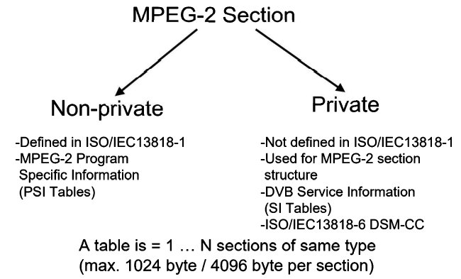

Figure 7.5-7a: Sections and tables according to MPEG-2

In the case of PSI/SI, the limit of the section length has been lowered to 1 Kbyte in almost all tables, the only exception being the EIT (Event Information Table) which is used for transmitting the electronic program guide (EPG). The sections of the EIT can assume a maximum length of 4 Kbytes because they carry a large amount of information as in the case of a week-long EPG.

If a section begins in a transport stream packet (Figure 7.5-7b), the payload unit starts indicator of its header is set to 1. The TS header is then followed immediately by the pointer which points (in number to bytes) to the actual beginning of the section. In most cases (and always in the case of PSI/SI), this pointer is set to zero which means that the section begins immediately after the pointer.

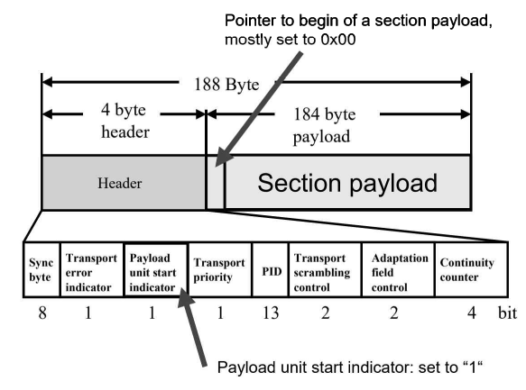

Figure 7.5-7b: Beginning of a section in an MPEG-2 transport stream packet

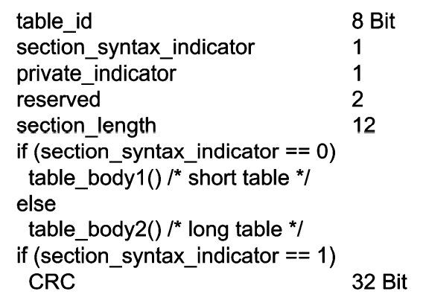

Figure 7.5-7c: Structure of a section

If the pointer has a value which differs from zero, remainders of the preceding section can still be found in this transport stream packet. This is utilized for saving TS packets, an example being MPE (multi-protocol encapsulation) over DSM-CC sections in the case of IP over MPEG-2 (DVB-H).

The structure of sections always follows the same plan (Figure 7.5-7c, Figure 7.5-7d). a section begins with the table_ID, a byte which signals the type of table. The section_syntax_indicator bit indicates whether this is a short type of section (bit=0) or a long one (bit=1). If it is a long section, this is then followed by an extended header which contains, among other things, the version management of the section and its length and the number of the last section. The version number indicates if the content of the section has changed (e.g., in case of a dynamic PMT or if the program structure has changed). A long section is always concluded with a 32-bit-long CRC checksum over the entire section.

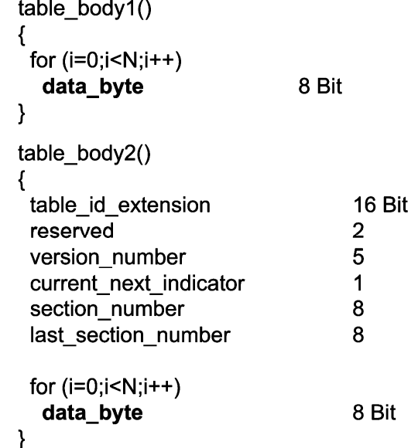

Figure 7.5-7d: Structure of the section payload

The detailed structure of a PAT and PMT can now also be understood more easily. A PAT (Figure 7.5-7e, Figure 7.5-7f) begins with the table_ID = 0x100. Its type is that of a non-private long table, i.e., the version management follows in the header. Since the information about the program structure to be transmitted is very short, a single section is virtually always sufficient (last_section_no = 0) and it also fits inside a transport packet. In the program loop, the program number and the associated program map ID are listed for each program. Program no, zero is a special exception, it informs about the PID of the later NIT (Network Information Table). The PAT is then concluded with the CRC checksum. There is one PAT per transport stream, but it is repeated every 0.5 sec. In the header of the table, an unambiguous number, the transport stream_ID, is allocated to the transport stream via which it can be addressed in a network (e.g., a satellite network with many transport streams). The PAT does not contain any text information.

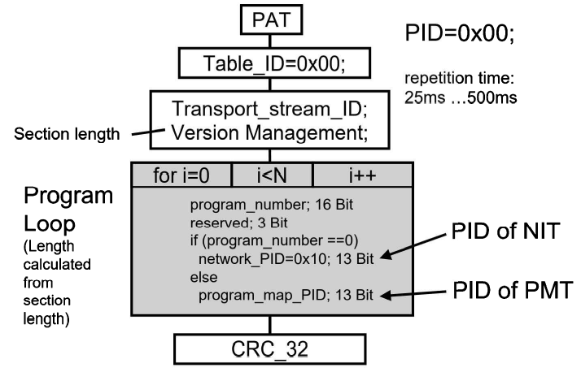

Figure 7.5-7e: Detailed structure of the PAT

The program map table (PMT) begins with the table_ID = 0x02. The PID is signaled via the PAT and is in the range of 0x20 … 0x1FFE. The PMT is also a so-called non-private table with version management and concluding CRC checksum. The header of the PMT carries the program_no, already familiar from the PAT. The program_no in PAT PMT must match, i.e., be equal.

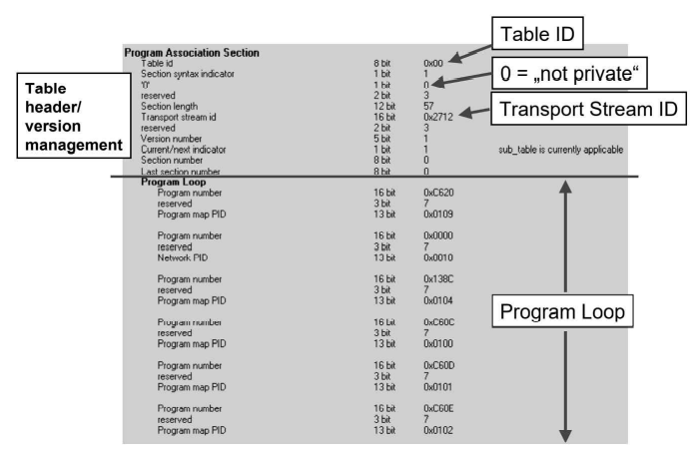

Figure 7.5-7f: Details of the program association table (practical example)

The header of the PMT is followed by the program_info_loop into which various descriptors can be inserted as required which described program components in more detail. It does not have to be utilized, however. The actual program components like video, audio or teletext are identified via the stream loop which contains the entries for the respective stream type and the PID of the elementary stream.

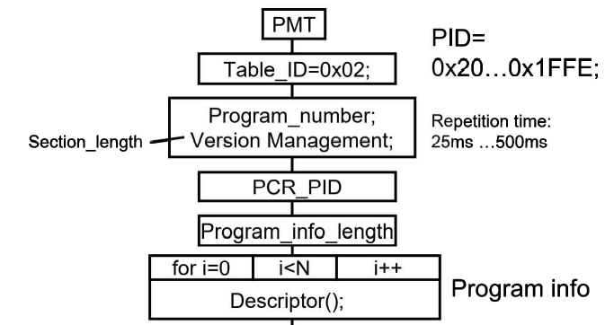

Figure 7.5-7g: Detailed structure of the program map table

It is possible to include a number of descriptors for each program component in the ES_info_loop. There is one PMT for each program and it is sent out every 0.5 sec. There is no text information in the PMT, either.

Figure 7.5-7h. shows an actual example of the structure of a program map table, which is quite short in this case. It will be discussed in more detail as representative of many other tables following. The example, recorded with an MPEG-2 analyzer, shows that the PMT begins with the table ID 0x02, a byte which clearly identified it as such.

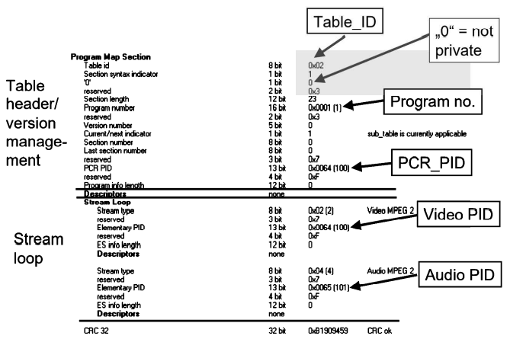

Figure 7.5-7h: Details of the program map table (practical example)

The section syntax indicator bit is set to 1 and tells one that this is a long table with version management. The subsequent bit is set to 0 and identifies this table as a so/called MPEG table. The section length says how long this current section of this table happens to be, namely 23 bytes long in this case. The field of the table_ID extension contains the program number; there must also be a corresponding entry in the PAT. The version number and the current/next indicator signal a change in the program map table. This information must be continuously checked by a receiver which must respond to a change in the program structure (dynamic PMT) if necessary. The section number tells what section this happens to be, and the last section does not inform about the number of the last section of a table. It is set to zero in this case, i.e., the table consists of only one section.

The PCR_PID (program clock reference-packet identifier) provides the PID on which the PCR value is broadcast. This is the video PID in most cases.

There should now be a program_info_loop but there is none in this example, a fact which is signaled by the length indicator program_info_length = 0.

However, the stream loop provides information about the video and audio PID. The stream type shows the type of payload namely MPEG-2 video and MPEG-2 audio in this case.

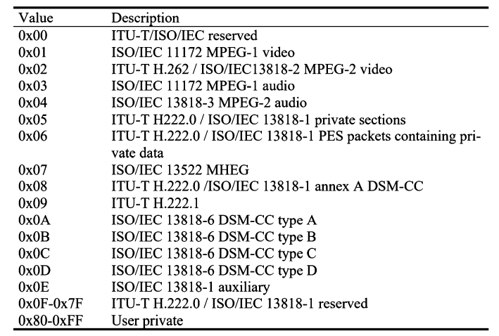

Table 7.5-7i: Stream types of program map table

### 7.5-8 The service information according to DVB (SI)

Taking advantage of the private section and private table features, the European DVB group has introduced numerous additional tables intended to simplify the operation of the set-top boxes or quite generally of the DVB receivers. Called service information (SI), they are defined in ETSI standard ETS300468.

They are the following tables (Figure 7.5-8a): the network information table (NIT), the service descriptor table (SDT), the bouquet association table (BAT), the event information table (EIT), the running status table (RST), the time&date table (TDT), the time offset.

Table (TOT) and, finally the stuffing table (ST). These eight tables will now be described in more detail.

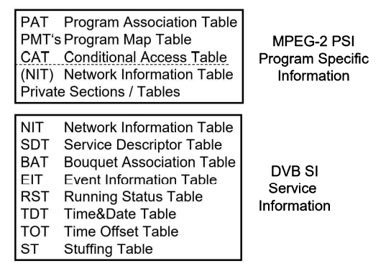

Figure 7.5-8a: MPEG-2 PSI and DVB SI

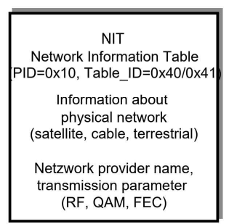

Figure 7.5-8b: Network information table (NIT)

The network information table (NIT) (Figure 7.5-8b, Figure 7.5-8c, Figure 7.5-8d) describes all physical parameters of a DVB transmission channel. It contains, e.g., received frequency and the type of transmission (Satellite, cable, terrestrial) and also all the technical data of the transmission, i.e., error protection, type of modulation etc. This table has the purpose of optimizing the channel scan as much as possible. A TV receiver is able to store all the parameters of a physical channel when scanning during setup, and it is possible, e.g., to broadcast information about all available physical channels within a network (e.g., satellite, cable), making it possible to do away with the actual physical search for channels.

The NIT contains the following information:

* Transmission path (satellite, cable, terrestrial)
* Received frequency
* Type of modulation
* Error protection
* Transmission parameters

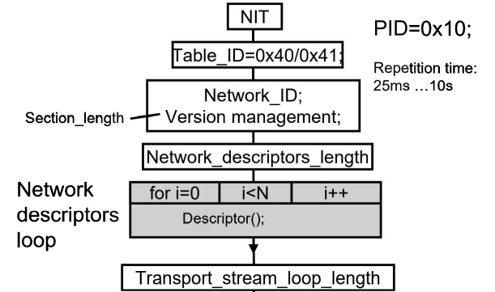

Figure 7.5-8c: Structure of the network information table (NIT)

The important factor in relation to the NIT is that many TV receivers may behave in a peculiar manner if the transmission parameters in the NIT do not match the actual transmission. If e.g., the transmit frequency given in the NIT does not correspond to the actual received frequency, many receivers, without any indication of reasons, may simply refuse to reproduce any picture or sound.

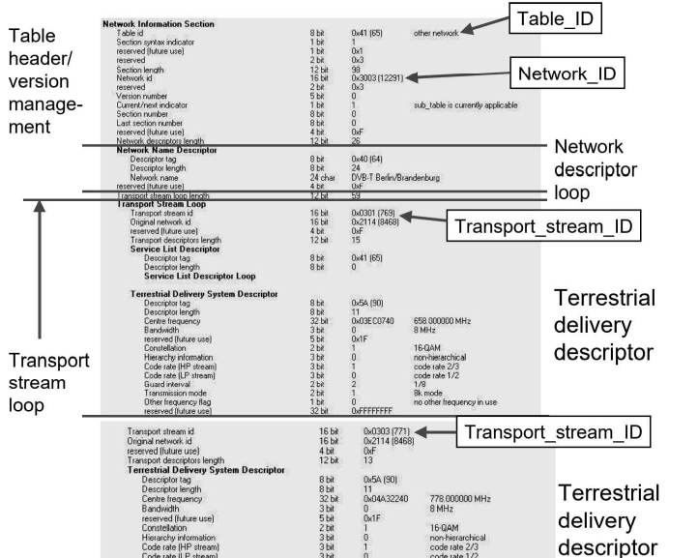

Figure 7.5-8d: Practical example of a network information table (NIT)

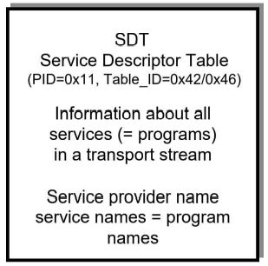

Figure 7.5-8e: Services Descriptor table (SDT)

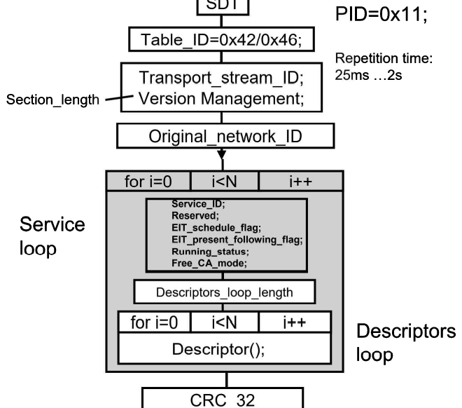

Figure 7.5-8f: Structure of the service descriptor table (SDT)

The service descriptor table (SDT) contains more detailed descriptors of the program carried in the transport stream, the services. Among other things, these are the program titles such as, e.g., CNN, CBS, Eurosport, ARD, ZDF, BBC, ITN etc. That is to say, in parallel with the program PIDs entered in the PAT, the SDT now contains textual information for the user. This is intended to facilitate the operation o the receiving device by providing lists of text.

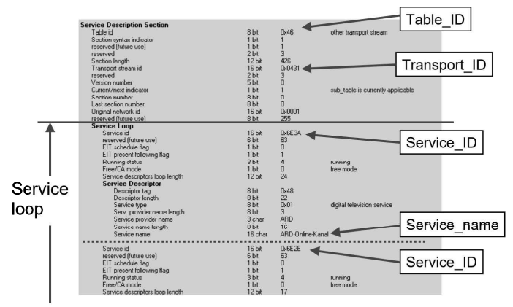

Figure 7.5-8g: Practical Example of an SDT

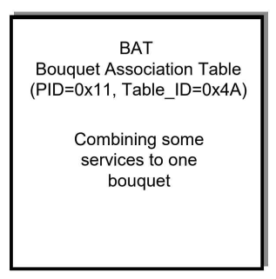

Figure 7.5-8h: Bouquet Association Table

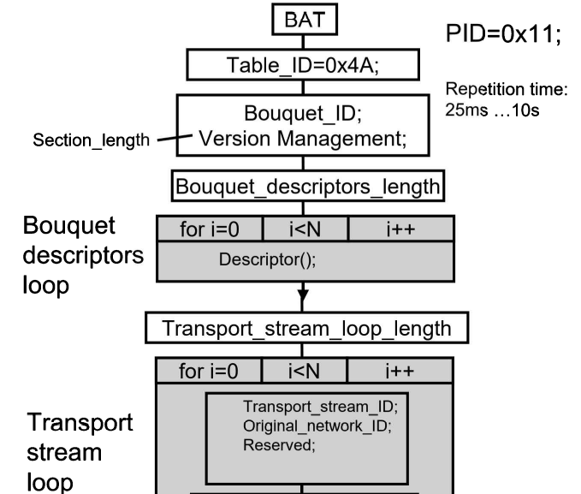

Figure 7.5-8i: Structure of a Bouquet Association Table (BAT)

A close relative of the service descriptor table is the bouquet association table (BAT). SDT and BAT have the same PID and differ only in the table ID. Whereas the SDT describes the program structure of several physical channels or of a large number of physical channels.

The BAT is thus nothing else than a multi-channel program table. It provides an overview of all services contained in a group. Program providers can make use of e.g., an entire bouquet of physical channels if a single channel is insufficient for transmitting the complete range of programs provided.

An example of this is the pay TV provider Sky. A handful of satellites or cable DVB channels are combined here to form a bouquet of this provider's channel. The associated BAT is transmitted in all individual channels and links this bouquet together.

in fact, however, a bouquet association table is found very rarely in a transport stream. Broadcasters in Germany, and premiere were broadcasting a BAT for their respective bouquet and sometimes a BAT can be found in networks of cable network providers.

But frequently, the BAT doesn't exist at all, as already mentioned. When it does exist, it tells by way of so-called linkage descriptors which service of a particular service ID can be found in which transport streams.

Many providers are also transmitting an electronic program guide (EPG) which has its own table in DVB, the so-called event information table, or EIT for short (Figure 7.5-8i and 7.5-8j). It contains the planned starting and stopping times of all broadcasts of, e.g., one day or one week. The structure which is possible here is very flexible and also allows any amount of additional information to be transmitted. Unfortunately, it is true that this feature is not supported by all TV receivers, or only inadequately so.

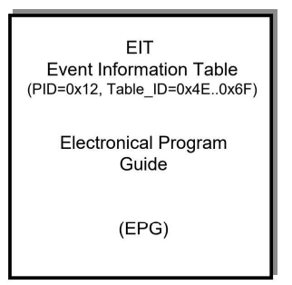

Figure 7.5-8j: EIT

Frequently, however, there are variations and delays in the planned starting and stopping times of broadcasts. To be able to start and stop, e.g., a video recorder at a given time, the relevant control information is transmitted in the running status table (RST). The RST can thus be compared to the VPS (video program system) signal in the data line of an analog TV signal. The RST is currently not being practiced, or, at least, has not been found by the author in a transport stream anywhere in the world, excepting synthetic transport streams. Instead, the data line containing the VPS has been adapted within DVB for controlling video recorders and similar recording media.

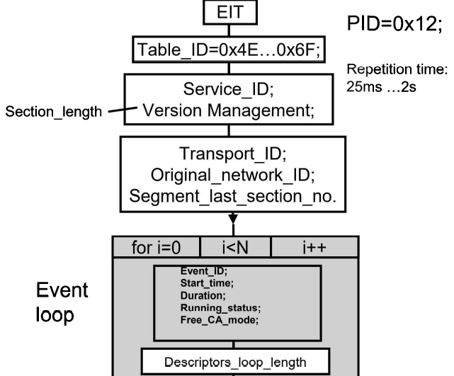

Figure 7.5-8k: Structure of the even information table EIT

The operation of the TV receiver also requires the transmission of the current clock time and the current date. This is done in two stages. In the time&date table (TDT) (Figure 7.5-8m and 7.5-8n), Greenwich mean time (GMT or UTC), i.e., the current clock time on the zero-degree meridian without any daylight-saving time shift is transmitted. The respective applicable time offsets can then be broadcast in a time offset table (TOT) (Figure 7.5-8m and 7.5-8n) for the various time zones. It depends on the software of the TV receiver how the information contained in the TDT, and TOT is evaluated, and to what extent. Complete support for this broadcast time information would require the TV receiver to be informed o its current location and, in a country, having a number of time zones such as Australia, especially, more attentions should be paid to this point.

It may sometimes be necessary to cancel certain information, especially tables in the transport stream. After a DVB-S signal has been received in a CATV head station, it can quite easily happen that, e.g., the NIT must be exchanged or overwritten or that individual programs must be rendered unusable for relaying. This can be done by means of the stuffing table (ST) (Figure 7.5-8o) which enables information in the transport stream to be overwritten. This happened especially at the beginning of the digital TV age.

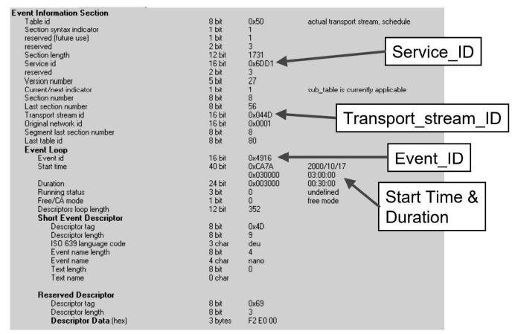

Figure 7.5-8l: Event Information Table (practical example)

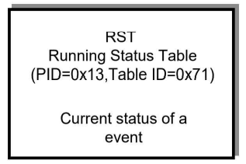

Figure 7.5-8m: Running Status Table (RST)

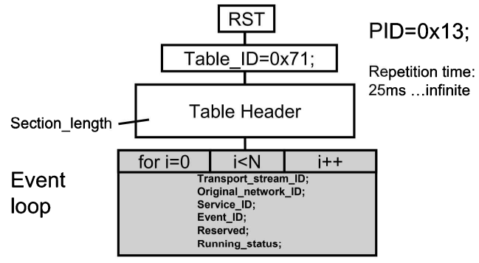

Figure 7.5-8n: Structure of the running table (RST)

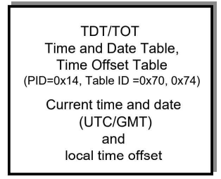

Figure 7.5-8o: Time and Date Table (TDT) and Time offset table (TOT)

The PIDs and the table IDs for the service information have been permanently allocated within DVB.

The PSI/SI tables are linked to one another via the most varied identifiers (Figure 7.5-8o). These are both PIDs and special, table-dependent identifiers. In the PAT, the PMT_PIDs are chained together by way of the prog_no. To each prog_no, a PMT_PID is allocated which refers to a transport stream packet with corresponding PMT of this associated program. The prog_no can then also be found in the header of the respective PMT. Prog_no = 0 is allocated to the NIT where the PID of the NIT can be found.

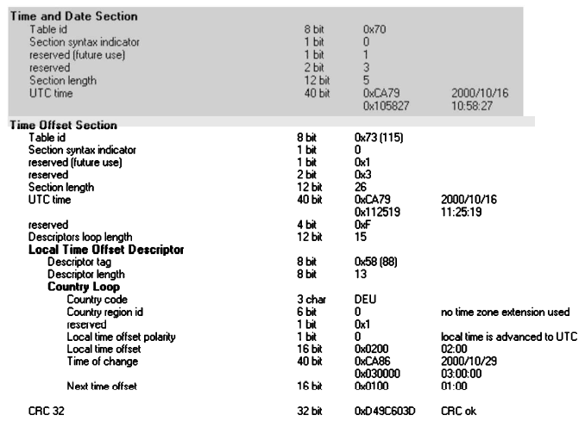

Figure 7.5-8p: Example of a time and date (TDT) and time offset table (TOT)

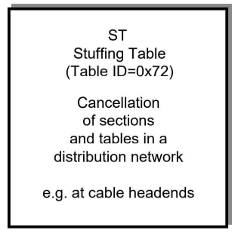

Figure 7.5-8q: Stuffing Table (ST)

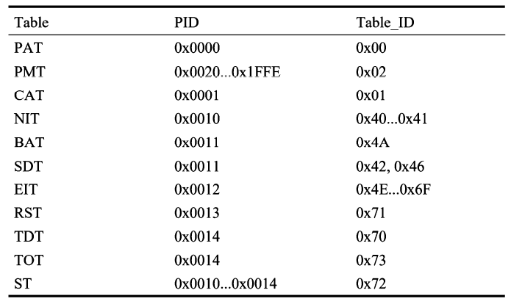

Table 7.5-8r: PIDs and table IDs of the PSI/IS tables

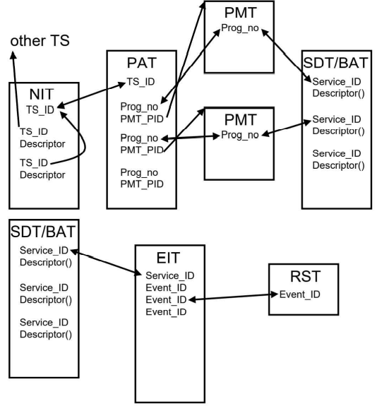

Figure 7.5-8s: Links between the PSI/SI tables

In the NIT, the physical parameters of all transport streams of a network are described via their TS_IDs. A TS_ID corresponds to the current transport stream; precisely this TS_ID can be found in the header of the PAT at the position of the table ID extension.

The services (= programs) contained in this transport stream are listed in the service descriptor table via the service IDs. The service IDs must correspond to the prog_no in the PAT and in the PMTs.

This is continued in the EIT: there is an EIT for every service. In the header of the EIT, the table_ID_extension corresponds to the service_ID of the associated program. In the EIT, the events are associated with these by way of event_IDs. if there are associated RSTs, then these are chained to the respective RST via these event_IDs.

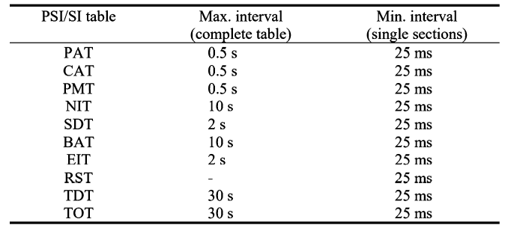

Table 7.5-8t: Repetition rates of the PSI/SI table according to MPEG/DVB

The repetition rates of the PSI/SI tables are regulated through MPEG-2 systems [ISO&IEC 13818/1] and DVB/SI [ETS 300468 (table 7.5-8s)

## 7.6 Asynchronous Serial Transport Stream Interface (TS-ASI)

The asynchronous serial transport stream interface (Figure 7.6a) has a constant data rate of 270 Mbit/s and can transmit (8-bit) data bytes at up to 27 MB/s. Due to the fixed 270 Mbit/s data rate of this interface, it is not in sync with the actual MPE-2 transport stream.

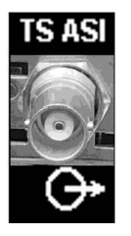

Figure 7.6a: TS-ASI connector (75 Ohms, BNC)

However, the advantage is that TS-ASI can use the same distribution system as SDI. Each byte is complemented with two additional bits based on a standardized table. They serve on the one hand to identify the data bytes (dummy bytes) used to fill up the 27 MB/s data rate, and, on the other handle, to prevent a DC voltage component in the serial signal.

The connector used is a 75-Ohm BNC socket with a level of 800 mVpp (+- 10 %).

The TS-ASI interface can be operated in two modes: burst- or single byte mode (Figure 7.6b). om the burst, the TS packets remain unchanged and dummy packets are inserted to reach the 270 Mbit/s data rate, which in single-byte mode, dummy bytes are inserted as padding to reach the 270 Mbit/s output data rate.

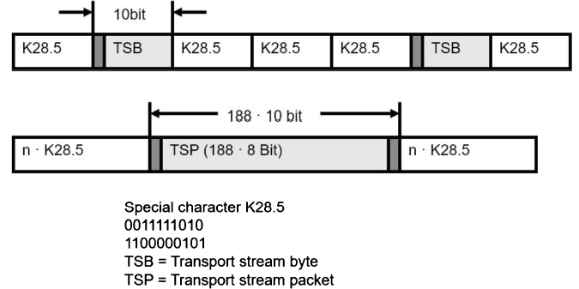

Figure 7.6b: TS-ASI in single-byte mode (top) and burst mode (bottom)

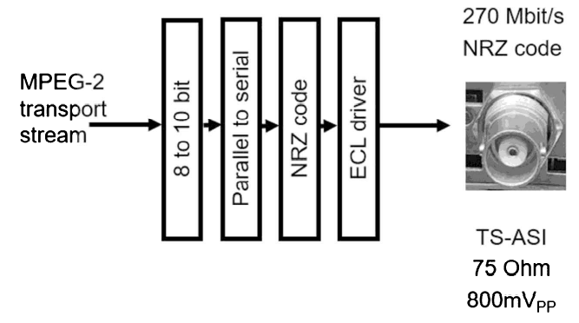

Figure 7.6c: TS-ASI interface, block diagram (no scrambler, NRZ code, ECL level)

## 7.7 DVB-IP interface

In an increasing number of applications, the TS-ASI interface that handles the MPEG-2 transport stream is replaced by the Gigabit Ethernet interface (CAT6 cable, RJ45 connector). This DVB-IP interface will completely supplant the TS-ASI in the medium term. It can be used to distribute multiple transport streams over a single interface, with stream addressing based on sockets (known from the PC world), which consist of a port number and an IP address.

## 7.8 Single-Frequency Networks in DVB-T in practice

Single-frequency networks (SFN) are special broadcasting networks. They must

* Be frequency-synchronous,
* Time-synchronous,
* Data-synchronous
* Meet the guard interval requirements.

To ensure that these preconditions are met in practice, they must also be measured and monitored during both commissioning and later in operation. Numerous hands-on measurements and insights in this field, initially far away from Europe, in Australia, and later mostly in the network of the Bayerischer Rundfunk, have led to writing this section. These insights are also applicable to single frequency networks of other standards, such as DVB-T2, ISDB-T, or DTMB. The first step is to plan the SFN appropriately based on the topographic and geographic structure. The transmitter spacing must not violate the guard interval condition. The transmitter spacing must not violate the guard interval condition, i.e., the distance between the transmitters must not exceed a certain maximum range. If this condition is not met, it can be cured by shifting the transmitters relative to each other by the delayed or premature transmission of the COFDM signal (static delay). This guarantees proper reception in areas where otherwise the difference between the signal paths would exceed the guard interval. This kind of shifting of the transmitters, however, may cause problems in other areas. Of course, the antenna pattern also plays a role. An SFB can be modeled by narrowing, i.e., decreasing the transmitted power in a direction. Most of the phenomena discussed in this chapter use the example of DVB-T and apply to other standards that use OFDM modulation, such as DAB or ISDB-T, and DVB-T2 as well. When referring to receivers in this section, the term initially meant external devices in most cases; these were also called set top boxes because they were often placed on top of the TV. Today, the DVB-T receivers are integrated into the flat screen sets – and nothing can be put on top of them as anything would fall off.

### 7.8-1 SFN measurement parameters

Let us first see which measurement parameters must be recorded in a DVB-T single-frequency network. Of course, the relationships valid for the SFN coverage measurements can also be applied to the special case of an SFN, namely an MFN (Multi Frequency Network). There, each transmitter operates alone on its own frequency. In contrast to the SFN, the receiver expects a single signal path from the transmitter, and eventually the right echo paths. Propagation time differences in an MFN are about 1 to 10 us instead of up to 200 us in SFNs. The parameters to be measured in the field are:

* Level or field strength
* Modulation error ratio
* Bit error ratios
* Channel impulse response
* Constellation diagram (visual assessment)

Naturally, the most important test parameter is firstly the signal level or field strength present on site. The signal level is measured as the output signal of a known test antenna. Its k factor or antenna gain can then be used for calculating the field strength. The formula for this is:

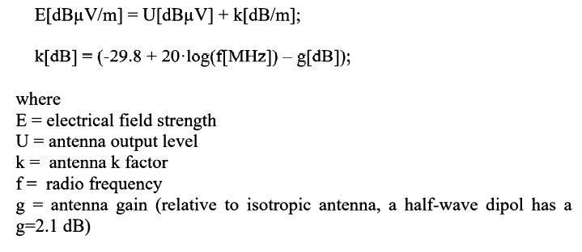

Figure 7.8-1a: Field Strength

The required minimum receiver input level depends on the selected modulation parameters and on the quality of the receiver.

In reality, the implementation losses must be added to this and these, in turn, depend on the chosen receiving situation. There are ultimately four receiving situations which are:

* Reception by fixed outdoor antenna
* Reception by portable outdoor antenna
* Mobile by portable indoor antenna
* Mobile reception

With reception by fixed outdoor antenna, the antenna gains of about 6 to 12 dB are added to this and ensures that correspondingly less field strength is required. Field strength is here defined at a corresponding height above ground, in most cases 10 m, and the measurements are therefore also taken under these conditions (mast, 10 m, directional antenna). However, it is advisable also to take into consideration the line losses etc. To the receiver (e.g., 6 dB) and to include these in the calculations. With reception by portable outdoor antenna there is no antenna gain. The reception situation to be considered is then 0 dB antenna gain and e.g., 2 m above ground. With indoor reception, attenuation losses of the walls and windows of up to about 20 dB must be added. Concrete buildings with metallized windows produce especially high attenuation. Polarization losses of 5 to 15 dB are another factor to be considered. Reception with a vertical rod antenna in a horizontally polarized DVB-T network, e.g., leads to a loss of about 15 dB. Portable indoor reception covers a very wide range with respect to minimum field strength. The antenna gain may also exhibit negative values. The most difficult case is mobile reception, DVB-T being a system which was originally not designed for this purpose. The time interleaver value is very short. Although the mobile field strength values measured do not differ from the stationary ones, the doppler effect plays a very large role and the changing receiving situations play havoc with the receiver. The signal to noise ratio (SNR) and the modulation error ratio (MER) differs greatly under mobile and stationary conditions and depend on location. The MER is the aggregate parameter in which all interference effects on the DVB-T reception can be mapped.

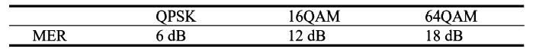

Table 7.8-1b: Minimum required MER at code rate = 2/3

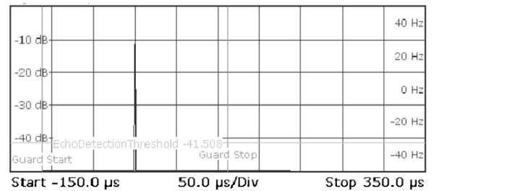

Figure 7.8-1c: Channel impulse response with one signal path

It is important to know that, as a simple fact of physics, the MET measured under mobile conditions can never correspond even approximately to that measured under stationary conditions. The MER is always, and also in every standard, a function of the speed of travel and of the multi-path reception conditions. The same also applies to the bit error ratios (BER). These are also not only dependent on the received level but can be derived directly from the MER. The minimum required BER before Reed Solomon or after Viterbi with quasi error free DVB-T reception is 2.10-4. There are three-bit error ratios in DVB-t:

* BER before Viterbi, or the channel bit error rate ratio
* BER after Viterbi or before Reed Solomon
* BER after Reed Solomon

It makes sense to measure all three BERs during the field test. The engineer obtains appropriate information especially from the BER after Viterbi, I.e., before Reed Solomon. Naturally, the measurement of the BERs in mobile operation will also result in quite different values in comparison with stationary measurements. The test results also depend on where in the SFN one is moving, the reason again being simply the effect of Doppler on the multipath reception in the various regions of reception. The channel impulse response (Figure 7.8-1c and Figure 7.8-1d) provided reliable information about the multi-path receiving conditions in the various regions in the SFN. It also tells one whether an SFN is running synchronously or not. In addition, the channel impulse response can be used for estimating whether the receiving situation could represent critical states with respect to synchronization to symbol and guard interval. Critical states are:

* Violation of the guard interval
* The pre-echo
* The 0-dB echo
* The quasi mobile receiving situation
* Radiation of different TPS bits

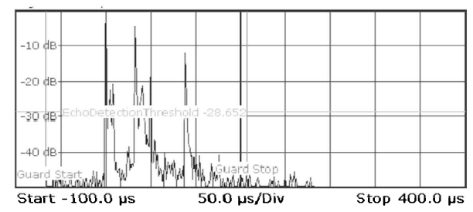

Figure 7.8-1d: Channel impulse response with multi-path reception with post-echoes

#### 7.8-1-1 Guard Interval Violation

The guard interval violation, among the critical receiving states, is the simplest to explain and is considered to constitute an absolute infringement of the SFN conditions. It simply involves the reception of signal paths which are outside the guard interval and still have sufficient energy. Such a problem can arise when transmitters are spaced too far apart, and delays have been selected wrongly or unfortunately at the transmitter sites, or simply with propagation overshoots. The energy of such a signal path becomes critical if it passes from the attenuation with respect to the main path into the order of magnitude of minimum SNR or minimum MER (fall-off-the-cliff), depending on the selected transmission parameters.

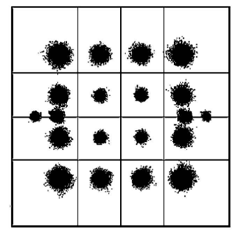

Figure 7.8-1-1a: Typical constellation diagram for a guard interval violation

This problem can be solved by a suitable choice of the delay times, i.e., the transmission times, of the CODFM symbols to the transmitter sites, by adapting the antenna patterns and the ERPs of the transmitters. In the case of a guard interval violation, a typical constellation diagram has larger constellation points outside than inside (Figure 7.8-1-1a)

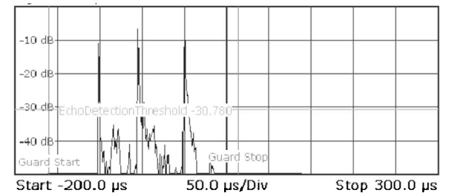

Figure 7.8-1-1b: Channel impulse response with pre-echoes

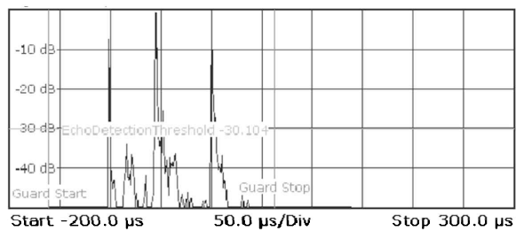

Figure 7.8-1-1c: Channel impulse response with pre-echoes

#### 7.8-1-2 Pre-echoes

Pre-echoes are signal paths in a single frequency network which appear with a lower level and earlier than the main path (Figure 7.8-1-1b). in theory, it should be possible for all receivers to handle this situation without any problem. In practice, however, it is found that many, mainly older DVB-T receivers cannot manage this. This also depends on the delay time between the 0-dB path, i.e., the main path, and the reduced pre-echo. The problem of the pre-echo can be explained simply by the fact that the receiver simply places the FFT sampling window symmetrically over the main path and thus pushes the pre-echo beyond the guard interval.

#### 7.8-1-3 The 0-dB Echo

It is called a 0-dB echo if 2 or more signal paths have the same level, but different delays appear at the receiver (Figure 7.8-1-1c). This can also lead to receiver synchronization problems, mainly in the case of longer delay differences from half the guard interval onward. In theory, a receiver should be able to cope also with this receiving situation without any problem. This problem, too, is explained by the receiver placing the FFT window so badly that one signal path is located outside the guard interval.

#### 7.8-1-4 Quasi mobile receiving situation

It is called a quasi-mobile receiving situation if the channel continuously changes due to continuously changing conditions of reflection. The behavior of a receiver in this situation depends on the characteristics of the channel correction of the receiver and, naturally, on the receiving situation. Quasi mobile receiving situations are encountered when e.g., there is no direct line of sight to the transmitters and the reception lives mainly from reflections, but these reflections are influenced by cars, trains, trams etc.

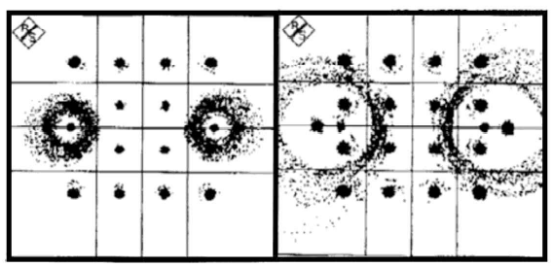

Figure 7.8-1.4a: Constellation diagrams in an SFN with differently transmitted TPS bits

#### 7.8-1-5 Transmission of non-identical TPS Bits

In DVB-T, a total of 67 bits are transmitted as so-called TPS (transmission parameter signaling) bits via 68 symbols. These bits represent a fast information channel from transmitter to receiver for conveying the transmission parameters. These transmission parameters are, among other things, modulation method, error protection etc. Apart from the TPS bits already defined originally in the DVB-T standard, there are the reserved bits, more and more of which are used, e.g., for cell ID and DVB-H.

A length indicator transmitted before the actual TPS payload bits tells how many of the reserved TPS bits are actually currently being used. It is important that all transmitters in an SFN transmit all TPS bits identically and completely synchronously. It has happened a number of times that transmitters in an SFN were configured differently and had transmitted length indicator and reserved bits differently. Depending on their location, the receivers which had then actually evaluated the TPS bits were unable to cope with the receiving situation and could not lock up. The TPS carriers work with DBPSK modulation, i.e., with differential BPSK modulation. The information is transferred in the difference from one symbol to the next. However, this means that from the point in time at which a TPS bit is transmitted differently than at other transmitter sites, the carrier vectors are pointing in the opposite direction and the DBPSK modulation no longer works, causing the circular distortions in the constellation diagram at the TPS points (see Figure 7.8-1-4a) it is strongly recommended always to have one or more test vehicles in the field for all changes being carried out in an SFN and to determine the situation also at the TPS carriers (e.g. carrier No 50).

#### 7.8-1-6 Frequency Accuracy of the Transmitters

It is important that all transmitters in an SFN transmit at the same frequency, as accurately as possible. The accuracy to be aimed for is 1.10-9 or better. The frequency accuracy can be easily verified with a suitable test receiver by measuring the impulse response. This provides a frequency accuracy of somewhat better than 0.5 Hz, a condition which normally can easily be met.

### 7.8-2 Practical Examples

The DVB-T single-frequency networks (SFNs) used as the example are DVB-T networks (but now running in DVB-T2) in the south of Germany, in Germany's largest federal state which has a geography of high (Alps) and low mountain ranges and includes the gentle foothills. This topography was of the greatest significance in the planning of the networks.

The southern Bavaria DVB-T network consists of the two transmitters, Olympic Tower Munich and Mt. Wendelstein. The Olympic Tower is a typical telecommunications tower to the North-West of Munich with a height of 292 m at about 450 m above sea level. It was originally used as a microwave tower for telephoning and was built in 1968. Microwaves have been largely replaced by optical fiber today and are no longer of the same significance as before. Thus, there are hardly any more microwave dishes in operation on the Olympic Tower. At the upper end of the Olympic Tower there are transmitting antennas for FM radio, DAB and now also for DVB-T.

The Mt. Wendelstein transmitter is located at about 1750 m above sea level on the mountain of the same name which has a total height of 1850 m. although it is not the highest mountain in Bavaria, or Germany, for that matter, it has certainly one of the most beautiful locations. Anyone who has been able to experience a sunrise or sunset there – which is something not many people are able to do because of the lack of a hotel at the top – will be able to confirm this.

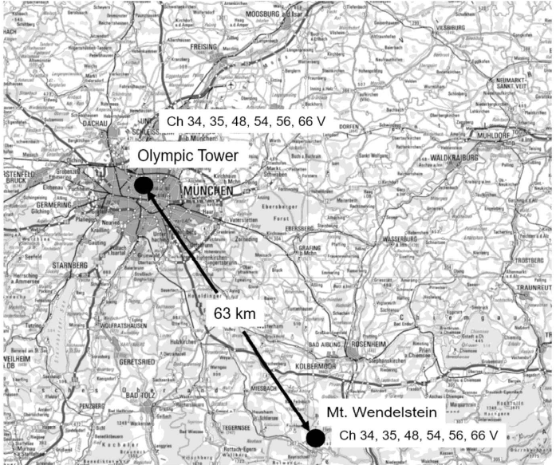

Figure 7.8-2a: DVB-T single frequency network Southern Bavaria (DTK500)

The Wendelstein transmitter belongs to the Bayerischer Rundfunk. The two Munich Olympic Tower and Wendelstein form the SFN Southern Bavaria which was taken into operation in the night of the 30th of May 2005. At the same time, this was the end of analog terrestrial television in Southern Bavaria. The Munich Olympic Tower and the Wendelstein transmitters broadcast 6 DVB-T channels completely synchronously on the same frequencies as DVB-T single frequency network. The data rates are about 14 Mbit/s each and each carry about 4 TV programs per data stream. Altogether, the viewer is thus provided with about 22 programs over terrestrial digital antenna TV. These TV programs, which are both public service programs and private programs, form a viable alternative to the satellite and cable media. The transmitting frequencies are now only located in the UHF band.

#### 7.8-2-1 Pre-echoes

The pre-echoes described occur mainly in regions in which the close path in terms of distance is attenuated more compared with the 0-dB path due to geographical obstacle (hills, mountains), in the region of the SFN Souther Bavaria described this occurs, e.g., to the North of the Munich airport in the vicinity of the course of the river Isar, where the Olympia Tower is shaded by hills and more distant Wendelstein transmitter thus dominates.

#### 7.8-2-2 The 0-dB Echoes

0-dB echoes occur whenever two or more paths appear with the same power level at the receiver due to the propagation conditions. In the SFN Souther Bavaria, such a situation occurs mainly in the region of the Erdinger Moos around Munich airport. It is very flat there and the Wendelstein and Olympia Tower transmitters are received partly with the same level, but with an extreme delay difference of about 140us.

#### 7.8-2-3 Quasi Mobile Channel

A quasi-mobile channel exists in regions where there is no direct line of sight to the transmitters. This is the case where the transmitters are shielded by obstacles and the reception survives with reflections partly from variable obstacles such as cars, trains or trams.

#### 7.8-2-4 TPS Bits

When SFNs are commissioned or re-organized, it may happen that not all transmitters (of on or of different manufacturers) are identically configured and that the transmitters thus transmit different TPS information. This occurred several times during the commissioning or conversion of the SFN.

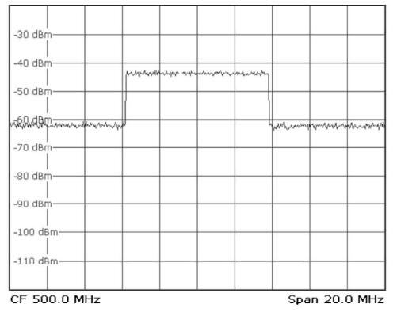

Figure 7.8-2-4a: Spectrum of a DVB-T signal in the AWGN channel

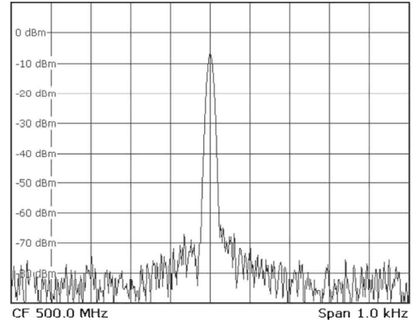

Figure 7.8-2-4b: Single CODFDM carrier in an AWGN channel

#### 7.8-2-5 Mobile DVB-T Reception

A question often asked is Up to what speed does DVB-T work? a question which is not easily answered. In principle, it must be said at this point that DVB-T was never intended for mobile reception and, therefore, does not have any characteristics especially provided for this purpose such as, e.g., a long time interleaver. Mobile reception depends mainly on the multi-path receiving situation. If only one signal path is received, mobile reception does not present a problem. The Doppler effect then only shifts the DVB-T spectrum in the direction of higher or lower frequencies, depending on whether one is moving toward the transmitter or away from it. At the usual travelling speeds, the frequency shift is the order of 50 to 100 Hz. This frequency shift does not present a problem for DVB-T receivers receiving one signal path. In the case of multi-path reception and Doppler shift, the problem is one of the spectrums smearing with all possible intermediate stages which will presented in examples in the following paragraphs.

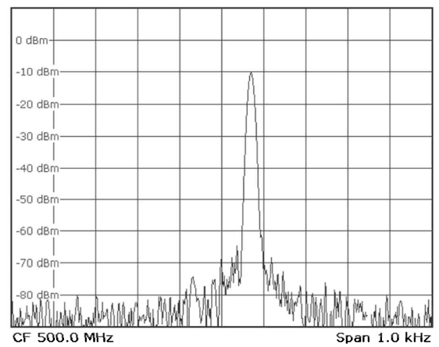

Figure 7.8-2-5a: Single Frequency-shifted DVB-T carrier in a mobile channel

##### 7.8-2-5-1 AWGN channel

In the AWGN channel, the carriers are only affected by noise, as shown in Figure 7.8-2-5-1a. the noise pedestal at about 20dB below the payload signal can be seen clearly at the shoulder.

The single COFDM carriers are at exactly the right frequency positions in the AWGN channel (Figure 7.8-2-4b). Each carrier is only affected by a greater or lesser noise fringe.

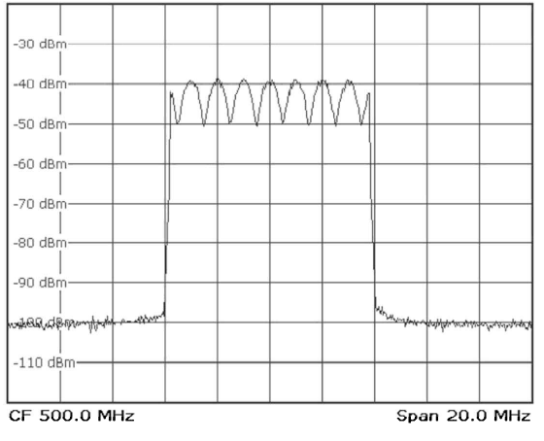

Figure 7.8-2-5-1a: Stationary multi-path reception of two signal paths

##### 7.8-2-5-2 Doppler Shift

During movement in the mobile channel, the complete DVB-T signal is frequently shifted (doppler effect). All single COFDM carriers are shifted towards higher or lower frequencies depending on whether one is moving towards the transmitter or away from Figure 7.8-2-5a. shows a single carrier, shifted by 70 Hz, of a DVB-T signal at a speed of 150 km/h moving towards the transmitter.

##### 7.8-2-5-3 Stationary Multi-path Reception

In the stationary multi-path reception, the only problem is fading. Depending on the difference in echo delay and echo attenuation, more or less deep dips occur in the signal spectrum as shown Figure 7.8-2-5-1a. the spacing of the dips corresponds to the inverse of the echo delay difference.

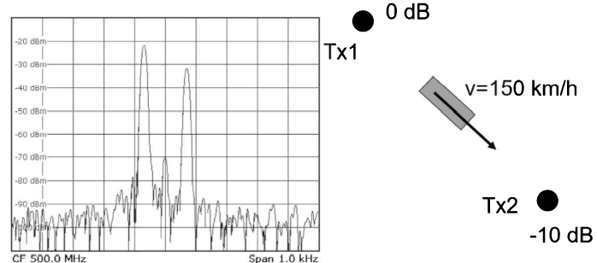

Figure 7.8-2-5-3a: Mobile multi-path reception of two signal paths

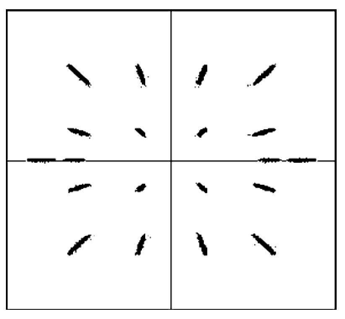

Figure 7.8-2-5-3b: DVB-T constellation diagram with unwanted amplitude modulation

##### 7.8-2-5-4 Mobile multi-path reception

In mobile multi-path reception, the DVB-T subcarriers are shifted simultaneously upwards and downwards in frequency (Figure 7.8-2-5-3a) or may not be shifted at all. Depending on the receiving conditions, this frequency smearing results in unwanted amplitude modulation of the DVB-T signal.

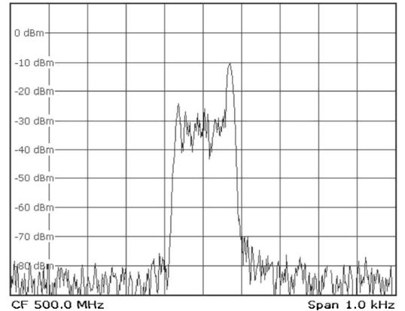

Figure 7.8-2-5-4a: Mobile Rice channel, v=150 km/h, power ratio = 10 dB

##### 7.8-2-5-5 Mobile Rice Channel

The model of the Rice channel simulates the case of multiple multi-path reception and dominant main path. Figure 7.8-2-5-4a. shows the spectrum of a single DVB-T carrier in the mobile Rice channel. The dominant main channel can be clearly seen at –10 dB.

##### 7.8-2-5-6 Rayleigh Channel

In the Rayleigh channel there is no longer a main path. It corresponds to the Rice channel with a power ratio = 0 dB. Figure 7.8-2.5.6a. shows an example of a single DVB-T carrier in the mobile Rayleigh channel at speed of 150 km/h.

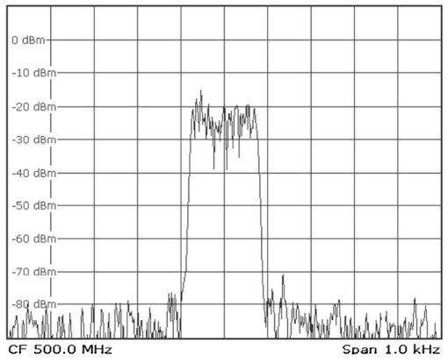

Figure 7.8-2-5-6a: Mobile Rice channel, v=150 km/h, power ratio = 10 dB

Comparable mobile situations can be created in a DVB-T receiver even by dried-out electrolytic capacitors in an antenna amplifier. Superimposed AC hum produced by these can create an unwanted amplitude modulation at 50 or 100 Hz. Figure 7.8-2-5-6b shows a corresponding constellation diagram.

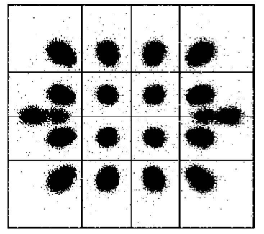

Figure 7.8-2-5-6b: Unwanted amplitude modulation caused by a broken

electrolytic capacitor in an antenna amplifier

### 7.8-3 Response of DVB-T Receivers

The response of DVB-T receivers in one or the older receiving situation is greatly dependent on the characteristics of the respective receiver, i.e., mainly on the characteristics of the installed tuner, the DVB-T chip, the MPEG decoder and the firmware of the receiver. In the next section, testing of the receiver will be discussed. The characteristics of the tuner can be differential as follows:

* Noise figure
* Phase noise
* RF and IF selectivity characteristics
* Linearity/intermodulation

The characteristics of the tuner essentially determine the minimum received level required and the adjacent-channel compatibility, especially with a high adjacent-channel level.

The DVB-T chip is mainly responsible for how well a receiver can handle different receiving situations such as:

* Pre-echo
* 0-dB echo
* Multi-path reception and quasi mobile reception
* Adjacent-channel occupancy
* TSP bits set differently
* Hierarchical modulation

The MPEG decoder and the firmware determine how the receiver responds to different transport stream contents. This relates to:

* The channel search (speed and characteristics under critical conditions
* The PSI/SI tables (e.g., response to dynamic PMT
* Response to network overlap (identical service in different TS)
* Decoding of the elementary stream
* Signaling of the source characteristics (mono/stereo)
* Error concealment
* Switching rate
* Stability
* Receiver configuration such as teletext, VPS, MHP

### 7.8-4 Receiver Test

The characteristics of TV receivers must be tested comprehensively, especially in terrestrial broadcasting in order to find out how well they are capable of handling the problem situations described in the previous sections. Receivers are tested in:

* The developments of receivers
* Production handover (EMI, EMC...)
* Receiver production for final testing
* Comparing receivers in test houses and at network operators

Experience has shown that DVB-T receivers especially have not been adequately stress tested. The maximum amount of tests should be performed at least during the receiver development, the production handover and the receiver comparison. These maximum tests are:

* Detecting the minimum receiver input level at some frequencies
* Detecting the minimum SNR at some frequencies
* The response at high adjacent-channel levels (close or more distant)
* The response with co-channel reception of analog TV
* The response of the receiver with network overlap
* Measuring the booting speed
* Measuring the switching speed
* Testing the teletext function
* Testing the VPS function
* Testing the response of dynamic PSI/SI tables
* Testing the firmware configuration and quality
* EMC tests
* Mechanical construction

The minimum tests in production must be suitably selected for the respective product by the manufacturer.

#### 7.8-4-1 Minimum Receiver input level in the AWGN channel

The minimum receiver input level should first be determined in the AWGN channel with different transmission (64QAM, 16QAM, QPSK, different code rates) at least 3 frequencies (one VHF and two UHF frequencies). The receiver is supplied with a signal path in this case. Starting with a level of about 50dBuV, this level is reduced until the visual and aural assessment of decoded video and audio shows that the receiver is no longer operating correctly. It is important that, when the precise point when the fall of the cliff occurs is determined, one always waits for a sufficiently long time (at least 1 minute) to see whether the receiver is really operating in a stable mode.

#### 7.8-4-2 Minimum SNR

Apart from determining the minimum receiver input level, it is of interest to determine the minimum signal/noise ratio in the AWGN channel. The results should then be compared with the minimum receiver input level measurement and discussed. These tests should also be performed at at least 3 frequencies, selecting, e.g., a sensible DVB-T receiver input level of 50 to 60 dBuV so that the receiver is neither supplied too poorly nor caused to go into attenuating mode. More and more noise is then added progressively until the fall off the cliff conditions is reached again. This, too, is then determined carefully as in 7.8-4-2.

#### 7.8-4-3 Adjacent-Channel Occupancy

In the adjacent-channel test, the response of a DVB-T receiver with a high adjacent-channel level is determined by placing an adjacent DVB-T channel below or above a payload channel. The level of the adjacent channel or channels is then increased more and more until no further reliable reception is possible. This test, too, is performed with different transmission parameters. The aim should be able to handle an adjacent-channel level which is at least 20 dB above the useful level. Such conditions could easily arise, especially with a mixed DVB-T/DVB-H/DAB scenario. This test should also be performed at 3 frequencies, at the least.

#### 7.8-4-4 Co-channel reception

Checking the co-channel reception of DVB-T with DVB-T is essentially already done since a non-synchronous DVB-T interference signal virtually looks like noise. Testing with analog TV in the co-channel, however, is definitely a noteworthy measurement but depends greatly on the ATV image content chosen.

#### 7.8-4-5 multi-path reception

In the multi-path reception test, the receiver is presented with a situation which can occur in real life in an MFN, using a test transmitter with a channel simulator (fading simulator)/

#### 7.8-4-6 Channel Search

Testing the channel search function of a receiver mainly tests the search rate and the search action under different conditions (incl. Adjacent channel occupancy). The test should also involve checking the performance of a receiver with wrong NIT entries. This also includes its performance in the case of network overlaps, i.e., when receiving the same services from different transport streams. This occurs in regions where the receiver is seeing two or more networks, i.e., at the edges of SFNs.

#### 7.8-4-7 Booting Speed and Action

In the world of computers, booting is known to be the initialization of a computer. Since a DVB-T receiver is also nothing else than a computer, it takes a certain time until it is ready for operation and a user will be interested to know how long this will take and how it takes place.

#### 7.8-4-8 Program Change

Users find it particularly bothersome if a program change takes a long time and is untidy. This test checks the receiver's reaction to zapping.

#### 7.8-4-9 Teletext

DVB provides for the tunneling of teletext via private PES packets and this is done mainly by the program providers operating under public law. In this arrangement, teletext is gated back into the vertical blanking interval of the video signal by the receiver at the analog output interface (SCART or cinch connector). A TV receiver connected there can then decode this teletext. It is also possible for the DVB-T receiver itself to decode the teletext and to output it as frame signal, storing a number of pages in its buffer. The teletext modes supported by a receiver, either gated into the vertical blanking interval or self-decoded, are a criterion for testing and comparing receivers.

#### 7.8-4-10 VPS Functions

In data line 16 in the vertical blanking interval of the analog TV signal, the VPS information for controlling video recorders has hitherto been transmitted, among other items. This signal, too, can be tunneled in DVB in private PES packets in the MPEG-2 data stream and used directly in the receiver (hard desk receiver) and/or gated back in line 16 at the CCVS interface. A video recorder connected there can then respond to this signal and control the recording. These functions, too, must be covered in a receiver comparison test.

#### 7.8-4-3-11 Dynamic PSI/SI tables

Dynamic PSI/SI tables means the change of these tables with time. EIT and TOT/TDT are clearly always dynamic but there are also so-called window programs which are transmitted only at particular time of the day and are signaled by changing PMTs, so-called dynamic PMTs. A change in the PMT is not recognized by all receivers, which is why the response to changes in PAT, PMTs and the SDT should be tested.

#### 7.8-4-12 Firmware Configuration

The way in which a DVB receiver can be operated and how especially the electronic program guide is handled depends on the firmware installed in the receiver. This is another matter to which attention should be paid in a receiver comparison test.

#### 7.8-4-13 Miscellaneous

Naturally, the receiver test also includes adherence to the EMC regulations, but this will not be discussed in greater detail at this point. As well, an assessment of the mechanical construction of the receiver case is of importance in a comparison of receiver in test establishments but this again will not be discussed any further here.

### 7.8-5 Network Planning

Naturally, network expansion is preceded by planning which today is done with the support of software tools. This involves simulation and determination of the network data such as antenna patterns, transmitter power, error protection. Guard interval, delays etc. and calculation of the coverage of the regions on the basis of geographical, topographical and morphological data and with knowledge of the possible transmitter sites. Firstly, the frequencies and powers, direction of radiation etc. are assigned by the regulatory authorities. In border regions this requires international coordination. Example of planning tools in the German-speaking area are:

* Tools by the Deutsche Telekom
* Tools by the Institut Fur Rundfunktechnik (IRT)
* Tools by the company LStelcom

The software CHIRplus_BC by the company LStelcom (Lichtenau near Baden-Baden, Germany), in particular, is encountered throughout the world. By now, the author also has gained the experience that with the appropriate use of planning tools, the problem areas described above for receivers (0-dB, pre-echoes) can be unambiguously identified, e.g., by clicking on corresponding buttons in the planning software.

### 7.8-6 Filling the Gaps in the coverage

Even in the days of analog television, gaps in the coverage were normally filled by so-called gap fillers, called translators. In analog television, alternative channels with guard band without adjacent channels being occupied were selected which supply a signal received from a master transmitter for covering a limited region. In this set-up, TV signals of a master transmitter, received by rebroadcasting reception, were translated into another TV channel and then retransmitted via a transmitted, thus covering a region which was otherwise shaded. In digital terrestrial television it is first assumed that many areas are automatically covered by the characteristics of digital television. Nevertheless, depending on the required coverage which, in turn, is dependent on the country concerned, additional gap fillers cannot be avoided. This is because, in analog television, reflections have not only led to reception not being possible at all, but in moderate cases have simply caused unsightly ghost images. There are no longer any ghost images in digital television and, because of COFDM, neither do echoes present problems to the same extent as in analog television. In theory, a COFDM system should be able to handle such a situation quite easily, of course. But if the received field strength is too low because of shading, such regions must still be covered by gap fillers even with digital terrestrial television. In digital television, these gap fillers can be operated both at the same frequency and at other frequencies. In analog television, these transmitters had to be operated at other frequencies. There are:

* Transmitters transmitting at the same frequency (gap fillers, SFN)
* Frequency-converting transmitters (transposers, MFN)
* Frequency-converting transmitters with remodulation (retransmitter, MFN)

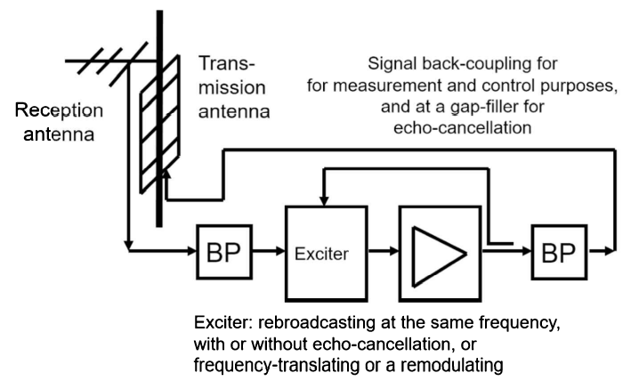

Figure 7.8-6a: Principle of a gap-filler or translator

To fill gaps in the coverage of SFNs, only gap fillers are used. In these transmitters transmitting at the same frequency, remodulation is impossible since going back to data stream level (demodulating) and remodulating would involve too much delay. This is why in this case the approach of downcoverting to a low intermediate frequency and upconverting again to RF and amplifying was adopted. It is important here that the receiving and transmitting antenna must be sufficiently well decoupled. Up to a certain extent, an equalizer can be of assistance here in providing echo cancellation.

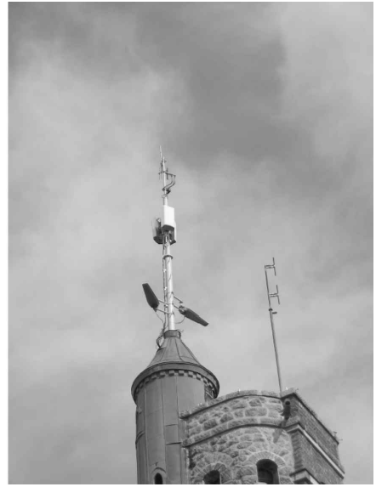

Figure 7.8-6b: Practical example of a translator or gap filler site

Apart from the transmitting antenna and the receiving antenna being sufficiently well decoupled, the correct orientation of the receiving antenna is also of great importance. If possible, only one signal path, and not several as in multi-path situation, should pre-echo situation or a 0dB echo path be radiated since this will lead to problems in many receivers as is well known. Otherwise, receiver problems are created not only over a small area at some locations but over a large area in the gap-filling region and possibly beyond. In the case of a frequency-converting transmitter, the approach via the IF can be selected as in the case of the gap filler, or one can choose a remodulation process. Remodulation is more expensive and means delay, of course. This is also the reason why remodulation is not possible in the gap filler because otherwise the SFN timing would be violated completely. However, remodulation is more stable and, above all, results in better signal quality. When the transmitter powers are greater, however, the recommended approach is always that of remodulation or of using the retransmitter, respectively.

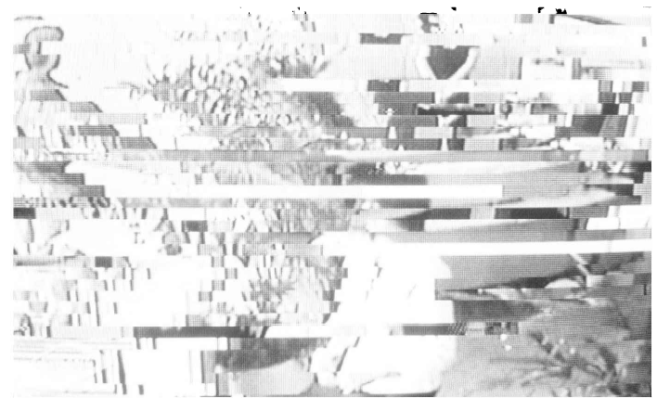

Figure 7.8-6c: Fall-off-the-cliff

### 7.8-7 Fall-off-the-cliff

Blocking artifacts caused by the compression are too often mistaken for artifacts caused by the transmission link. An image of the output of a receiver which, due to bit errors, has been brought to the limit of decodability, i.e., the fall-off-the-cliff state, looks quite different from an image which has been rendered unsightly due to too much MPEG compression. In the case of bit errors, entire slices are missing within a line.

### 7.8-8 Summary

The empirical values described in this chapter on the basis of DVB-T can also be applied to other terrestrial transmission standards. The differences to DAB, ISDB-T, DVB-T2 and other standards lie in the details of error correction and modulation, but the principle always remains the same. So, while this chapter focuses on DVB-T based on the author's experience, the principles are not limited to DVB-T. This section presented experiences and problems of real networks in the hope that these experiences will help to identify and resolve most real-world problems and dispel the fear from the new digital television. Digital television is different from its analog counterpart, but not more mysterious if one has the experience.

## 7.9 MPEG-2 transport stream – TS

An MPEG-2 transport stream consists of packets having a constant length of 188 bytes (Figure 7.9). The packet itself is divided into a header component of 4 bytes length and a payload component of 184 bytes. The first byte of the header is the sync byte which has a constant value of 0x47. The next three bytes in the header are used for signalling important transport parameters.

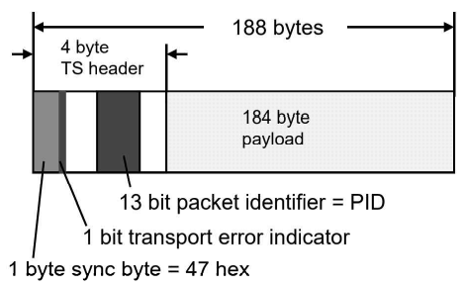

Figure 7.9: MPEG-2 Transport Stream (TS)

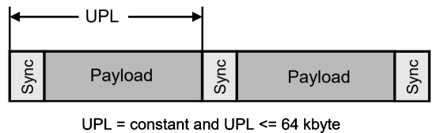

Figure 7.9a: Generic Fixed Packetized Stream (GFPS)

### 7.9-1 Generic Fixed Packetized Streams – GFPS

Generic Fixed Packetized Streams (GFPS) are data streams which have a packet structure and the packet length of which is known and is constant (Figure 7.9-1a). The beginning of a packet is marked with a special sync byte. An example of a relevant application would be ARM data signals with a constant length of 53 bytes. The length of a GFPS must not exceed 64 Kbytes for else it would be a Generic Continuous Stream – a GCE.

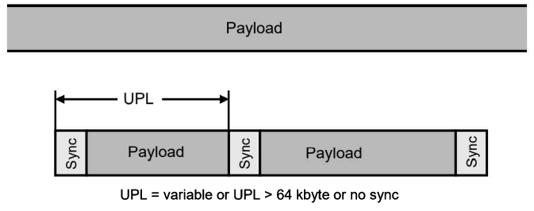

Figure 7.9-1a: Generic Continuous Stream (GCS)

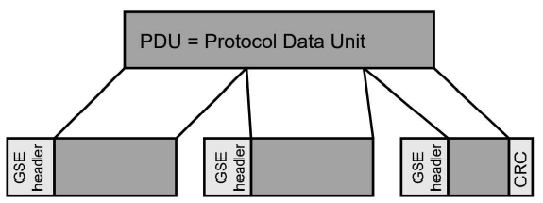

Figure 7.9-1b: Generic Continuous Stream – GCS

### 7.9-2 Generic Continuous Streams – GCS

Generic Continuous Streams (GCS) do not have any packet structure (Figure 7.9-1a). Thus, the modulator interface does not recognize any boundaries in the data stream. Generic continuous streams are the most generalized form of data streams. Generic continuous streams are also data streams which have a packet structure which doesn't differ from that of GFPS but the packet length of which varies or is longer than 64 Kbytes.

### 7.9-3 Generic Encapsulated Streams – GSE

Generic Encapsulate Streams (GSE) have a packet structure the packet length of which varies. The beginning of the packet is provided with a special GSE header as defined in the DVB GSE standard [TS102606]. The user data packet is prefixed by a GSE header in the GSE header in the GSE encapsulator and a CRC is formed over the entire data packet, which CRC is then appended. The user data packets can also be divided into a number of packets where each packet starts with a GSE header (Figure 7.9-1b). This type of data did not yet exist at the time when DVB-S2 became standard.

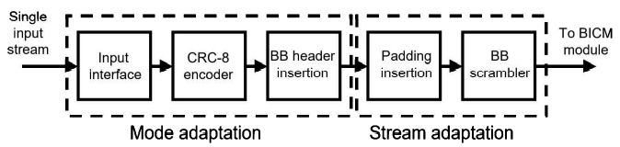

Figure 7.9-3a: Input Processing with a single input stream

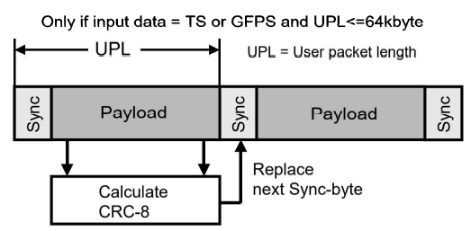

Figure 7.9-3b: CRC-8 encoding

## 7.10 DVB-T2

DVB-T2, the Second Generation Digital Terrestrial Video Broadcasting norm [DVB A122r1], [ETSI EN 302744] is a completely new DVB-T standard. Like its predecessor, the BBC was the driving force behind the development of DVB-T2. The purpose was to force the UK to implement HDTV coverage together with MPEG-4 source coding. DVB-T2 was initially intended to increase the net data rate by at least 30 to 50 percent relative to DVB-T (1). In fact, nowadays these original goals can be exceeded.

#### 7.10-1 Introduction

Similarly, to DVB-T (1), DVB-T2 uses the COFDM modulation method, but with modified and extended constellation diagrams. Outer forward error correction is provided by BCH coding, as in DVB-S2, while LDPC coding and subsequent bit interleaving are applied as inner forward error correction.

The complete FEC frame structure corresponds to that of DVB-S2. LDPC coding has been known since the 1960s (Low Density Parity Check Codes) but requires huge calculation power in the receiver and has become viable only since about 2002, due to current chip technologies. From spring 2006 to March 2008, seven multi-day DVB-T2 meetings took place. The one held in May a preliminary 2008, adopted a preliminary paper that was published by the ETSI in May 2008 as a draft, and later elevated to standard. In autumn 2008 the implementation guidelines and the T2 modulator interface (T2-MI) were published. For many countries, DVB-T2 came too early or too late, depending on how it is viewed, because these countries had already introduced DVB-T and a switch to DVB-T2 at the time of publication would not have been appropriate or would have found no acceptance. In 2010, the first DVB-T2 networks were put into operation in the UK, followed by Italy and many field trials. As of 2010, only DVB-T2 networks (with the exception of ISDB-T networks in many countries in South America or DTMB networks in China) went into operation, e.g., in South Africa, Russia, or latest in Germany in 2017. In many countries, the switch from DVB-T (1) to DVB-T2 is imminent. The DVB-T2 rollout scenarios can be divided into:

* Countries that are already operating DVB-T (1) with demand for more data rate
* Countries that still operate fully analog television

#### 7.10-2 Theoretical Maximum Channel Capacity

However, before discussing the DVB-T2-standard in detail, the theoretical limits of the terrestrial transmission channel will first be considered on the basis of an 8-Mhz-wide channel, looking at various receiving conditions from portable indoor antenna to fixed outdoor antenna, with characteristics known from DVB-T. The maximum possible data rate in theory is expressed in approximation by the Shannon-limit via the following formula if the signal-to-noise ratio is about or more than 10 dB.

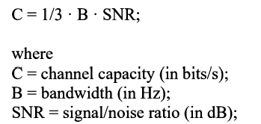

Figure 7.10-2a: Signal to noise ratio

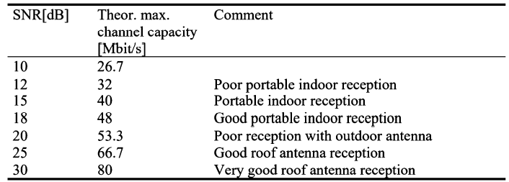

Table 7.10-2b: Theoretical maximum channel capacity of an 8-Mhz-wide TV channel

In DVB-T, the data rates in an 8-Mhz channel in DVB-T networks designed for portable indoor-reception are frequently about.



And in DVB-T networks designed for roof antenna reception they are in most cases about



The aim in DVB-T2 is to achieve data rates which are higher by at least 30 to 50% without familiarity with the DVB-T2 standard, it can thus be expected that, given comparable conditions, the following data rates can be achieved:

* Portable indoor reception (SFN, long guard interval): 17.3 to 19.9 Mbit/s
* Roof antenna reception (SFN, long guard interval): 29.1 to 33.6 Mbit/s

The error protection alone will bring 30%. Additional features such as:

* 16K- and 32K-mode
* Extended carrier mode
* 256QAM modulation
* Flexible Pilot Pattern

Will bring further improvements in the data rate.

#### 7.10-3 DVB-T2- Overview

The essential core parameters of DVB-T2 are:

* Several MPEG-2 transport stream input or possibly generic streams as baseband signals (up to 255)
* Approx. At least 30% higher net data rate mainly due to the improved BCH+LPDC error protection already used in DVB-S2
* Compatibility with the Geneva 2007 Frequency Plan (8m 7m 6 MHz bandwidth)
* Additional bandwidths 1.7 MHz and 10 MHz
* Stationery, but also mobile applications
* COFDM
* 1K, 2K, 4K, 8K, 16K and 32-Mode
* Guard interval ¼, 1/8, 1/16, 1/32. 19/256 and 1/128
* Modulation scheme QPSK, 16QAM, 64QAM and 256QAM
* Q-delayed rotated constellation diagram
* RF frame-structure with P1 and P2-symbol at the beginning of frame
* Flexible pilot structure with fixed and distributed pilots
* PAPR reduction (Peak to Average Power Ratio) reduction, i.e., reduction of the crest-factor (2 different methods)
* Variable coding and modulation (the transmission parameters can be changed in operation)
* Time interleaving
* Time slicing
* Optional MISO-principle (Multiple input, single output)
* Inbuilt FEFs (Future Extension Frames) for later extensions
* Auxiliary data streams as an option
* Time frequency slicing (TPS) mentioned in the Appendix of the standard

The details of DVB-T2 will now be discussed in the following sections.

#### 7.10-4 Baseband Interface

The DVB-T2 baseband interface handles one or more data input. DVB-T2 is not any more restricted to transfer only MPEG-2 transport streams, it also provides for so-called generic streams as possible input formats, being able to handle a maximum of 255 input streams. The place where these streams are to be multiplexed was initially undecided. The answer came with the T2-MI standard, the modulator interface for DVB-T2 (Figure 7.10-4a). Multiplexing is performed in the headend or in multiplex center, with the DVB-T2 modulator being fed a single data stream via DVB-T2-MI. This data stream, similarly, to the ETI stream in DAB, contains all the information necessary for the modulator (L1 signaling): it contain all PLP baseband frame data, besides the time stamp for synchronizing single frequency networks. The baseband interface has already been discussed.

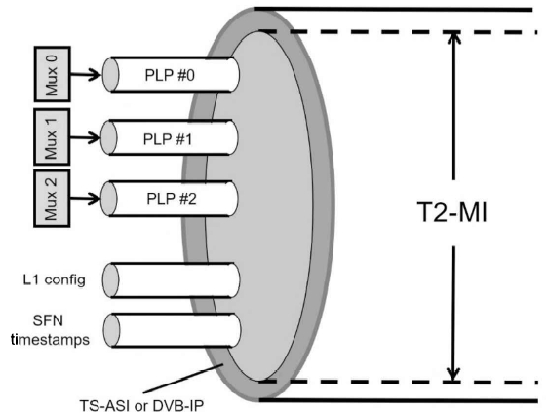

Figure 7.10-4a: The T2-MI interface protocol

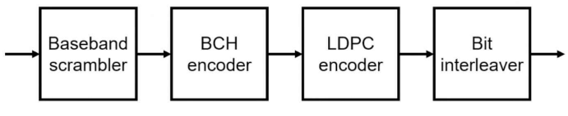

Figure 7.10-4b: DVB-T2 error protection (BCH stands for Bose-Chaudhuri Hocquenghem)

DVB-T2 has two modes: Mode A (Single PLP) and Mode B (Multiple PLPs). Only in Mode A are all the processing steps performed in the modulator itself; in Mode B, the T2-MI interface is right after the scheduler.

In Mode B, variable Coding and Modulation (VCM) can be used from PLP to PLP, and this can also be done dynamically, i.e., the transmission parameters for the next DVB-T2 frame may change, and this must be signaled dynamically. This is done in the Padding Field of the baseband header. There is also an optional common PLP containing information for several or all PLPs. Mode B can be operated in:

* HEM (High Efficiency Mode), in case of transferring MPEG-2 Transport Streams or GSEs, and
* NM (Normal Mode), which is compatible with DVB-S2

For further details on signal processing in the baseband interface, refer to Baseband Signal for DVB-X2.

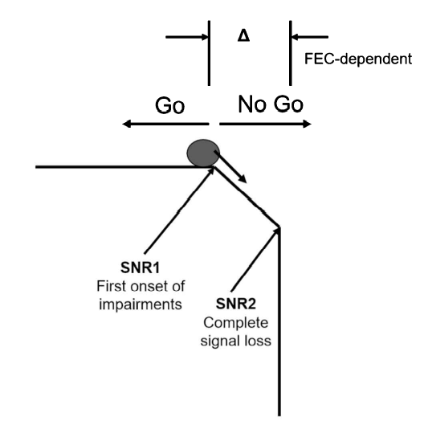

Figure 7.10-4c: Fall-off-the-cliff

#### 7.10-5 Forward Error Correction

The improved forward error correction (Figure 7.10-4b) results in an SNR gain, as in DVB-S2. All in all, the system gets closer to the Shannon limit with such an improvement. This measure alone increases the net data rate by 30 percent. Similarly, to DVB-S2, error protection in DVB-T2 consists of a baseband scrambler, a BCH block coder, an LDPC block coder, and subsequent bit interleaver. The DVB-T2 modulator first randomizes (baseband scrambler) the baseband frame, including the baseband header and the padding block, and then feeds this frame to the FEC block where the BCH code is added as a first step. Subsequently, the LPDC coder appends a further error protection with a length depending on the code rate selected. The selectable code rates are the following:

* ½ (highest)
* 3/5
* 2/3
* ¾
* 4/5
* 5/6 (lowest)

Code rate ½ means maximum error protection and minimum net data rate, which code rate 5/6 corresponds to minimum error protection and maximum data rate.

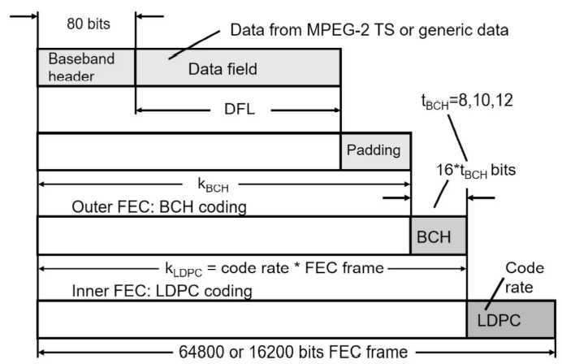

Figure 7.10-5a: DVB-T2 FEC frame

Just like DVB-S2, DVB-T2 can be operated using a short (16K) or a long (64K) FEC frame (Figure 7.10-5a). The performance differences with respect to the SNR required are minimal and are in the range of a few tenths of a dB. The short FEC frame may be more favorable for low-data-rate data streams, and the long FEC in case of higher data rates. The data throughput now achievable in DVB-T2 is between 7.49 Mbit/s (QSPK, Code Rate=½) and 50.32 Mbit/s (256QAM, Code Rate=5/6). The necessary minimum SNR values are between 0.4 dB and25.9 dB (Tables 37.2 and 37.3). The fall-off-the-cliff (Figure 7.10-4c) is significantly steeper compared to DVB-T: transition from Go to No-Go occurs within a few steps of one hundredths of a dB. The reason is the cascading of two block codes. Data rate examples are listed in table 7.10-5d. for 8 MHz channel width, 32K mode, guard interval of 1/128 and PP7. Using other transmission parameters will, however, result in numerous other data rates. Listing all possible combinations would take up many pages.

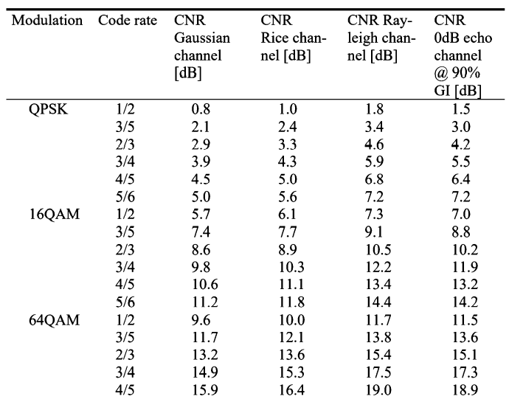

Figure 7.10-5b: CNR limits for a BER of 1.10-4 after LDPC

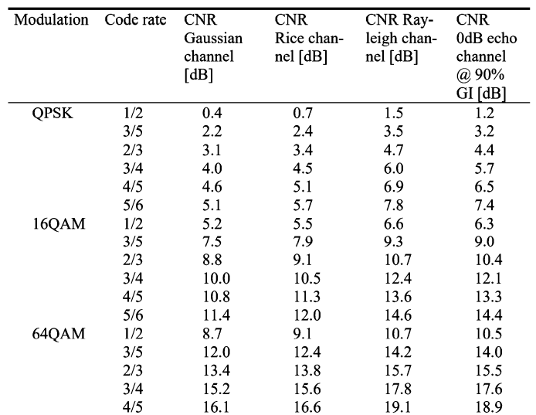

Table 7.10-5c: CNR limits for a BER of 1.10-4 after LDPC, short 16K FEC frame

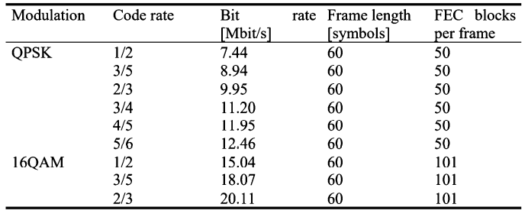

Table 7.10-5d: DVB-T2 channel capacity in the 8-MHz channel

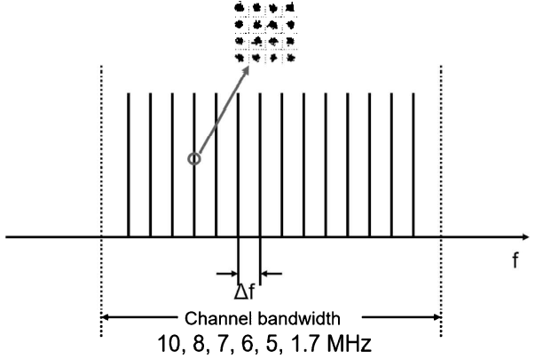

Figure 7.10-5e: DVB-T2 channel

#### 7.10-6 COFDM Parameters

DVB-T2 supports channel bandwidths of 1.7, 5, 6, 7, 8 and 10 MHz (Figure 7.10-4c). The actual signal bandwidth is slightly narrower because of the guard band at the upper and lower end of the DVB-T2 channel (Table 7.10-6d). Table before shows the CODFM parameters in the 8-MHz channel possible in DVB-T2. In the case of the 7- and 6-MHz and 1.7- and 10-MHz channel, respectively, (Figure 7.10-5e), the parameters must be adapted correspondingly by a factor of 7/8 and 6/8 etc., as can be seen in Table 7.10-6b., not every guard interval is possible in every COFDM mode. Apart from one exception (P1 symbol), the guard interval (Figure 7.10-6a) is also a cyclic prefix (CP) in DVB-T2, i.e., a repetition of the symbol end in the corresponding length.

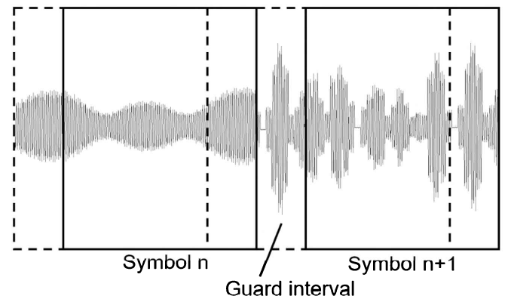

Figure 7.10-6a: Symbol and guard interval as a cyclic prefix (CP)

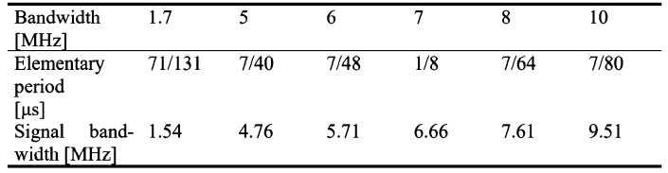

Table 7.10-6b: DVB-T2 channel- and signal bandwidths

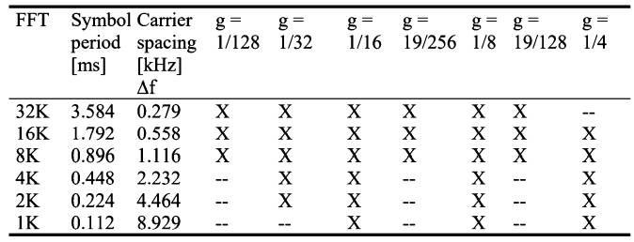

Table 7.10-6c: DVB-t2 COFDM parameters in the 8-MHz channel

A 16K and a 32K mode was provided in order to achieve less time overhead and thus a higher net data rate (6% overhead in the 32K mode, 25% in the 8K mode) with the same absolute guard interval length. The longest guard interval is now more than twice as long as the longest guard interval in DVB-T (0.224 ms); 0.532 ms in DVB-T2, 32K, g=19/128, correspond to a maximum transmitter distance of almost 160 km. Narrower signal bandwidths (7, 6, 5, 1.7 MHz) lead to even longer symbols and thus also lead to longer intervals. With these guard interval-lengths nationwide single-frequency networks can be implemented. The 32K mode is the mode providing the longest symbols and thus has the least overhead in the guard interval; at the same time, it serves to implement the largest single frequency networks. However, the 32K mode, due to its much narrower subcarrier spacing, is the mode least suitable for mobile use. The mode most suitable for mobiles is the 1K mode which has the largest subcarrier spacing. But it thus also has the shortest symbols and is, therefore, the one least suitable for forming large SFNs.

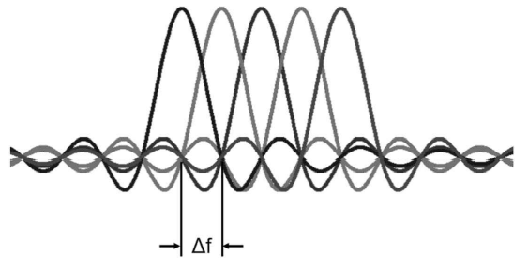

Figure 7.10-6d: Sin(x)/x shaped spectra of the OFDM carriers

#### 7.10-6-1 Normal Carrier Mode

In the DVB-T2 normal carrier mode, the bandwidths of the useful signal approximately correspond to the bandwidths of DVB-T. Between the useful signal spectrum and the beginning of the adjacent channel there is at the lower and the upper end of the DVB-T2 channel the so-called guard band which has a width of up to about 200 kHz. The guard-band has several tasks, the most important of which is to protect the adjacent channels (Figure 7.10-6-1b). The shoulder of the OFDM signal must decay within the guard band. One cause of the shoulders is the superimposition of the tails of the sin(x)/x-functions of each modulated single carrier. It can be demonstrated, however, that the more carriers are used, the more the resultant shoulders are suppressed; i.e., the 1K mode inherently has higher shoulders than the 32K mode. These shoulders are lowered as much as possible by digital filtering measures in the modulator. Nevertheless, it can also be demonstrated with a very good test transmitter that in the short range, the shoulders are much lower in the 32K mode than in the 1K-mode. There are simple mathematical reasons for this. The more carriers are used, the better the sin(x)/x tails will cancel.

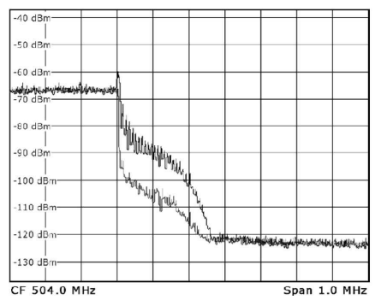

Figure 7.10-6-1a: Shoulders of the DVB-T2 signal in 32K and 1K mode in comparison

#### 7.10-6-2 Extended Carrier Mode

Since the sin(x)/x tails, and thus the shoulders, drops more towards the adjacent channels in the modes having more carriers, it was provided in DVB-T2 to support a wider spectrum above the 8K mode in the Extended Carrier Mode. The advantage is that this increases the data rate of the DVB-T2 signal.

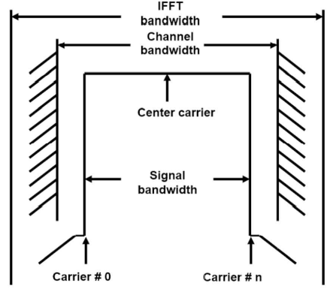

Figure 7.10-6-2a: DVB-T2 spectrum with upper and lower guard bands

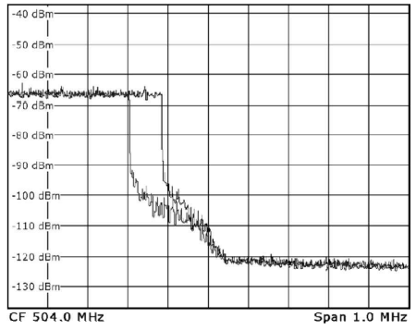

Figure 7.10-6-2b: DVB-T2 spectrum in normal and extended carrier mode

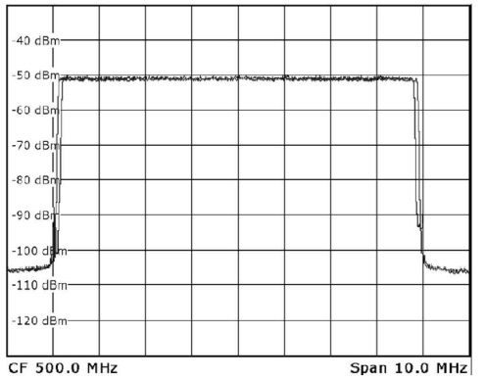

Figure 7.10-6-2c: Overall DVB-T2 spectrum in normal and extended carrier mode (32K)

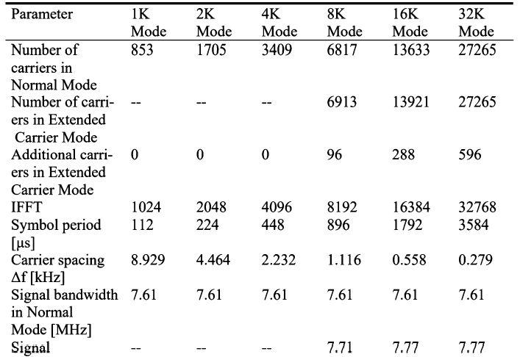

Table 7.10-6-2d: DVB-T2 OFDM parameters in the 8 MHz channel

### 7.10-7 Modulation Patterns

The modulation patterns used in DVB-T2 are coherent gray coded QAM orders. The constellations possible in DVB-T2 are:

* QPSK
* 16QAM
* 64QAM
* 256QAM

Differential modulation is not supported in DVB-T2. The first three QAM orders fully correspond to the mapping used in DVB-T. It is a special feature that the constellation diagrams can be either reversed or rotated (flipped) to the left by a certain angle; so-called rotated, Q-delayed constellation.

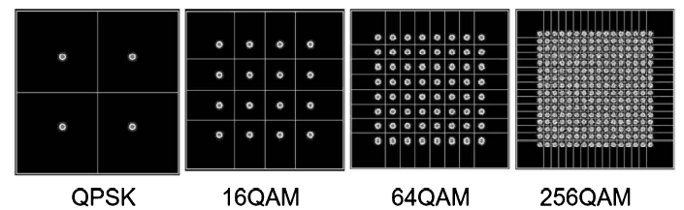

Figure 7.10-7a: non-rotated normal constellation

#### 7.10-7-1 Normal Constellation Diagram

In the case of QPSK, 16QAM and 64QAM, the normal non-rotated constellation diagram exactly corresponds to the constellation diagram of DVB-T. In addition, 256QAM was also defined as a possible constellation in DVB-T2. 256QAM makes sense because of the improved error protection Figure 7.10-7a. shows the no-rotated variants of the constellation diagram possible in DVB-T2.

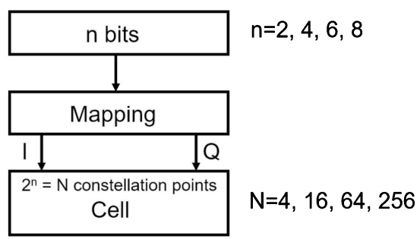

Figure 7.10-7-1b: Definition of a cell

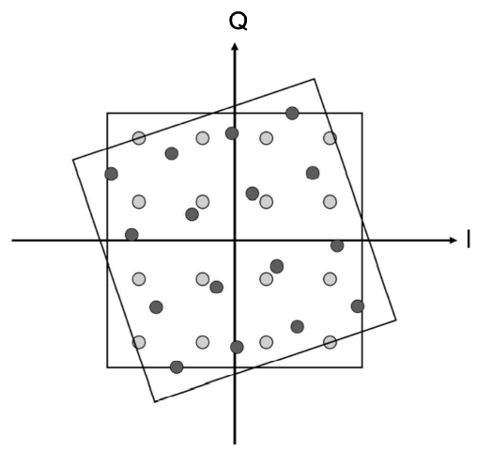

Figure 7.10-7-1c: Rotated and Q-delayed constellation diagram

#### 7.10-7-2 Definition of Cell

The term cell (Figure 7.10-7-1b) will now have to be defined. This term is mentioned time and again in the DVB-T2 standard. Thus, there is also, e.g., a so-called cell interleaver. A cell is simply the result of mapping a later carrier. In contrast to DVB-T, mapping is not carried out after all interleaving processes but relatively early, after the error protection and after the bit interleaver. However, this is still followed by the cell-interleaver, the time interleaver and the frequency interleaver which is why the mapping result cannot yet be allocated to a carrier and why the term cell was introduced. A cell is, therefore, a complex number consisting of an I-component and a Q-component, i.e., a real part and an imaginary part (Figure 7.10-7-1b).

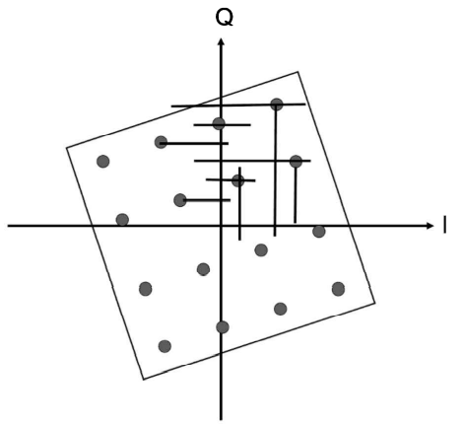

Figure 7.10-7-2a: Discrete mapping of constellation points on the I and Q axis

#### 7.10-7-3 Rotated Q-delayed Constellation Diagram

If rotated constellation diagram used, the information about the position of a constellation points is contained both in the I component and in the Q component of the signal. In a case of disturbance, this can be used for providing more reliable information about the position of the constellation point, in contrast to a non-rotated diagram. Contributing to better decodability. In contrast to a non-rotated constellation diagram, the IQ information, which is now discrete, can be used for soft decisions if necessary. Practice will show how much actual benefit can derive from this.

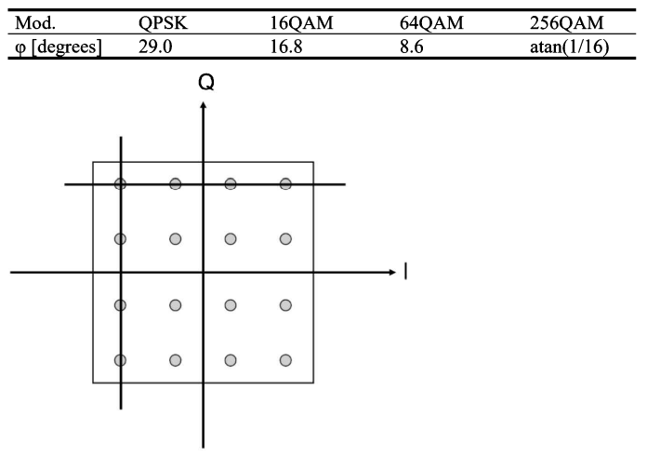

Table 7.10-7-3a: Angles of rotation of the constellation diagrams

In reality, however, the whole process is slightly more complex. With a rotated diagram, the Q component is not transmitted on the same carrier, or more precisely in the same cell, but with delay on another carrier. From one QAM, virtually two ASKs (Amplitude Shift Keying modulations) in the I and Q direction are then produced which are then transmitted on independent carriers – cells which are disturbed differently in practice and are thus intended to contribute to the reliability of demodulation. However, practice has shown that rotated constellation diagrams do not provide benefits for the current generation of DVB-T2 receiver chips.

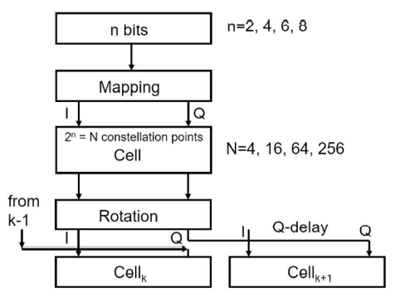

Table 7.10-7-3b: Mapping, rotation and Q-delay

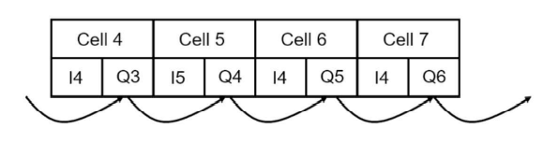

Table 7.10-7-3c: Cyclic Q-delay between adjacent cells

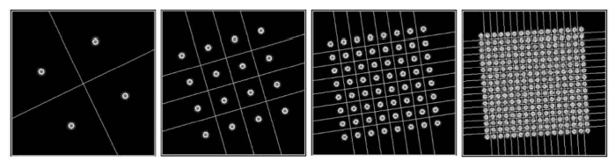

Table 7.10-7-3c: Rotated constellation diagram in DVB-T2

### 7.10-8 Frame Structure

A physical layer frame in DVB-T2 begins with a P1 symbol used for synchronization and frame-finding, followed by one or more P2 symbols containing layer-1 (L1)-signaling data for the receiver. This is followed by symbols which carry the actual payload data. The theoretically up to 255 input data streams are transmitted in so-called physical layer pipes (PLPs) in which the different contents can be transmitted with higher or lower data rate and more or less robustly (error protection and modulation). This is called variable Coding and Modulation (VCM). In addition, the transmission parameters of the PLPs can also be changed dynamically from T2 frame to T2 frame. The current transmission parameters of all PLPs are signaled in the P2 symbols; dynamic L1 signaling for the receiver takes place in the padding-field of the baseband frame.

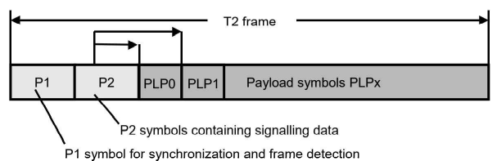

Figure 7.10-8a: Structure of a DVB-T2 frame

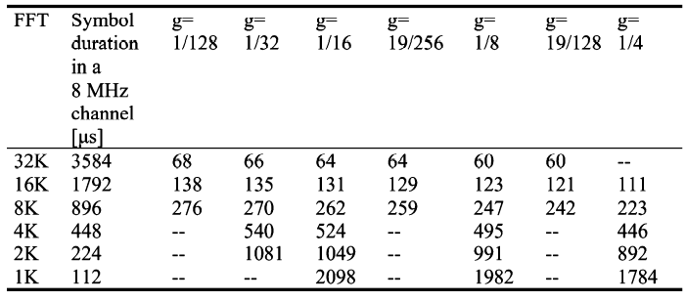

Table 7.10-8b: Maximum length of a DVB-T2 frame in numbers of OFDM symbols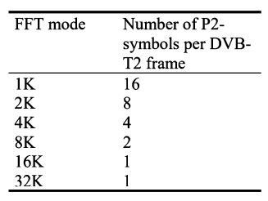

Table 7.10-8c: Number of P2 symbols per DVB-T2 frame as a function of the DVB-T2 FFT mode

Apart from the FFT mode, almost all transmission parameters can be changed from physical layer pipe (PLP) to physical layer pipe. As already mentioned, their signaling and the addressing of the PLP (Start, Length etc.) is handled via the P2 symbols called L1-signaling. The number of P2 symbols depends on the FFT mode; the reason being simply the different data capacity of the symbols, depending on the FFT mode. The 1K mode has the shortest symbols and thus the lowest data capacity per symbol. In the 32K mode, it is possible to transmit more data per symbol due to the much longer symbols. This is possible to the extent that the data transmission can even begin in the P2 symbols due to unused capacity.

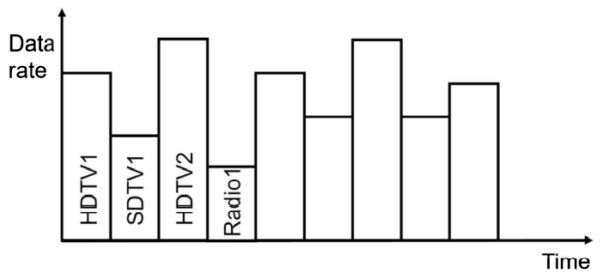

Figure 7.10-8d: Variable Coding and Modulation (VCM)

A DVB-T2 frame thus consists of:

* A P1 symbol
* 1...16 P2 symbols (depending on FFT mode)
* N data symbols (PLP data, FEF, auxiliary data, dummy cells)

A frame can have a maximum length of 250 ms, resulting in a maximum number of data symbols which, in turn, is dependent on the FFT mode and the guard interval. The net data rate per PLP can fluctuate due to different transmission parameters. A data stream carrying HDTV services, e.g., requires a higher data rate than a data stream transporting SDTV services or a data stream transporting pure audio broadcasting services.

#### 7.10-8-1 P1 Symbol

A P1 symbol (preamble symbol 1) marks the beginning of a frame, similar to the null symbol in DAB. Overall, the P1 symbol is used for:

* Marking the beginning of the DVB-T2 frame
* Time and frequency synchronization
* Signaling the basic transmission parameters (FFT mode, SISO/MISO)

The P1 symbol has the following characteristics:

* FFT mode = 1K
* ½ guard interval with frequency offset before and after the P1 symbol
* Carrier DBPSK modulated
* 7-bit signaling data (SISO/MISO/Future Use (3bits), use of FEF (1 bit), FFT (3bits))

So that the P1 symbol could be identified easily and reliably, two guard intervals were appended – one in front and one behind. This results virtually in a double correlation during the autocorrelation, in addition, the carriers are all shifted upward in frequency in the cyclical pre- and post-fix. Pre- and post-fix are not exactly of the same length.

#### 7.10-8-2 P2 Symbols

The layer 1 signaling (L1 signaling) is transmitted from the modulator to the receiver in 1.... 16 P2 symbols (preamble symbols 2) per DVB-T2 frame. Physically, preamble symbols 2 has almost the same structure as later data symbols. The FFT mode corresponds to that of the data symbols and is already signaled in the P1 symbol. However, the pilot density is greater.

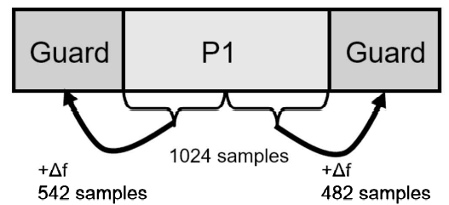

Figure 7.10-8-2a: P1 symbol

A P2 symbol consists of a pre- and post-signaling component. Both components are differently modulated, and error protected. The pre-signaling-component is permanently BPSK-modulated and protected with a constant error protection known to the receiver. The transmission parameters of the P2-pre-signaling component are:

* BSPK modulation
* FEC = BCH+16k LDPC
* LDPC code rate = ½

The transmission parameters of the P2 post-signaling component are:

* BPSK, QPSK, 16QAM or 64QAM
* FEC = BCH+16K LDPC
* LDPC code rate = ½ or ¼ with BPSK
* LDPC code rate = ½ with QPSK, 16QAM or 64QAM

P2 data in part 1 (constant length, L1 pre-signaling):

* Guard interval
* Point pattern
* Cell ID
* Network ID
* PAPR use
* Number of data symbols
* L1 post-signaling parameters (FEC and mod. Of L1 post)

P2 data in part 2 (variable length, L1 post-signaling):

* Number of PLPs
* RF frequency
* PLP IDs
* PLP signaling parameters (FEC and mod. Of PLP)

In the higher FFT modes, not all the carriers are needed for the L1 signaling. This free capacity can then be used already for the actual data transmission. i.e., the transmission of the PLPs can start already in the P2 symbols. Although this sounds somewhat adventurous to someone with years of experience and probably doesn't simplify its implementation, it does bring additional capacity either.

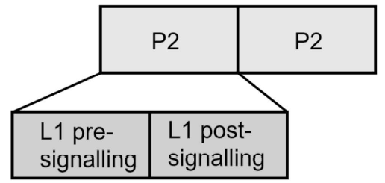

Figure 7.10-8-2b: Symbol, frame, superframe

#### 7.10-8-3 Symbols, Frame, Superframe

A DVB-T2 frame is composed of a P1 symbol, 1 to 16 symbols and N data symbols which can contain PLP data, future extension frames and auxiliary data, as well is dummy cells. Several frames, in turn, become one superframe.

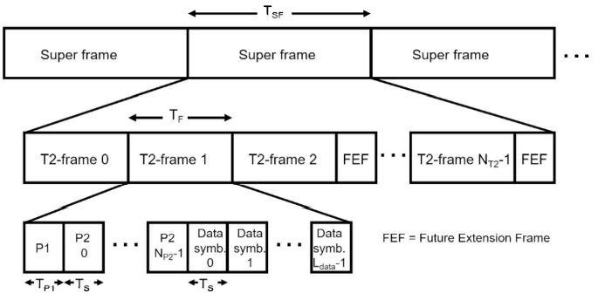

Figure 7.10-8-3a: Symbol, frame and superframe

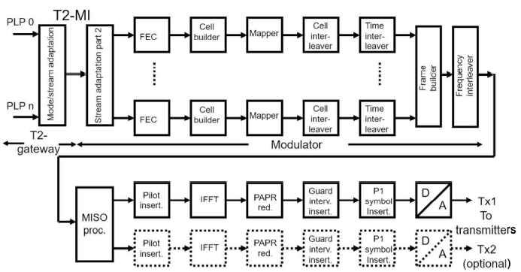

Figure 7.10-8-3b: Block diagram of the DVB-T2 modulator

### 7.10-9 Block diagram

The complete block diagram of the DVB-T2 modulator (Figure 7.10-8-3b), in comparison to that of the DVB-T (1) modulator, clearly reflects the comprehensive dimensions of the DVB-T2 standard. The left-hand side shows the input signal processing block, divided into the T2 gateway function group and the function group belonging to the DVB-T2 modulator. These are followed by the various physical layer pipe paths, each consisting of a FEC section, a Cell Builder, a Mapper, a Cell Interleaver and a Time Interleaver. All PLP branches then merge together in the Frame Builder block. Frequency interleaving and MISO processing then complete the processing chain. Note the two possible outputs, MISO Mode 1/ SISO and MISO Mode 2; these processing groups will be explained later.

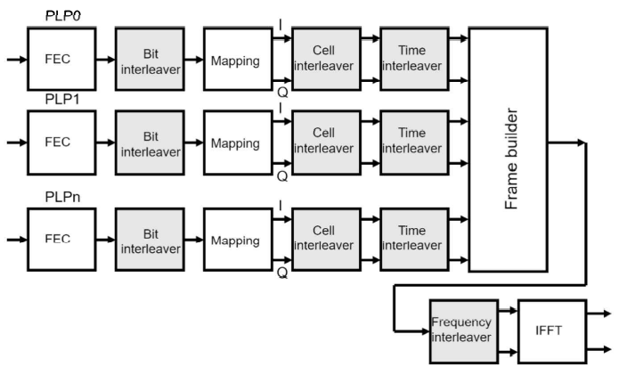

Figure 7.10-9a: lnterleavers in DVB-T2

### 7.10-10 Interleavers

In DVB-T2, interleaving (Figure 7.10-9a) is separated into:

* Bit interleaving
* Cell interleaving
* Time interleaving
* Frequency interleaving

The bit interleaver is a very short interleaver. It corresponds to the DVB-S2 bit interleaver and like that operates at the FEC frame level. The bit interleaver has the task of optimizing the characteristics of the error protection for immunity against burst errors, independently of the other interleavers. The cell interleaver also operates at FEC frame level and interleaves the cells already mapped, i.e., the IQ values. It improves the performance mainly in conjunction with the rotated and Q-delayed constellation. The time interleaver then distributes the information over a time which can be adjusted within wide ranges. The time interleaver is of assistance mainly with mobile reception, with long burst errors and with impulsive noise when the frequency interleaver distributes the information as randomly as possible to the various DVB-T2 OFDM carriers. Notches due to multipath reception will then lead to reduced losses.

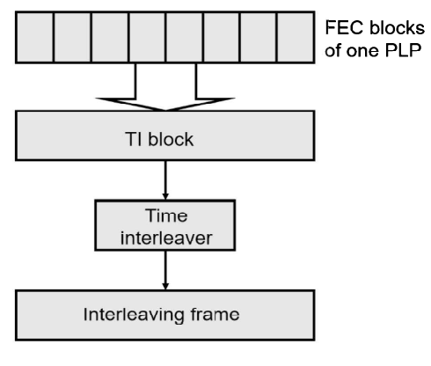

Figure 7.10-10a: DVB-T2 time interleaving

#### 7.10-10-1 Types of interleaver

Back in the 1960s, David Forney had the idea of improving error protection with regard to susceptibility to burst errors by applying time interleaving. Interleavers are interleavers are intended to distribute a data stream in time or frequency during transmission as randomly as possible, but so as to be recoverable by receivers. There are:

* Block interleavers
* PRBS interleavers

The interleavers used in DVB-T2 are either block interleavers or PRBS interleavers.

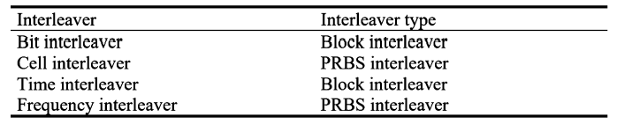

Table 7.10-10-1a: Interleavers types in DVB-T2

A block interleaver will first read the data, e.g., line by line, into a block and then read them out again, e.g., column by column, or in zig-zag form. A PRBS interleaver is controlled by a pseudo random sequence and distributes the data even more randomly.

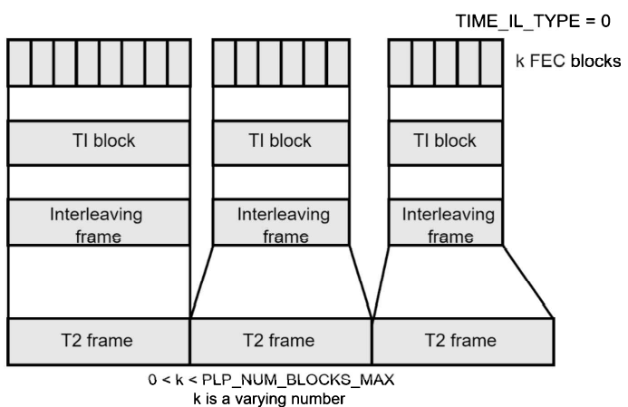

Figure 7.10-10-1b: Time interleaver, type 1

#### 7.10-10-2 DVB-T2 time interleaver configuration

The time interleaver has the task of distributing the data of a PLP over a very long period if possible (several hundred milliseconds). This increases robustness burst errors. Burst errors can occur mainly in mobile reception and with impulsive noise. In the DVB-T2 time interleaver, several FEC blocks are combined to form one or more-time interleaving blocks, and these are then interleaver and result in an interleaving frame. The time interleaver in DVB-T2 can be set by the following configuration parameters:

* TIME_IL_TYPE (1 Bit) 0 or 1
* TIME_IL_LENGTH (8 Bit) in blocks per interleaving frame
* FRAME_INTERVAL (8 Bit) in frames
* PLP_NUM_BLOCKS_MAX (10 Bit) in blocks 0 … 1023

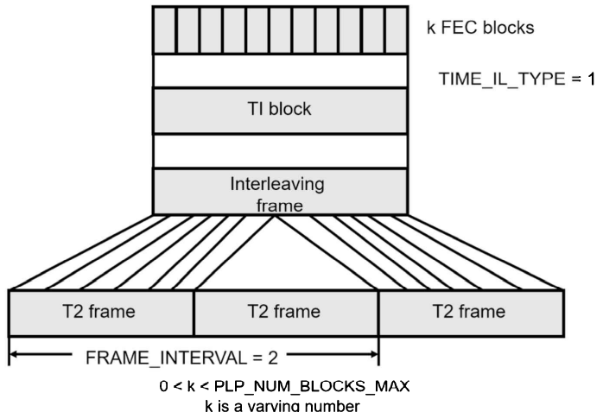

Figure 7.10-10-2a: Time interleaver, type 2

These enable the time interleaver to be set within wide ranges. The T1 configuration parameters of each PLP are signaled via the L1 post signaling part in the P2 symbols.

The TIME_IL_TYPE can be used for deciding whether the time interleaving is to take place within one T2 frame (TIME_IL_TYPE = 0) or distributed over several T2 frames (TIME_IL_TYPE = 1).

TIME_IL_LENGTH specifies the number of interleaving blocks per time interleaving frame.

FRAME_INTERVAL defines the interval between two frames carrying the time interleaving data of a PLP. I.e., gaps or T2 frames can now be inserted between interleaving data of PLPs, and thus greater interleaving intervals can be achieved.

PLP_NUM_BLOCKS_MAX specifies how many FEC frames may be maximally combined to form one-time interleaving block.

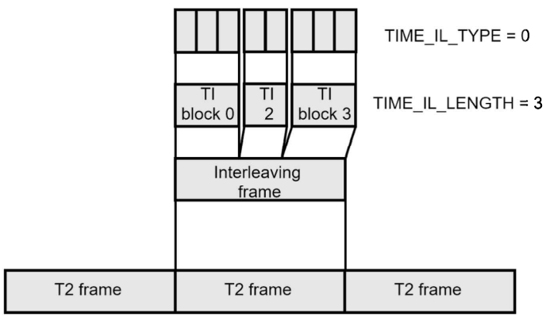

Figure 7.10-10-2b: Time interleaver, Type 3

Having selected these T1 configuration parameters, 3-time interleaver types can now be implemented, namely

* Typ 1: a time interleaver block in one-time interleaving frame, mapped in exactly one T2 frame (TIME_IL_TYPE=0, TIME_IL_LENGTH=1)
* Typ 2: a time interleaver block in one-time interleaving frame, mapped in several (n) T2 frames with definable frame interval between them (TIME_IL_TYPE=1, FRAME_INTERVAL=n)
* Typ 3: a definable number (m) in one-time interleaving frame mapped in one T2 frame (TIME_IL_TYPE=0, TIME_IL_LENGTH=m0

Each of these 3-time interleaver-types has different TI characteristics which are listed in the table.

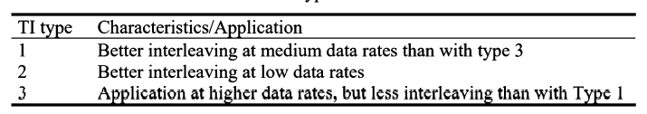

Figure 7.10-10-2c: Characteristics of the T1 in DVB-T2

Since most T2 applications only use one PLP at a very high data rate, usually time interleaver type 3 is selected with TI_Length = 3.

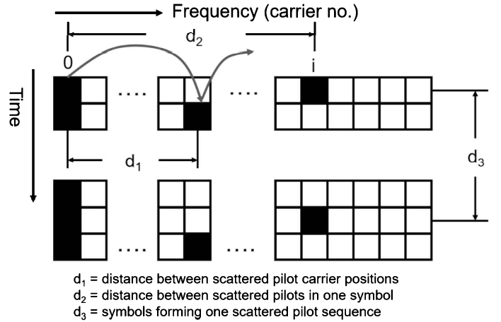

Figure 7.10-10-2d: Parameters for pilot pattern in DVB-T2

### 7.10-11 Pilots

In COFDM systems, the following tasks must basically always be implemented by special-carriers:

* Frequency lock (AFC = Automatic Frequency Control)
* Channel estimation – and channel correction
* Signaling of the transmission parameters

For this purpose, DVB-T has the following pilot signals, namely:

* Continual pilots for the AFC
* Scattered pilots for the channel estimation
* TPS carriers for signaling

DVB-T2 has the following pilots, namely:

* Edge pilots at the beginning and the end of the channel,
* Continual pilots
* Scattered pilots
* P2 pilot at every 3rd carrier position
* Frame-closing pilots for cleanly closing a frame

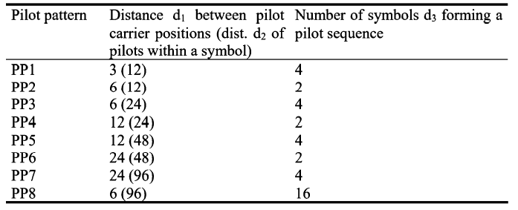

Table 7.10-11a: Pilot pattern in DVB-T2

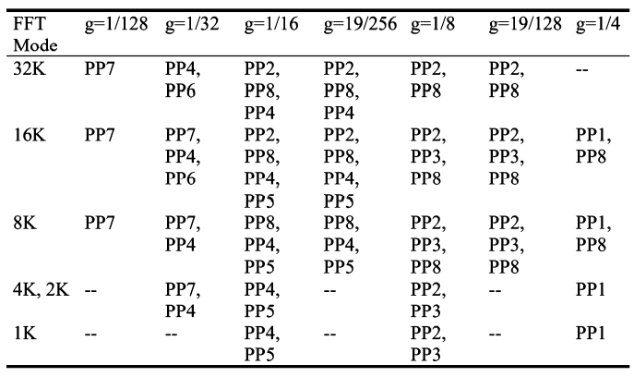

Table 7.10-11b: Scattered pilot pattern in SISO mode

In DVB-T2, the information of the previous TPS carriers is contained in the P2 symbols. There are no longer any TPS carriers, but there are continual and scattered pilots. In addition, the term edge pilot was introduced; it is not actually a special feature and was already provided in DVB-T where it fell under the category pilot. The edge pilots are simply the first and last pilot in the spectrum. The scattered pilots have several selectable, more or less dense, pilot patterns. Less dense pilot patterns means that there are more payload carriers, resulting in a higher net data rate. Denser pilot patterns (see in the figure and table, however, allow for a better channel estimation especially in the presence of difficult reception conditions such as multipath reception and mobile reception. When planning the network, the corresponding pilot pattern can then be selected in dependence on the planned coverage. Not all pilot patterns (called PP1 to PP8) can be used in all modes and guard interval configurations.

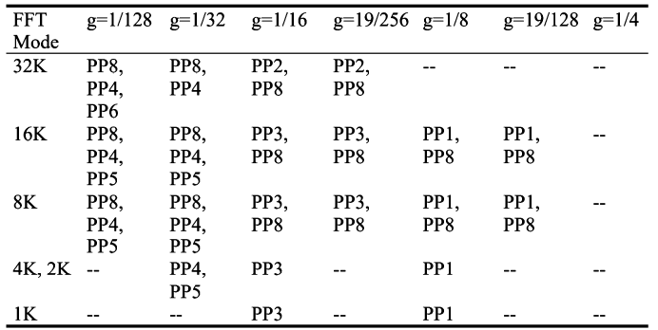

Table 7.10-11c: Scattered pilot pattern in SISO mode

The pilots are called boosted pilots because they have a higher amplitude than the payload carriers. This makes pilot detection easier and channel estimation more accurate. However, the actual amplitude depends on the selected pilot pattern (see Table 7.10-11d).

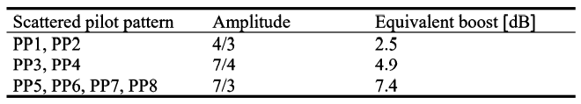

Table 7.10-11d: Amplitudes of the scattered pilots

### 7.10-12 Sub-Slicing

Without sub-slicing (Figure 7.10-12a), a PLP will arrive in the receiver in one piece in a timeslot in DVB-T2, I.e., the peak data rate may be relatively high for a PLP and then there may be no further reception of these data for a relatively long period. Sub-slicing divides the PLPs into smaller morsels which are then transmitted synchronously from PLP to PLP in the DVB-T2 frame. A PLP can be divided into 2 to 6480 subslices in sub-slicing. The subslices of the various PLPs then follow one another synchronously within a T2 frame. More subslices means more time diversity and less buffer memory demand, and fewer subslices means less time diversity, but offers the possibility of saving more energy in the receiver.

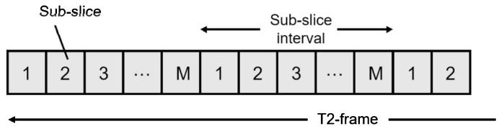

Figure 7.10-12a: Sub-Slicing

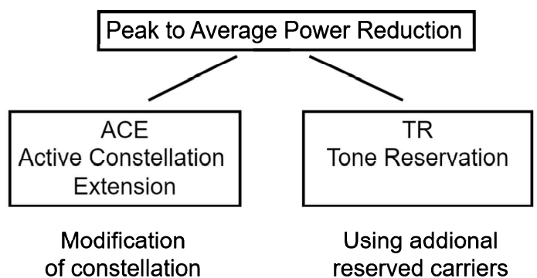

Figure 7.10-12b: PAPR (Peak to Average Power Ratio Reduction)

### 7.10-13 Time-Frequency-Slicing (TFS)

Time-frequency-slicing (TFs) is mentioned as an option in the appendix to the DVB-T2 standard. This would make it possible to radiate the PLPs or their subslices in up to 8 different RF channels. The complexity would be very high at the transmitting end since up to 8 transmitting trains would have to be implemented and the receiver would then require at least two tuners. It is questionable whether TFS will become reality, although this is already contained as a requirement in the first version of the NorDig-Spec for DVB-T2 receivers.

### 7.10-14 PAPR Reduction

PAPR reduction stands for Peak to Average Power Ratio Reduction (Figure 7.10-13b) and means nothing else than the reduction of the crest factors. The crest factor is the ratio of the maximum peak voltage to the RMS value. In theory, the crest factor can assume very high values in COFDM systems. In practice it is maximally about 12 to 15 dB, clipped at about 12 to 13 dB in the power transmitter. There have been relevant discussions and contributions since the beginning of the applications of COFDM. In order to be able to limit this crest factor in DVB-T2, two methods of PAPR are provided, namely Active Constellation Extension (ACE) (Figure 7.10-14a) and Tone Reservation (TR).

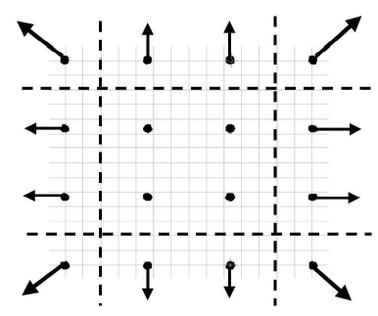

Figure 7.10-14a: PAPR – ACE – Active Constellation Extension

In the case of the Active Constellation Extension, the fact is used that the outermost constellation points could be shifted further out within certain limits, without restriction in the demodulation, in order to reduce the current crest factor by the summation of all carriers and by suitably adapting certain carrier amplitudes. However, the ACE is not possible with rotated constellation diagrams which is why this method will probably not be used in DVB-T2. In the case of the Tone Reservation, certain carrier bands are not intended for payload data transmission and also not for pilot tones. If necessary, these carriers, which are normally not switched on, can be activated so that they reduce the crest-factor. It is then up to the respective DVB-T2 modulator in its characteristics determined by the respective manufacturer to set these carriers in amplitude and phase in such a way that they really decisively reduce the crest-factor at the transmitter site. This is of minor importance in the interplay with neighboring sites in an SFN.

PAPR can be used mainly for increasing the efficiency of the transmitter output stages, which would be a real cost saving for the operation. However, due to the crest factor, there has always been a great need for discussion with respect to the correct dimensioning, especially in the case of the mask filters, the antenna combiner, the antenna cable and the antenna itself.

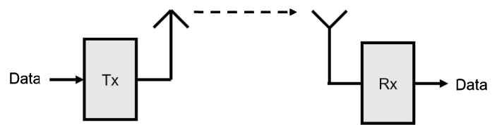

Figure 7.10-14b: SISO = Single Input – Single Output

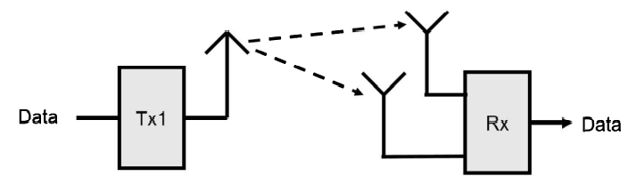

Figure 7.10-14c: SIMO = Single Input – Multiple Output

### 7.10-15 SISO/MISO Multi-Antenna Systems

DVB-T2 contains MISO (Multiple Input/Single Output) as an option. This means that possibly two transmitting antennas may be used which, however, do not radiate the same transmitted signal as in an SFN. Instead, adjacent symbols are transmitted repeatedly once by one and once by the other transmitting antenna in accordance with the modified Alamouti principle. This is an attempt to come close to the Shannon limit, especially in the mobile channel. SISO (Single Input/Single Output) is the traditional case of a terrestrial transmission link.

This arrangement uses exactly one transmitting and receiving antenna. SIMO (Single Input/Multiple Output) corresponds to diversity-reception with one transmitting antenna and several receiving antennas. In motor vehicles, in some cases 2 – 4 receiving antennas bonded to the vehicle's windows are employed DVB-T reception.

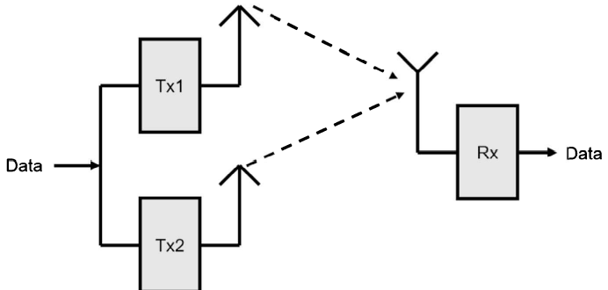

Figure 7.10-15a: MISO = Multiple Input – Single Output

#### 7.10-15-1 MISO according to Alamouti

In the case of MISO according to Alamouti, however, two transmitting antennas and one receiving antenna are used. The aim is to save on antenna expenditure in the receiver by changing to transmit diversity. This is also called space/time diversity according to [ALAMOUTI]. A further possibility would also be MIMI (Multiple Input/Multiple Output) with several transmitting and receiving antennas. The idea of the MISO principle goes back to [ALAMOUTI], 1998. This principle is already being used repeatedly at the two transmitting antennas. At the receiving antenna, a superimposed grouping of adjacent symbols always arrives which, without modification, would result in mutual interference and could thus no longer be separated in the receiver. In the case of the Alamouti principle, on the other hand. The adjacent symbols are not radiated unmodified at the various transmitting antennas, but in accordance with the Alamouti code. According to [ALAMOUTI], the two adjacent symbols Sn are first present at antenna 1 and Sn+1 at antenna 2. then symbol Sn+1 is applied in negative conjugate complex form to antenna 1 and at the same time symbols Sn is radiated in conjugate complex form at transmitting antenna 2.

This will enable the receiver to separate two adjacent symbols again by means of suitable complex mathematical operations on these symbols

In addition, the channel transfer function from transmitting antenna 1 to the receiver and transmitting antenna 2 to the receiver must be known. I.e., it is necessary to perform a channel estimation over all transmitting and receiving paths.

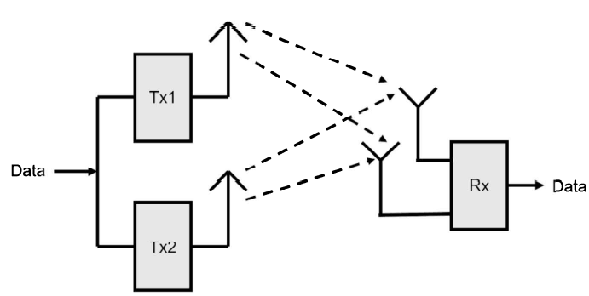

Figure 7.10-15-1a: MIMO – Multiple Input – Multiple Output

#### 7.10-15-2 Modified Alamouti in DVB-T2

It is intended to employ the MISO principle both at only one site and distributed over SFN sites. Used at one site, this can be done by horizontal and vertical polarization. However, DVB-T2 uses a modified Alamouti coding. At antenna 1, the cells C1, C2, C3, C4,… are present unchanged. It is only at antenna 2 that correspondingly changed cells are radiated. This has the advantage that the DVB-T2 system can be easily reduced to SISO by simply omitting the second transmitting path.

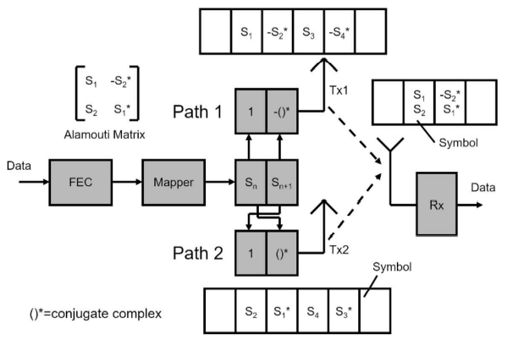

Figure 7.10-15-2a: MISO principle according to Alamouti

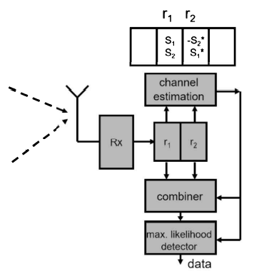

Figure 7.10-15-2b: MISO signal reception in the receiver

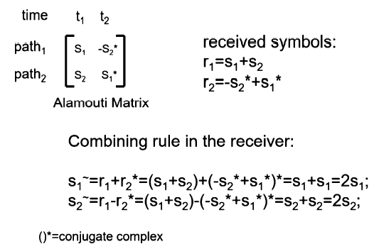

Figure 7.10-15-2c: MISO signal processing in the receiver

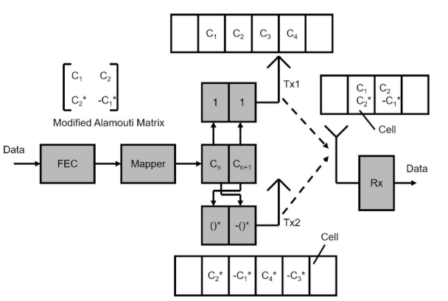

Figure 7.10-15-2d: Modified Alamouti in DVB-T2

This alone is not all, however. In DVB-T2, MISO is not applied via space/time diversity but via space/frequency diversity (based on adjacent cells in the spectrum). I.e., at transmitting antenna 2, adjacent pairs of carriers are radiated interchanged compared with those radiated at transmitting antenna 1. one great advantage of this modified Alamouti principle in DVB-T2 that the signal from transmitting antennas 1 and 2 are no longer correlated with one another. This makes it possible to avoid the notches prevalent in DVB-T and DAB, especially when using distributed MISO in an SFN. The principle of MISO by H- and V- polarization is called co-located MISO in DVB-T2.

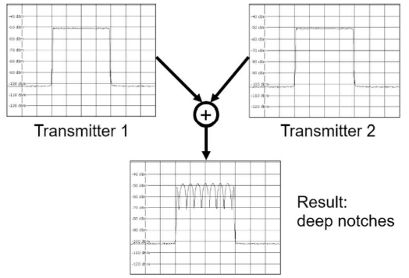

Figure 7.10-15-2e: Reception of two signal paths in an SFN without MISO, with fading

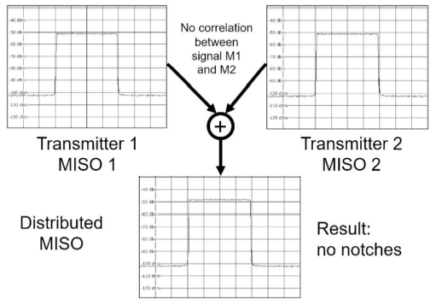

Figure 7.10-15-2f: Reception of two signal paths in a distributed DVB-T2, without fading notches

### 7.10-16 Future Extension Frames

DVB-T2 inherently already provides for possible expansion in so-called Future Extension Frames. These are special frames with as yet undefined transmission parameters which can be tied into the DVB-T2 frame structure. They are signals via P2 symbols.

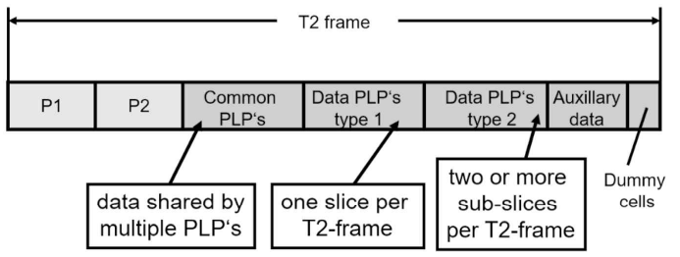

Figure 7.10-16a: DVB-T2 frame with auxiliary stream data

### 7.10-17 Auxiliary Data Stream

At the end of a DVB-T2 frame, auxiliary stream data can still be appended. These are customer-designer error–protected and mapped IQ values. A normal DVB-T2 receiver does not need to be able to evaluate these data.

### 7.10-18 DVB-T2-MI

In order to be able to conduct several (up to 255) data streams synchronously to the DVB-T2 modulator and transmitters in Mode B (Multiple Physical Layer Pipes), the T2-Mi modulator interface was defined. Apart from supplying the data stream, it also handles the control and signaling.

### 7.10-19 SFNs in DVB-T2

Naturally, it should be possible to implement single frequency networks also in DVB-T2, the main reason being the economic use of frequencies. Frequencies are expensive and are becoming even more scarce. Being able to reuse the same frequency is, therefore, important. Single frequency networks allow this at several adjacent transmitter sites in isolated, single frequency networks. DVB-T2 additionally allows larger interference-free single frequency networks to be formed.

Single frequency networks must meet the following conditions:

* Frequency synchronism
* Time synchronism
* Data synchronism
* Guard interval condition, I.e., maximum transmitter spacing must not be exceeded

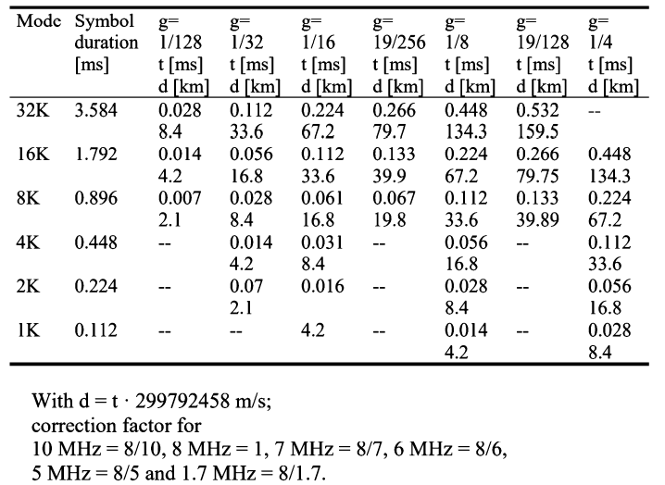

Figure 7.10-19a: Guard interval sizes in DVB-T2 (8 MHz-channel)

Frequency synchronism is achieved by frequency standards at the transmitter site, generally a professional GPS receiver providing a 10-MHz reference. Time and data synchronism is achieved by time stamps in the baseband feed signal. This is the T2-MI signal in DVB-T2. The DVB-T2 modulator synchronizes its frame structure to these stamps. The guard interval condition is met by suitable network's planning with planning software (LStelcom]. The new factor in DVB-T2 is the possibility of distributed MISO. There are transmitter sites which radiate either MISO mode 1 or 2. The advantage of this method is that destructive fading no longer occurs between two adjacent transmitter sites. However, the appropriate choice and simulation of the MISO modes is also a new challenge for network planning.

### 7.10-20 Transmitter Identification Information in DVB-T2S

There is a DVB document describing options for DVB-T2 transmitter signature to be able to identify a T2-transmitter in an SFN. But that algorithm is not implemented in DVB-T2 transmitters. DAB has the TII signal in the Null symbol for this purpose. Transmitter identification was not possible in DVB-T since this would have violated synchronism and would have led to several disturbances in an SFN. The cell ID in DVB-T only allowed an SFN cell to be identified. The cell ID is here built into reserved TPS bits.

DVB-T2 has the capability of inserting Auxiliary Stream and FEFs (Future Extension Frames) into a T2-frame. Normal DVB-T2 receivers will ignore the Auxiliary Stream and FEFs. DVB-T2 provides for such transmitter identifiers or transmitter signatures to be inserted into the T2 frames either via the Auxiliary Streams or via the FEFs. Similar to DAB, these would be certain active carriers which are activated only at individual carriers within the Auxiliary Streams and would be switched off at all other transmitters is an SFN. By means, the signals of the channel impulse response in an SFN can then be correlated with the individual transmitter. The signaling of the transmitter identification via the FEFs provides for broadcasting certain different signatures or sequences over the transmitters which can be identified by correlation and thus also enable the individual transmitters in an SFN to be recognized. The additional signalling of the transmitter identification is an overhead which, however, should occupy only very little payload data rate. In DVB-T, transmitter identification has always been wished for by the maintenance technicians who had to perform the coverage tests, but it had been a wish which could not be fulfilled. DVB-T2 transmitter identification information is currently not implemented in DVB-T2 transmitter and DVB-T2 test receivers. Important is that the Cell ID must not be used for transmitter identification!

### 7.10-21 Performance

The goal was to achieve a 30 percent higher performance compared to DVB-T. In some cases, data rates can be increased by a factor of 1.5 to almost 2 under comparable conditions. On the flip side, this standard is about 150% more complex than DVB-T. Combined with the new video and audio compression standards like MPEG-4 H.264 AAC, this new standard brings a tremendous performance increase in terms of program variety and quality. DVB-T2 is so far ahead of its time in that it will take a while until a new standard possibly replaces it, especially considering that it has come very close to the Shannon limit. In 2017, Germany switched to DVB-T2 and the new video codec H.265/HEVC. This also means, however, that existing TV terminals with an already integrated DVB-T2 receiver do not necessarily meet the preconditions for reception, because only a certain group of receiver sets support HEVC.

### 7.10-22 T2-Lite

A few years after DVB-T2 was released, a technical variant described in the T2 document annex appeared under the name T2 Lite. The targeted devices were once again mobile TV terminals. The technical parameters of a T2 Lite receiver were constrained in terms of memory requirements, and additional specific code rates were defined. T2 Lite signals will be transmitted in Future Extension Frames (FEF) of DVB-T2. As a significant feature, the OFDM mode in the FEF frames can and may be different from that in the rest of the DVB-T2 signal. This means that mobile receivers can be offered lower-order OFDM modes that are easier to receive on a mobile device than the signal transmitted for stationary DVB-T2 receivers. Normal DVB-T2 receivers will simply ignore the DVB-T2 Lite signal.

### 7.10-23 Outlook

At present (as of 2019), alongside ATSC3.0, DVB-T2 is the most modern digital terrestrial television standard. Since the technology became available in 2010, more and more DVB-T2 networks are being built worldwide or existing DVB-T networks are converted to DVB-T2. Germany switched from DVB-T (1) to DVB-T2 between March 2017 and April 2019, with a preliminary multiplex put into operation already in May 2016. Simultaneously, a new video source coding system, H265/HEVC has also been introduced. The two methods make it possible to broadcast 5 to 6 HDTV programs per 8 MHz channel instead of the previous 4 SDTV programs. The number of programs depends on the technical broadcasting parameters that are not the same in all regions of Germany. The switchover from DVB-T (1) to DVB-T2 in all regions in Germany will last until 2019.

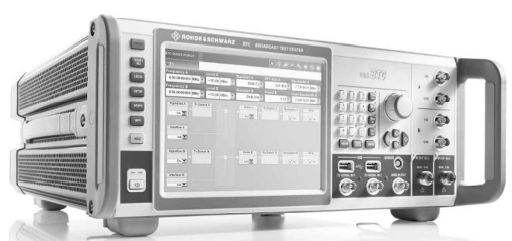

Figure 7.10-23a: Broadcast Test Center BTC; used for simulation of complex SFN

## 7.11 Modulation Signal Feed

The modulating signal or distribution signal is fed from the source (studio, headend, etc.) to the transmitter over:

* Directional microwave radio link
* Fiber
* Satellite
* Wire

Via redundant paths. The distribution signal is generated in the so-called headend, understood in digital broadcasting as the source encoder (MPEG encoder, Dolby encoder, etc.). the multiplexer and the SFN adapter (also called MIP inserter in DVB-T). For single-frequency networks, a timestamp must be added (e.g., to the MIP in the case of DVB-T) to the distribution signal before it is passed to the distribution network at the output of the headend. Burying a cable is costly, and in mountains it is not even advisable due to avalanches, so the signal is mostly passed over the air via directional radio links. Satellite connections, which are highly reliable, are costly because the transponder renting is expensive. Also, SFN synchronization when using satellite feed requires dynamic propagation time compensation due to the varying satellite orbit positions, especially since the satellites used for such purposes are often near their end of life due to cost considerations. Transmitter buildings typically have a dedicated area (rack, room, etc.) for receiving the distribution signal coming from the distribution path. It is common to have redundant distribution paths (e.g., second microwave link, directional reception from other stations in the case of VHF FM radio, etc.). The modulating signals are also often monitored (distribution signal monitoring) and then fed to the modulators in the transmitting racks.

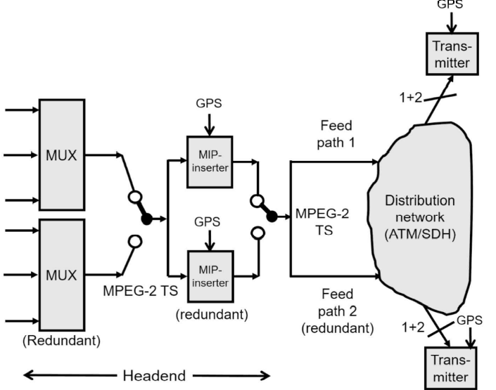

Figure 7.12a: DVB-T Distribution network: headend (encoder, multiplexer, MIP inserter)

## 7.12 Terrestrial Broadcast-Transmit Station

A terrestrial broadcast-transmit station consists of the following parts and rooms:

* Signal distribution section (incoming modulating signals)
* Transmitter room
* Cooling
* Antenna combiner/filter
* Transmitter control room
* Power supply, diesel generator/generator
* Social rooms, and
* Broadcasting antenna

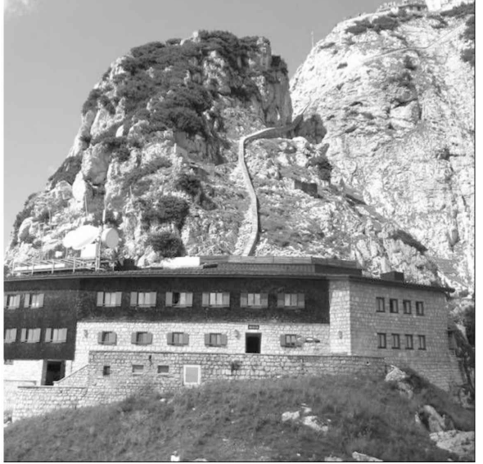

Figure 7.12a: Transmission station Wendelstein, Bayerischer Rundfunk, directional antennas and cable duct for the transmission cable clearly recognizable

Large transmitter sites have separate rooms for the various technical segments, while some have all the technical facilities housed in one or more containers. Many transmit stations used to be manned around the clock, but currently on-site personnel are increasingly rare. Many transmitters are remotely monitored and controlled. The components and the technology of the transmitter site are detailed in the following chapters.

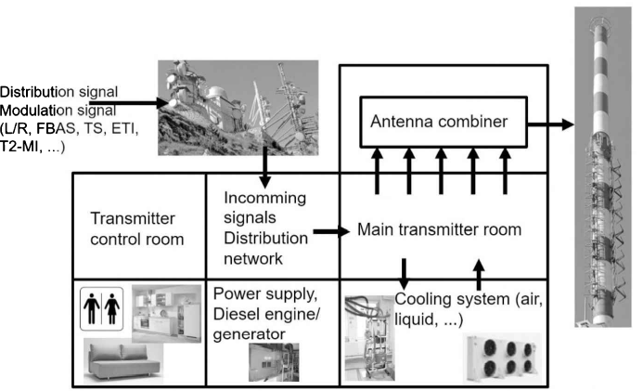

Figure 7.12b: Structure of a terrestrial transmit station: entry point of the modulating signals (distribution), main transmit room, antenna combiner with mask filters, cooling system, control room, power supply, transmission antenna system, lounges in manned stations.

## 7.13 Modulator, Exciter

The modulator, the main functional unit of the exciter receives the signal to be transferred and modulates it onto the RF signal. The format of the modulating signal depends on the transmission standard: V/UHF FM, analog TV, digital TV such as DVB-T, DVB-T2, ISDB-T, etc. Consequently, it can be one of the following:

* Analog audio signal, mono
* Analog audio signal, stereo L/R
* V/UHF FM stereo multiplex signal
* Analog FBAS signal associated with analog audio signal
* MPEG-2 transport stream
* DAB ETI signal
* T2 MI signal
* ISDB-T BTS signal, etc.

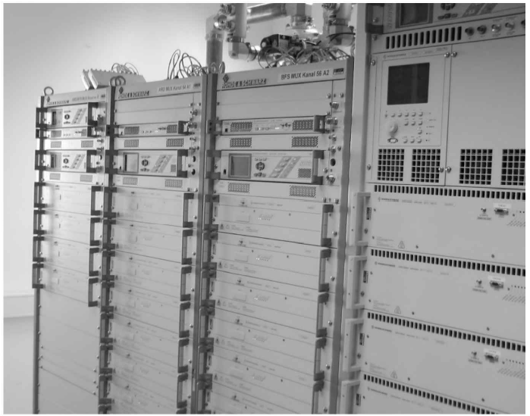

Figure 7.13a: DVB-T transmitter racks, transmitter station Wendelstein, Bayerischer Rundfunk

The RF signal at the modulator output is already in the correct frequency range but with a very low power of a few milliwatts or watts; it is, however, sufficient for driving the transmit amplifier. This latter one is mostly preceded by a power splitter that divides the modulator's output signal into two branches with correct power and phasing for the amplifiers.

In addition to the above, the OFDM modulator of a single frequency network (DVB-T, DVB-T2, DAB/DAB+, ISDB-T, etc.) also gets a high precision 1 PPS clock signal and a 10 MHz reference signal from a GPS reference frequency source.

The exciter includes further functions in addition to modulation, and consists of the following components:

* Input interface for modulating input signals on the main and redundant signal path
* Modulator
* Interface for the time and frequency reference
* Optional integrated GPS receiver
* Synthesizer/frequency locking/reference frequency source
* Nonlinear predistortion stage
* Linear predistortion stage
* Output amplifier

Nonlinear predistortion serves to compensate as much as possible for the remaining nonlinearities of the subsequent power amplifiers. This is typically done in the IQ path by using correction tables, which are set during the adjustment of the transmitter. Predistortion itself is performed in DTV/DAB systems by observing the shoulders and lowering them to a good shoulder distance. This was initially performed manually in the transmitter test facility but is being increasingly replaced by automatic equalization. In analog television, equalization criteria are obtained by observing special measurement parameters like luminance nonlinearity, differential gain, differential phase, and ICPM. Manual linear predistortion serves to compensate for the amplitude response and group delay response of the subsequent band pass filters (mask filter, antenna combiner).

## 7.14 GPS Time/Frequency Reference

Transmitter frequencies used to be derived from highly precise frequency sources like rubidium references or via a time signal transmission (DCF77); currently, this is performed exclusively by using GPS time and frequency references. These GPS receivers use the Global Positioning System to provide time information, a 1PPS clock, and a usually highly precise 10 MHz reference signal. These GPS reference sources normally consist of a GPS antenna, a GPS receiver with a 1PPS (1 pulse per second) output signal and a 10 MHz VCO (Voltage Controlled Oscillator) locked to the 1PPS signal by a phase locked loop (PLL). The trick here is to lock it on as fast as possible in order to provide a stable 1PPS time reference and a 10 MHz clock signal, and to maintain them for as long as possible even if the GPS signal is lost.

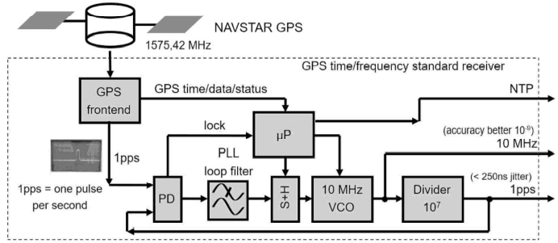

Figure 7.14a: GPS time/frequency reference source